**K. S. School of Engineering & Management (KSSEM)**

* **Address:** No.15, Mallasandra, Off. Kanakapura Road, Bengaluru-560109
* **Contact:** +91 9900710055
* **Affiliations:** VTU, Belagavi; Approved by AICTE, New Delhi; Accredited by NAAC
* **Admission:** Open for the Academic Year 2026-2027. Contact: 9900710055

**Department of Civil Engineering**

* **Program Offered:** Bachelor of Engineering in Civil Engineering
* **Curriculum Focus:** Structural analysis, geotechnical engineering, transportation, water resources, environmental engineering, and construction management
* **Career Opportunities:** Structural engineer, site engineer, project manager, transportation planner, environmental consultant

**Vision & Mission**

* **Vision:** To emerge as one of the leading Civil Engineering Departments by producing competent, quality, ethical engineers with a strong foundation in infrastructure development and research.

**Recent Events & Activities**

* **ACETECH Field Visit:** Conducted on 18.10.2024
* **FDP on Women in STEM:** A five-day program from October 17th to 21st, 2022, with Ms. Sailaja, Vice President of TCS Banking Solutions, as the chief guest
* **AICTE Sponsored FDP:** Six-day program on Recent Trends in Sustainable Construction Technologies (18th to 23rd December 2023)
* **Civil Hackathon:** Organized in December 2024
* **National Seminar on Sustainable Built Environment:** Held on 02-02-2023 and 03-02-2023
* **Industrial Visit:** Students visited Sai Krushna Charitable Trust in Hossadoddi Village on 19th August 2022

**Placements & Alumni**

* Alumni are placed in renowned companies, driving innovation and excellence
* Testimonials highlight the supportive environment, quality education, and exposure to research and extracurricular activities

**Important Links**

* **AICTE, VTU, IEEE, KSHEC**
* **Student Welfare:** Grievance Redressal Cell, Disciplinary Measures, Committees
* **Quick Links:** Careers, Online Fee Payment, Admission Enquiry, Contact, Accreditation & Approvals, Login
* **Scholarships:** National Scholarship Portal, SC Scholarships
* **Group of Institutions:** KSGI, KSIT, KSSA, KS Polytechnic, KS Hospital, KS Credit Co-op Bank

**VISION**

* To emerge as one of the leading Civil Engineering Department by producing competent and quality ethical engineers with strong foot hold in the areas of Infrastructure development and research.

**MISSION**

**Department of Civil Engineering shall,**

* Provide industry oriented academic training with strong fundamentals and applied skills.
* Engage in research activities in Civil Engineering and allied fields and Inculcate the desired perception and value system in the students.

**Upcoming Events**

|  |
| --- |
| **Presentation by 8th sem students on Best practices adopted by construction industry**  March 29th 2023 Ultra Tech will evaluate the presentation on best practices adopted by 8th sem students |

|  |  |
| --- | --- |
| Event Image | **Pre-Employment Training**  Pre-Employment Training in Association with UltraTech Cement Limited for Final year Students.  [View Image](https://kssem.edu.in/images/1678699272670_image.jpg) |

|  |  |
| --- | --- |
|  | **TWO DAY NATIONAL CONFERENCE**  Department of Civil Engineering organizes National Seminar on Emerging Trends in Sustainable Built Environment on 02-02-2023 and 03-02-2023.  [View Image](https://kssem.edu.in/images/1666081395193_image.pdf) |

|  |  |
| --- | --- |
|  | **FIVE DAY FDP**  The Challenges And Opportunities For Women In Science, Technology, Engineering & Mathematics (Stem).  [View Image](https://kssem.edu.in/images/2c9f8d4183ac80c40183b61af9fc002b_image.pdf) |

|  |  |
| --- | --- |
|  | **AICTE ACTIVITY_IMPROVE EDUCATION QUALITY IN VILLAGE_SESSION 2**  Department of Civil Engineering Students of IV Semester will visit Sai Krushna Charitable Trust at Hossadoddi Village, Kanakapura Road to train high school students in an innovative manner on 27th August 2022 as apart of AICTE Activity.  [View Image](https://kssem.edu.in/images/1661489829338_image.pdf) |

* [**Profile**](https://kssem.edu.in/civil_dept#profile)
* [**PEO**](https://kssem.edu.in/civil_dept#peo)
* [**M.Tech**](https://kssem.edu.in/civil_dept#mtech)
* [**R & D**](https://kssem.edu.in/civil_dept#research)
* [**Time Table**](https://kssem.edu.in/civil_dept#timetable)
* [**Syllabus**](https://kssem.edu.in/civil_dept#syllabus)
* [**Professional Bodies**](https://kssem.edu.in/civil_dept#professional_bodies)
* [**News Letter**](https://kssem.edu.in/civil_dept#newsletter)
* [**Faculty**](https://kssem.edu.in/civil_dept#faculty)
* [**FDP**](https://kssem.edu.in/civil_dept#fdp)
* [**Consultancy**](https://kssem.edu.in/civil_dept#consultancy)
* [**NPTEL**](https://kssem.edu.in/civil_dept#nptel)
* [**Achievers**](https://kssem.edu.in/civil_dept#achievers)
* [**Alumni Achievers**](https://kssem.edu.in/civil_dept#alumniAchievers)
* [**Infrastructure / Facilities**](https://kssem.edu.in/civil_dept#facilities)
* [**Gallery**](https://kssem.edu.in/civil_dept#gallery_dept)
* [**Departmental Library**](https://kssem.edu.in/civil_dept#library_dept)
* [**Placement Details**](https://kssem.edu.in/civil_dept#placement_dept)
* [**Higher Education**](https://kssem.edu.in/civil_dept#higher_education)
* [**Student Club**](https://kssem.edu.in/civil_dept#student_club)
* [**Teaching and Learning**](https://kssem.edu.in/civil_dept#teaching-learning)
* [**Internships & Projects**](https://kssem.edu.in/civil_dept#internship)
* [**Industrial / Site Visit**](https://kssem.edu.in/civil_dept#industrial_visit)
* [**Events**](https://kssem.edu.in/civil_dept#events)
* [**E-resources**](https://kssem.edu.in/civil_dept#resources)
* [**Project Exhibition**](https://kssem.edu.in/civil_dept#project_exhibition)
* [**MOUs Signed**](https://kssem.edu.in/civil_dept#mou-signed)
* [**NBA**](https://kssem.edu.in/civil_dept#nba)
* [**Social Activities**](https://kssem.edu.in/civil_dept#social_activities)
* [**Other Details**](https://kssem.edu.in/civil_dept#other_details)

**Profile**

Department of Civil Engineering is established in the year 2010 and offers four year undergraduate course leading to Bachelor's degree in Civil engineering affiliated to Visveswaraya Technological University, Belgaum.

Department of Civil Engineering also offers Masters in Structural Engineering program since 2013. Research centre has been established in the year 2016-17 with more than 10 research scholars.

The Department aims at producing eminent Civil Engineers for the Nation and also across the Globe. The Department has eminent faculty with wide range of experience in consultancy, research, teaching, training and field experience which will help the students to gain practical knowledge which is very essential for their future endeavours.

**Head Of The Department Desk**

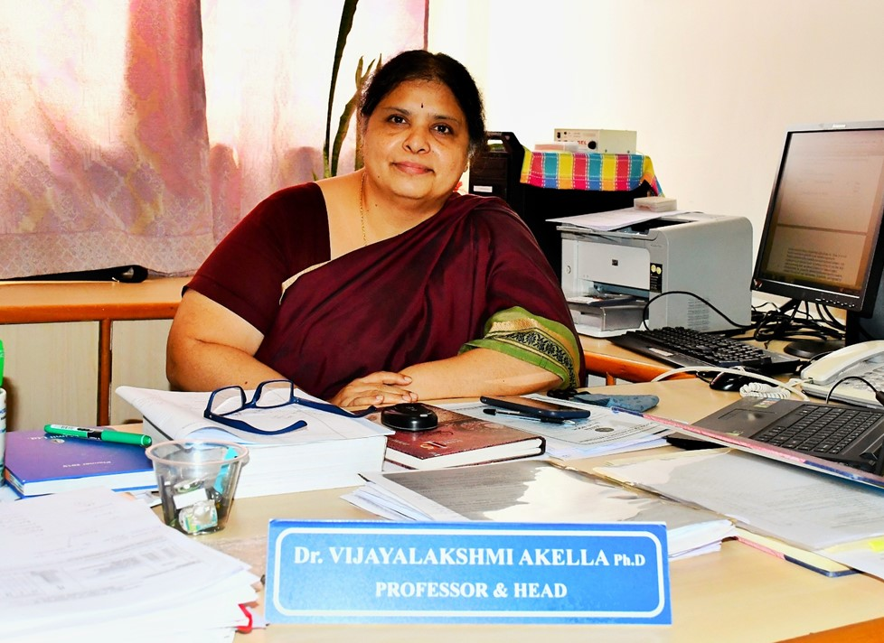

**Dr. Vijayalakshmi Akella**

**Professor & Head**

**Ph.D**

I take the privilege to welcome you all to the Department of Civil Engineering at KSSEM. The Department of Civil Engineering has been in existence since the inception of KSSEM in 2010 and has grown into a full-fledged department with specialization in STRUCTURAL Engineering. Besides high quality teaching and instruction at both UG and PG levels, the Department is actively involved in basic and applied research and consultancy and provides high quality technical advisory support through various R&D projects and consultancy to various organizations. The faculty members of the department are involved in high quality research and consultancy activities. The Department of Civil Engineering with its multifaceted faculty continues to maintain and cultivate its strong links with the infrastructural industry. We encourage students to engage in extra-curricular and co-curricular activities, essential for development, nurturing of team spirit, and developing organizational skills.

The Department of Civil Engineering aims to produce Competent, disciplined, quality Engineers and administrators to the society to make India a major industrial power. We conduct workshops on state of art technologies, invite experienced industrial experts, hands on training on non-destructive techniques, GIS, GPS technologies, site visits etc

**Long term goals**

* Inspire the leaders of tomorrow to take on the challenge of creating and sustaining the built environment that underpins our society.
* Create engineers who successfully adapt and innovate solutions for the built environment.
* To train the graduate students to appreciate the importance of service to their profession and to their communities.

**Short term goals**

* Train the students on broad set of skills.
* Inculcate the habit to have inquisitive attitude
* **PROGRAM EDUCATIONAL OBJECTIVES (PEOs)**
* **PEO - 1 :**
* Focus on developing a clear understanding of the basic principles and theories of Civil Engineering to build a strong foundation for advanced learning and practical applications.
* **PEO - 2 :**
* Pursue a successful professional career in Civil Engineering by working in the construction industry, public sector, teaching profession and as an entrepreneur.
* **PEO - 3 :**
* Emphasize the importance of pursuing higher education to enhance professional skills.
* **PEO - 4 :**
* Inculcate ethical values in the students.
* **M. Tech in Structural Engineering**
* This course is designed to help the students improve their experience in structural engineering. Issues addressed in the course will help familiarize the student with common challenges in the design office and on the site.
* **The main objectives of the course are to :**
* To provide our students receiving master's degrees with a strong technical education that will prepare them for successful professional careers in industry, or for continued research in their area of specialization.
* To provide our students with fundamental Structural Engineering principles that can be applied across multiple engineering applications (such as Aerospace, Civil, Marine, and Mechanical).
* To provide our students with broad multi-disciplinary skills necessary to accomplish professional objectives in a rapidly changing technological world.
* To provide our students with the ethical standards, communication and collaboration skills essential for professional practice and career advancement.
* **Eligibility:**
* Candidates who have acquired BE/B.Tech or equivalent degree in Civil Engineering by securing not less than 50% marks in aggregate are eligible. However in case of candidates belonging to SC/ST/Group, the aggregate percent of marks in qualifying examination should not be less than 45%. The admissions are through central counseling on the basis of merit in PGCET or GATE. A few seats are also available under sponsored and Management quota. GATE qualified candidates are eligible for scholarship through AICTE.
* This is a 2-year graduate program which involves three semesters of intense coursework and a final semester project, either in the institute or as an internship at leading companies, making it a job-centric program.
* **Areas of research work:**
* Structural Engineering is involved in the planning, analysis, design and health monitoring of buildings, bridges, industrial facilities and other structures. Graduates of this program are well prepared to pursue a Ph.D. in structural engineering or work in structural engineering consulting or design, construction, aerospace, and related fields.
* Structural Engineering, Health Monitoring of Bridges, Nondestructive Testing, Structural Dynamics, Floor Vibrations for Human Comfort and Sensitive Equipment, Bridge Analysis and Design, Structural Analysis/Design, Earthquake Engineering, Steel Design, Concrete Design are some of the areas of research work.
* **Placement Opportunities:**
* Reputed companies like Aashraya Projects, Akshaya Builders and Developers, Balagi Developers, Brigade Group, Daya MK, Edifice Builders, ETA star, Galaxy Developers, Greater Bangalore Estates, Habitat Ventures, Home space, Inset Builders and Developers, JSR Enterprise housing Projects, Maxwortj Realty, MBR Builders, Multi Group, NBR Developers, NCC Urban, Nitesh Estates and many more?
* **Contact:**
* [hod.civil@kssem.edu.in](mailto:hod.civil@kssem.edu.in)

### Research and Development

Research centre has been established in the year 2016-17 with more than 10 research scholars.

### R & D Activities

### Sponsored Projects

UNNATH BHARATH ABHIYAN [[View here]](https://kssem.edu.in/images/1729589280744_image.jpeg)

VGST FUNDED SANCTIONED PROJECT [[View here]](https://kssem.edu.in/images/2c9f8d418345fb7d01835f4570fc0089_image.pdf)

VTU FUNDED SANCTIONED PROJECT [[View here]](https://kssem.edu.in/images/2c9f8d418345fb7d01835f44f8480088_image.pdf)

VTU FINANCIAL ASSISTANCE SPONSORED STUDENT PROJECT LIST [[View here]](https://kssem.edu.in/images/2c9f8d418248e4ae01826326f95c010b_image.pdf)

KSCST FUNDING SANCTIONED STUDENT PROJECT LIST [[View here]](https://kssem.edu.in/images/1729578179704_image.pdf)

SPONSORED NATIONAL SEMINAR LIST [[View here]](https://kssem.edu.in/images/1748079492431_image.pdf)

### Ph.D Pursuing

RESEARCH SCHOLAR INHOUSE [[View here]](https://kssem.edu.in/images/1748081140789_image.pdf)

RESEARCH SCHOLAR EXTERNAL [[View here]](https://kssem.edu.in/images/1729579110486_image.pdf)

### Ph.D Awardees

Dr.Vijalayalakshmi Akella [[View here]](https://kssem.edu.in/images/1748081312324_image.pdf)

Dr Arekal Vijay [[View here]](https://kssem.edu.in/images/1748081387900_image.pdf)

Dr.Rashmi HR [[View here]](https://kssem.edu.in/images/1748081421999_image.pdf)

Dr. Amrutha Dhiraj [[View here]](https://kssem.edu.in/images/1748081480419_image.pdf)

Dr.Naveena M.P [[View here]](https://kssem.edu.in/images/1748081512786_image.pdf)

* SIX DAYS FDP ON HOLISTIC DISASTER MANAGEMENT: LINKING RESILIENT INFRASTRUCTURE WITH SUSTAINABILITY [[view here]](https://kssem.edu.in/images/1748063154284_image.pdf)
* FIVE DAY FDP ON THE CHALLENGES AND OPPURTUNITIES FOR WOMEN IN SCIENCE, TECHNOLOGY, ENGINEERING & MATHEMATICS. (STEM) [[view here]](https://kssem.edu.in/images/1665204243015_image.pdf)
* TWO DAYS NATIONAL SEMINAR ON PERFORMANCE OF CLIMATIC RESPONSIVE BUILDINGS [[view here]](https://kssem.edu.in/images/1663822709325_image.pdf)
* FIVE DAYS FDP ON SMART SOLUTIONS IN CIVIL ENGINEERING [[view here]](https://kssem.edu.in/images/1663820635739_image.jpg)
* RESOURCE RECOVERY AND REUSE : WASTE TO WEALTH [[view here]](https://kssem.edu.in/images/1657952670953_image.pdf)
* NATIONAL CONFERENCE ON ADVANCES IN STRUCTURES AND MATERIALS [[view here]](https://kssem.edu.in/images/1663821160404_image.pdf)
* SIX DAYS FDP ON HOLISTIC DISASTER MANAGEMENT: LINKING RESILIENT INFRASTRUCTURE WITH SUSTAINABILITY [[view here]](https://kssem.edu.in/images/1748063154284_image.pdf)
* FIVE DAY FDP ON THE CHALLENGES AND OPPURTUNITIES FOR WOMEN IN SCIENCE, TECHNOLOGY, ENGINEERING & MATHEMATICS. (STEM) [[view here]](https://kssem.edu.in/images/1665204243015_image.pdf)
* TWO DAYS NATIONAL SEMINAR ON PERFORMANCE OF CLIMATIC RESPONSIVE BUILDINGS [[view here]](https://kssem.edu.in/images/1663822709325_image.pdf)
* FIVE DAYS FDP ON SMART SOLUTIONS IN CIVIL ENGINEERING [[view here]](https://kssem.edu.in/images/1663820635739_image.jpg)
* RESOURCE RECOVERY AND REUSE : WASTE TO WEALTH [[view here]](https://kssem.edu.in/images/1657952670953_image.pdf)
* NATIONAL CONFERENCE ON ADVANCES IN STRUCTURES AND MATERIALS [[view here]](https://kssem.edu.in/images/1663821160404_image.pdf)
* **Faculty**
* Faculty Details [[View Details]](https://kssem.edu.in/img/ce/CV-stafflist-2025-26.pdf)
* [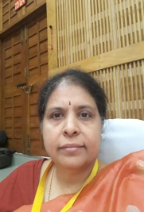](https://kssem.edu.in/images/1663826738365_image.jpg)
* **Dr VIJAYALAKSHMI AKELLA**
* **PROFESSOR and HEAD**
* Ph.D
* [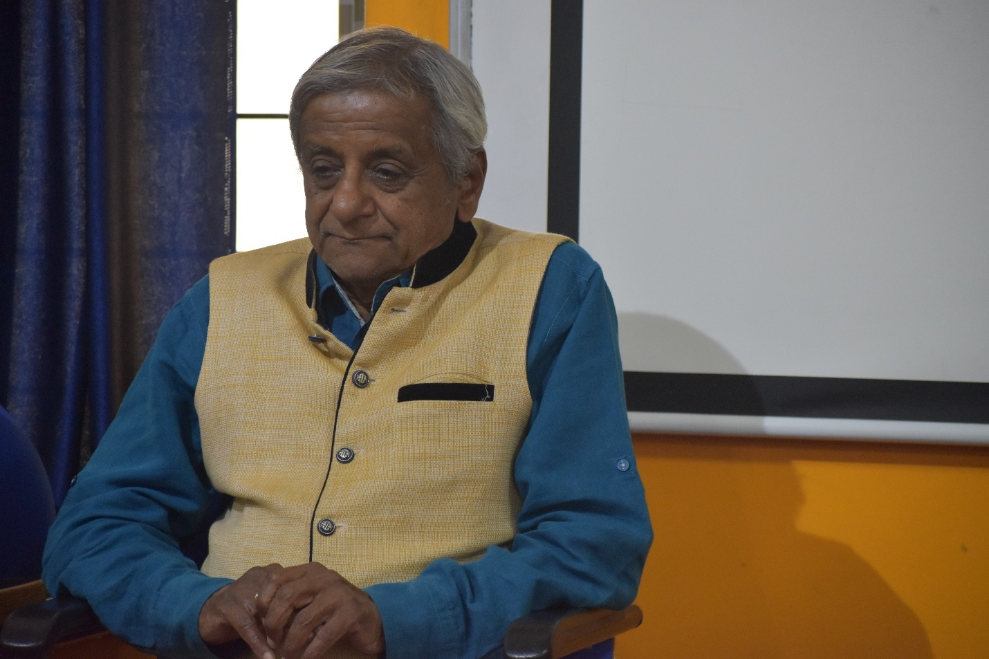](https://kssem.edu.in/images/1659422307249_image.JPG)
* **Dr. B K RAGHUPRASAD**
* **Professor (Visiting Faculty)**
* Ph.D (IISc)
* [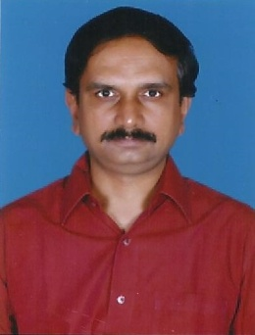](https://kssem.edu.in/images/1659417622975_image.jpg)
* **Dr. AREKAL VIJAY**
* **Professor**
* Ph.D (Geotechnical Engineering)
* [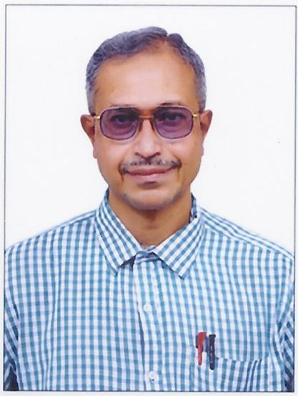](https://kssem.edu.in/images/2c9f8d4183ac80c40183acfed256000e_image.jpg)
* **Mr.VEERENDRA KUMAR M**
* **Associate Professor**
* M.E (Structural Engineering)
* [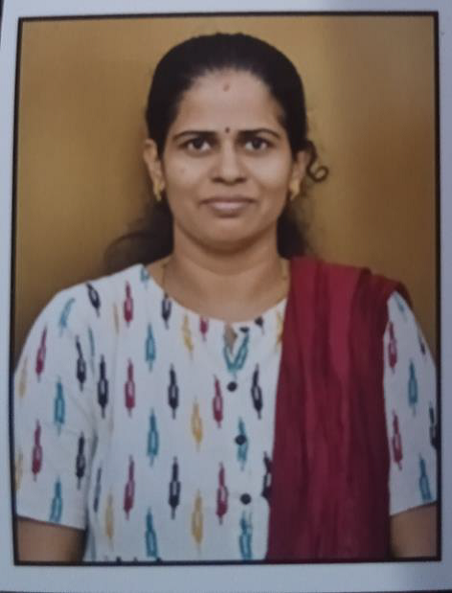](https://kssem.edu.in/images/1659418405025_image.png)
* **Dr. RASHMI H R**
* **Associate Professor**
* Ph.D (Environmental Engineering)
* [](https://kssem.edu.in/images/2c9f8d418422ef900184516d5d840029_image.jpg)
* **Dr.NAVEENA M.P**
* **Asst.Professor**
* Ph.D
* [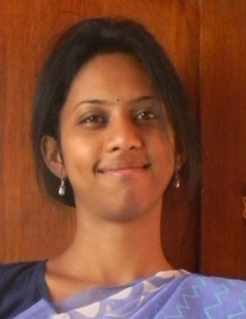](https://kssem.edu.in/images/2c9f8d418248e4ae01825d24899d00e0_image.jpg)
* **Dr. AMRUTHA DHIRAJ**
* **Assistant Professor**
* Ph.D
* [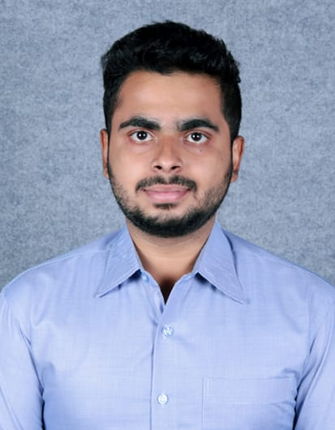](https://kssem.edu.in/images/2c9f8d418248e4ae01825d25705e00e1_image.jpeg)
* **Mr. PRASHANTH M**
* **Assistant Professor**
* M.Tech (Ph.D)
* [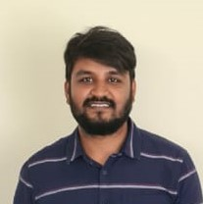](https://kssem.edu.in/images/1659424050278_image.jpeg)
* **Mr. MANJUNATH B**
* **Assistant Professor**
* M.Tech (Structural Engineering)
* [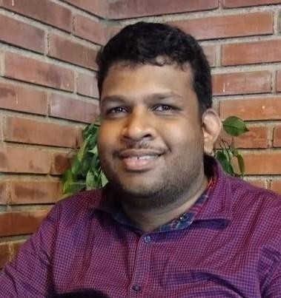](https://kssem.edu.in/images/1667809124056_image.jpg)
* **Mr. SHASHI PRASAD N**
* **Assistant Professor**
* M.Tech in (Structural Engineering)
* [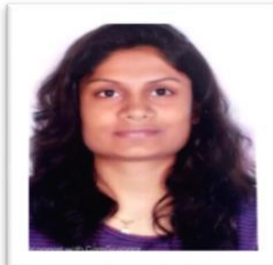](https://kssem.edu.in/images/1756713165728_image.PNG)
* **Mrs.Sahana K**
* **Assistant Professor**
* M.Tech
* [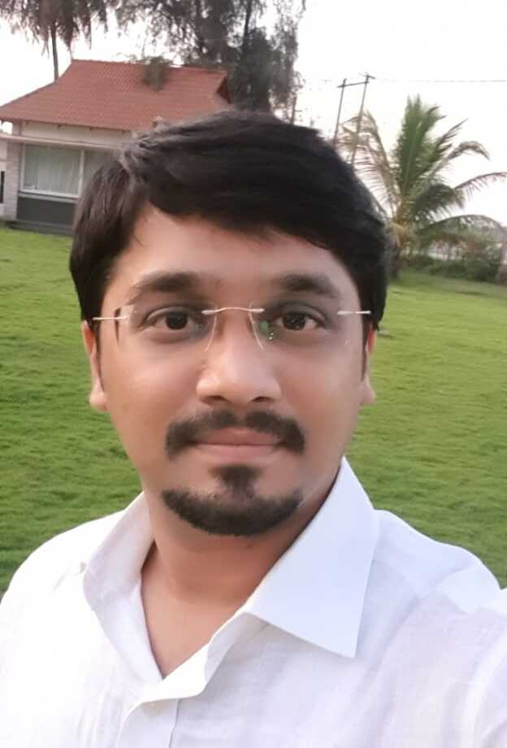](https://kssem.edu.in/images/2c9f858d995389ae01995390a3e70000_image.jpeg)
* **Mr. Vinay Venkatesh**
* **Assistant Professor**
* M.Tech
* [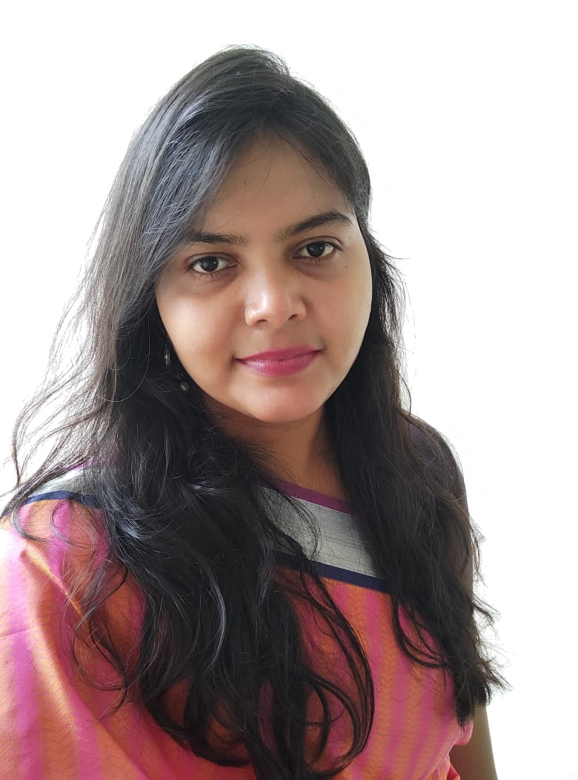](https://kssem.edu.in/images/2c9f8d418b13f419018bae4faa7e0031_image.jpg)
* **Mrs.PALLAVI M**
* **Asst.Professor**
* M.Tech (Ph.D)
* **Dr.A V GANESHA**
* **Visiting Faculty**
* Ph.D
* **Supporting Faculty**
* [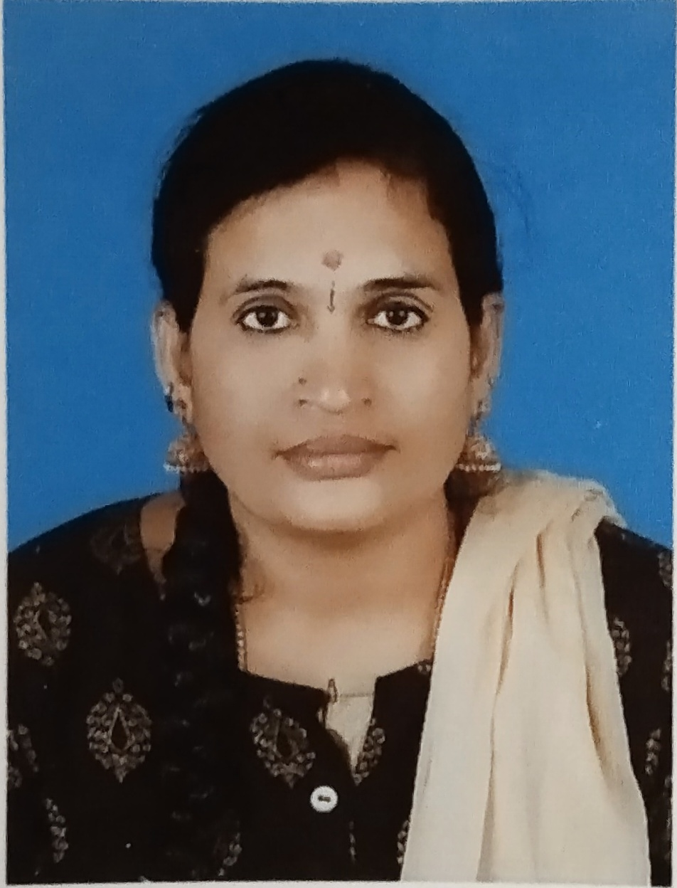](https://kssem.edu.in/images/1659422532160_image.jpg)
* **Mrs. ROOPAVATHI V**
* **Assistant Foreman**
* Diploma (B.E in Civil Engineering)
* [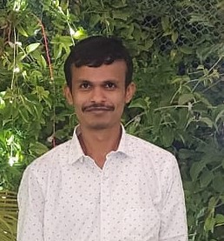](https://kssem.edu.in/images/1659682064607_image.jpeg)
* **Mr. KANTHARAJU M J**
* **Instructor**
* Diploma
* [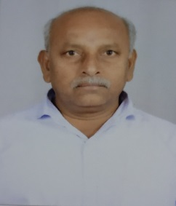](https://kssem.edu.in/images/1659424200657_image.jpg)
* **Mr. SREEVATSA**
* **Instructor**
* Diploma
* [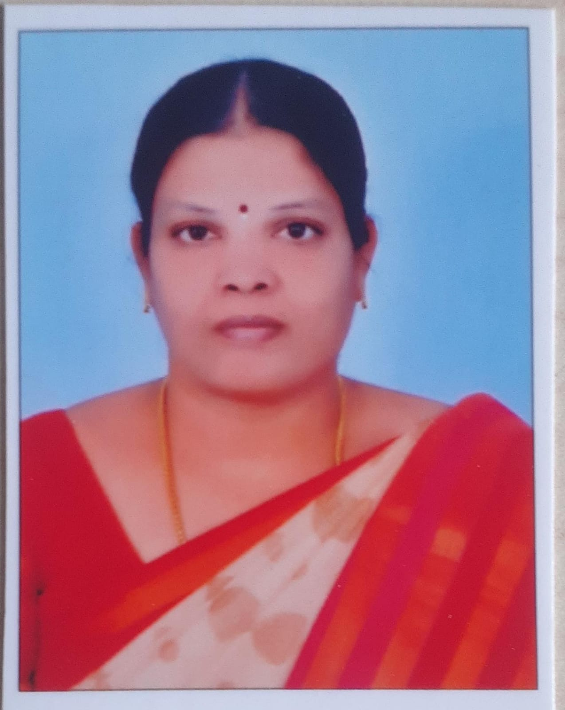](https://kssem.edu.in/images/1729585381928_image.jpeg)
* **Mrs. KAVITHA B**
* **office Assistant**
* Degree
* [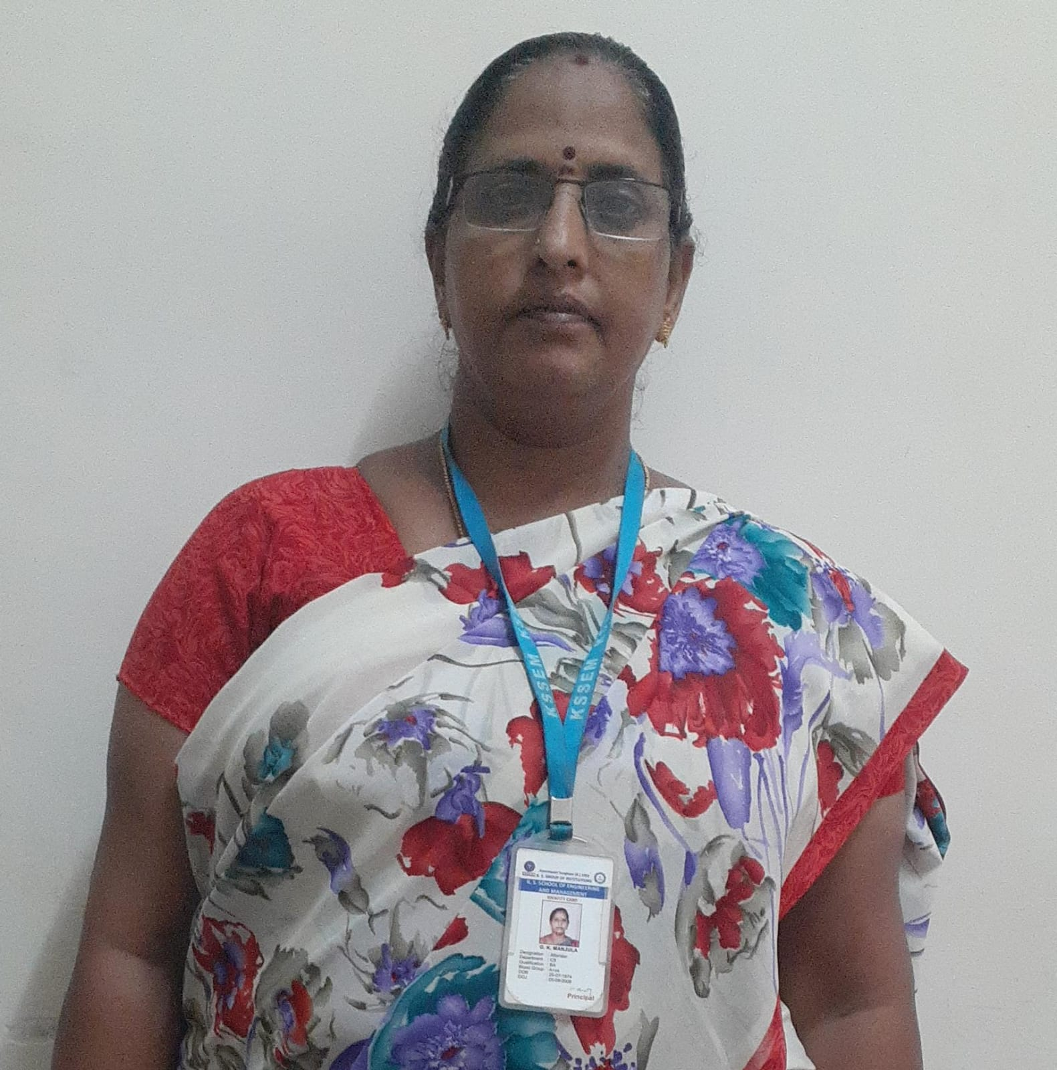](https://kssem.edu.in/images/1729585111212_image.jpeg)
* **Mrs.MANJULA G K**
* **Attender**
* B.A
* [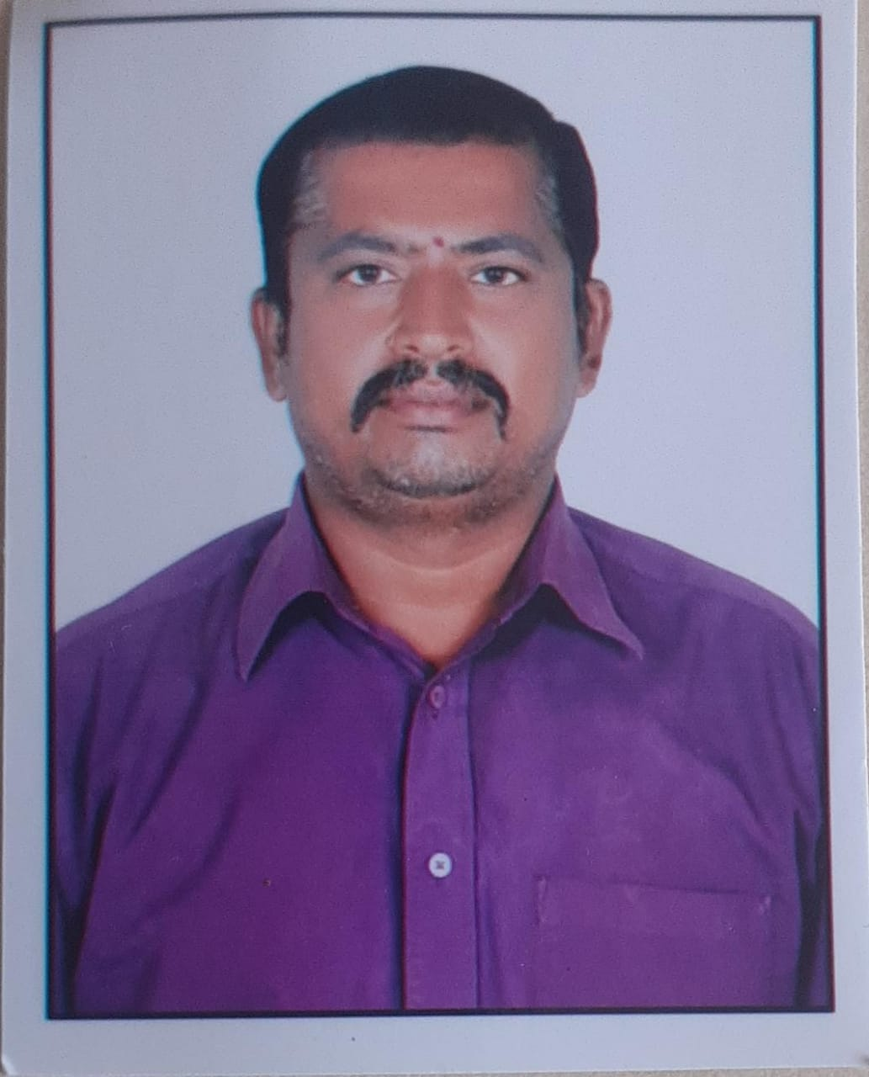](https://kssem.edu.in/images/2c9f8d4192b3391e0192b354106e000c_image.jpeg)
* **Mr. PRAKASH M S**
* **Attender**
* 10th

### Department Achievers

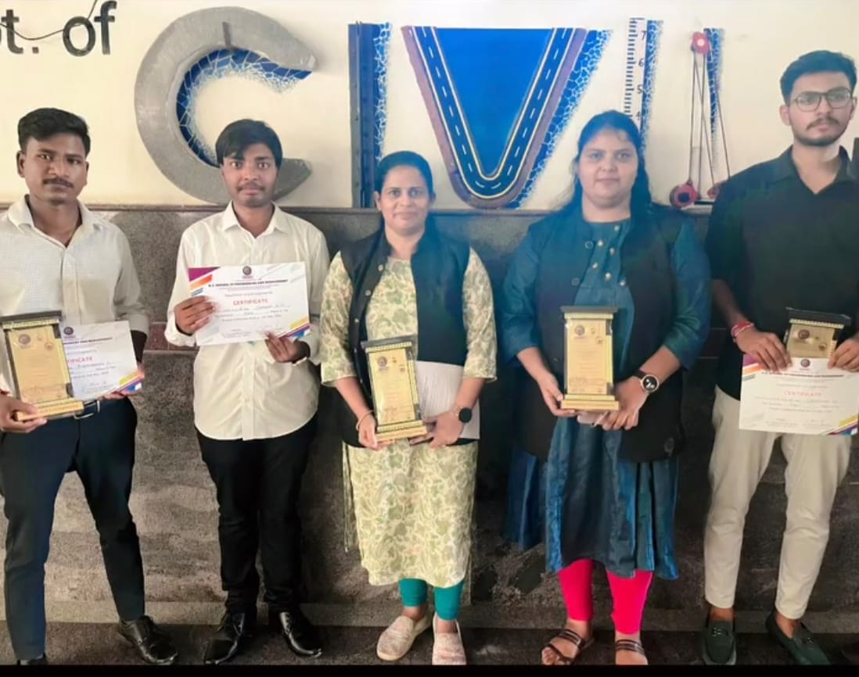

### WINNERS OF THE PROJECT EXHIBITION 2023-24

2025-02-21

Project Exhibition for U G Final Year Students was organized on 8th of May 2023 by K. S. School of Engineering and Management for the students on "Innovative ideas in their projects" Project Title: " "Potential use of biofilters, constructed wetland and solar driven disinfection for grey water treatment in rural areas. " Project Students: Lakshmisha,Chandan, Bhemmaraju Guide: Dr.Rashmi HR and Mrs Pallavi M

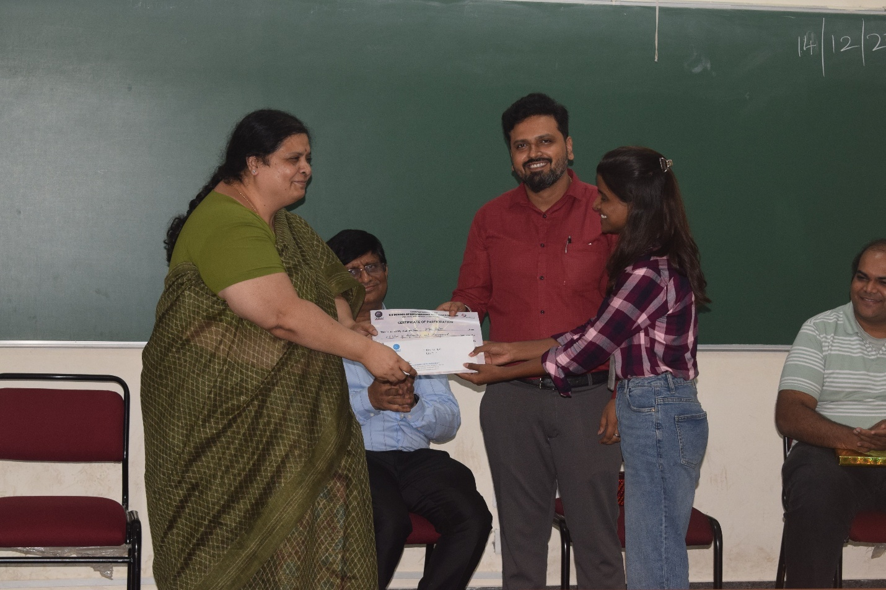

### DEPARTMENT OF CIVIL ENGINEERING CIVIL HACKATHON 2024-INTER-COLLEGE EVENT

2024-12-14

We are thrilled to announce the successful completion of the event "REVIT REVOLUTION" organized as part of Civil Hackathon 2024, proudly sponsored by Rapsol Technologies Pvt. Ltd. Congratulations to Shilpa Sajjan from 7th Semester, Civil Engineering, KSSEM, for securing First Prize and winning a cash award of ?6000. A special thank you to Mr. Niranjan Balaji for sponsoring and supporting the event.

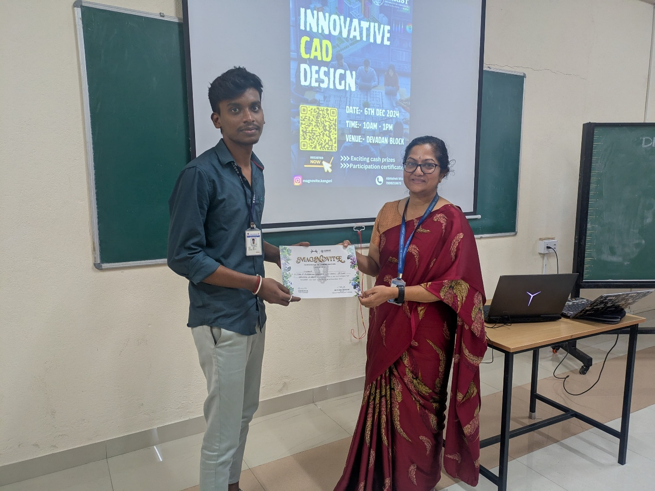

### CAD DESIGNER COMPETITION

2024-12-06

Aadithen B, a 5th-semester Civil Engineering student, won second prize along with a cash award of Rs 3,000 in the Innovative CAD Designer Competition held at Christ University, Bengaluru.

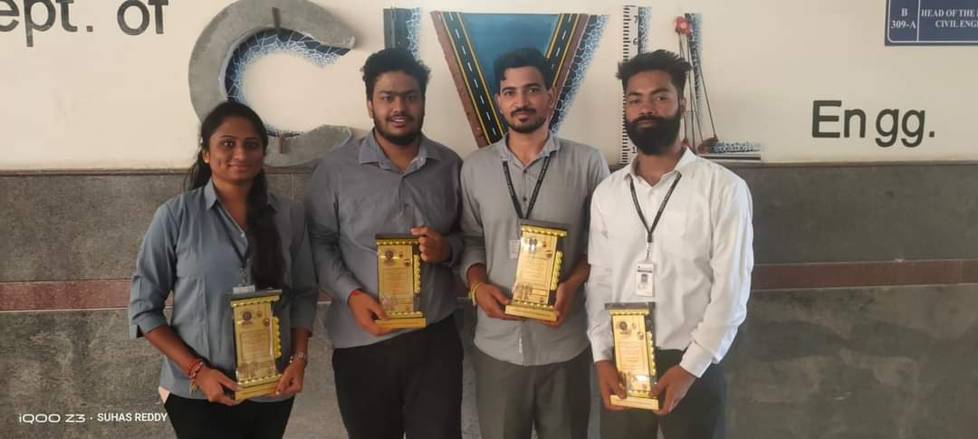

### WINNERS OF PROJECT EXHIBITION 2022-2023

2023-05-08

Project Exhibition for U G Final Year Students was organized on 8th of May 2023 by K. S. School of Engineering and Management for the students on "Innovative ideas in their projects" Project Title: " "Experimental and Analytical Study on Seismic Behaviour of RCC Portal Frame " Project Students: Banashree, Suhas, Santhosh Kumar, Umesh Kumar Singh Guide: Prof. Manjunath B and Prof.Sai Suhma BA

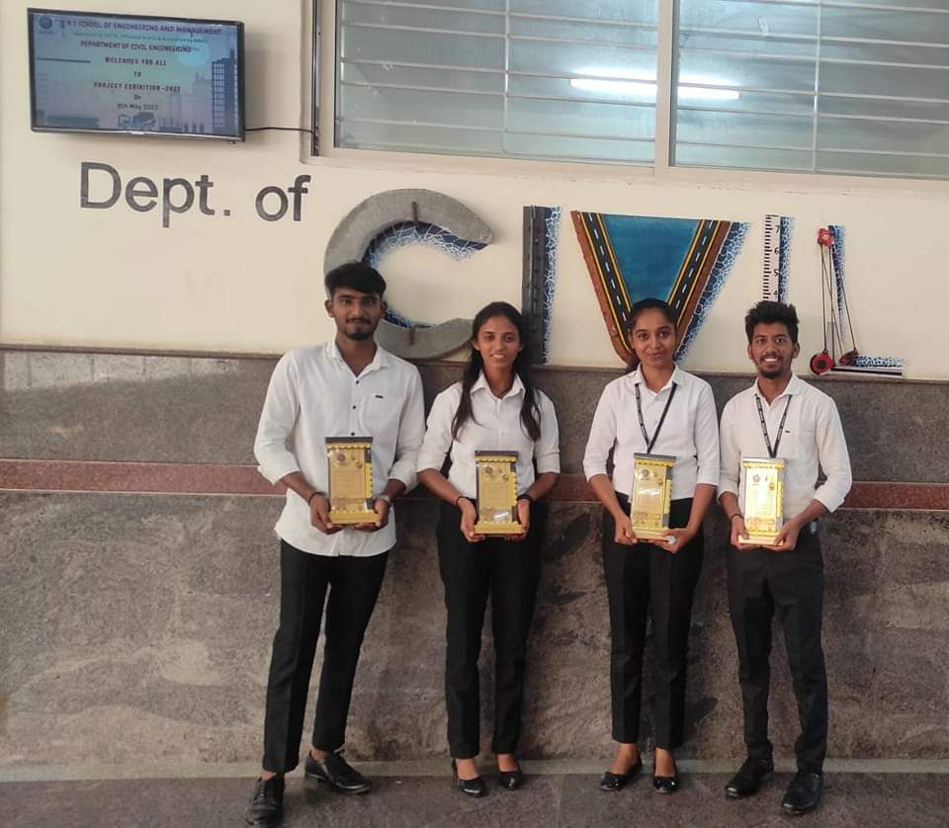

### RUNNERS OF PROJECT EXHIBITION 2022-2023

2023-05-08

Project Exhibition for U G Final Year Students was organized on 8th of May 2023 by K. S. School of Engineering and Management for the students on "Innovative ideas in their projects" Project Title: " "Experimental Study on Seismic Behaviour on scaled Masonry Structure " Project Students: Jayaprasad Yadav, Ranjitha, Mamrutha, Suni Gouda Patil Guide: Prof. Manjunath B

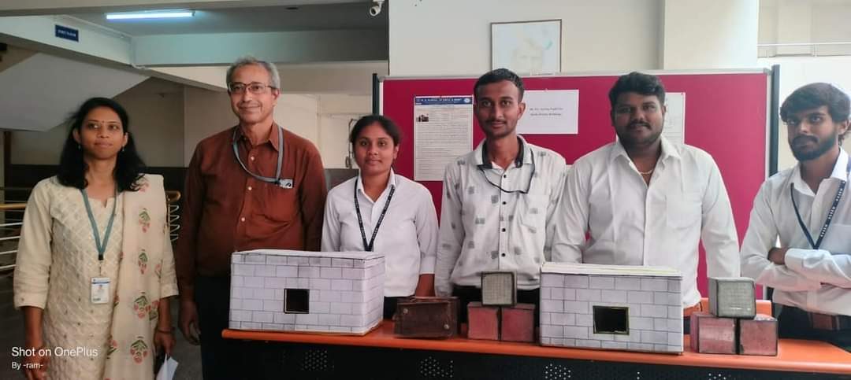

### RUNNERS OF PROJECT EXHIBITION 2022-2023

2023-05-08

Project Exhibition for U G Final Year Students was organized on 8th of May 2023 by K. S. School of Engineering and Management for the students on "Innovative ideas in their projects" Project Title: " "Experimental Investigations on Low strength Translucent Blocks" Project Students: Shwetha, Ramchandra Gowda, Sadhashiva, Arjun Gowda Guide: Prof. Veerendra Kumar M and Prof. Amrutha D

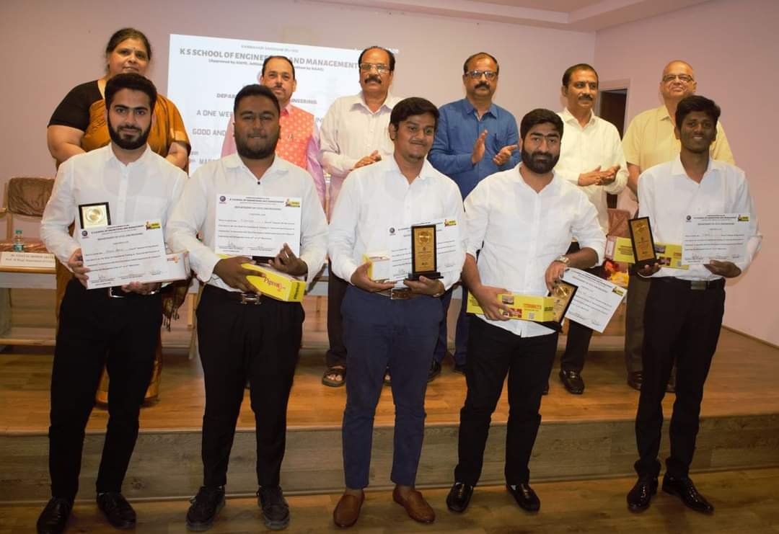

### WINNER OF PRESENTATION ON PRE-EMPLOYMENT TRAINING ON GOOD AND BAD PRATCICES OF CONSTRUCTIONS

2023-03-29

Bharath Kadam and his team got the winning Prize for the presentation on Pre-Employment Training on Good and Bad Practices of Construction _Association with UltraTech Cement Limited.

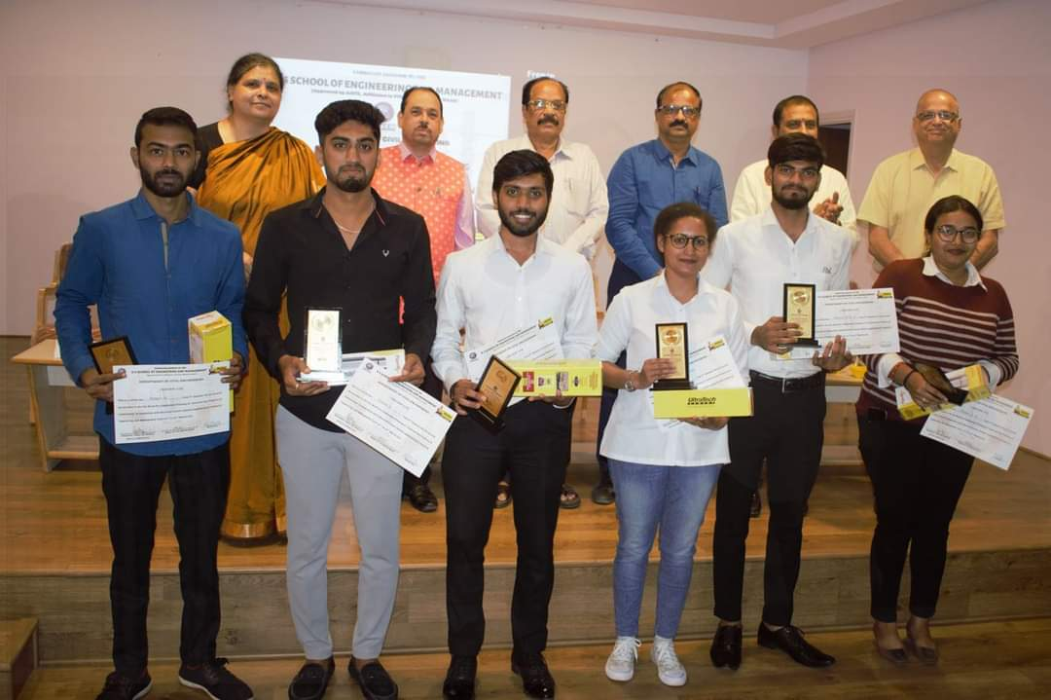

### RUNNER OF PRESENTATION ON PRE-EMPLOYMENT TRAINING ON GOOD AND BAD PRATCICES OF CONSTRUCTIONS

2023-03-29

Kishore S and his team got the winning Second Prize for the presentation on Pre-Employment Training on Good and Bad Practices of Construction_ Association with UltraTech Cement Limited.

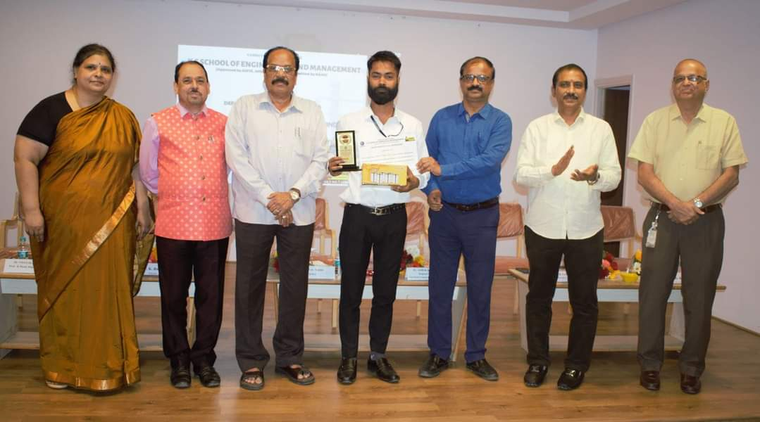

### SPECIAL PRIZE OF PRESENTATION ON PRE-EMPLOYMENT TRAINING ON GOOD AND BAD PRATCICES OF CONCTRUCTION

2023-03-29

Umesh Kumar Singh has a Special Prize for the best individual presentation on Pre-Employment Training on Good and Bad Practices of Construction_ Association with UltraTech Cement Limited.

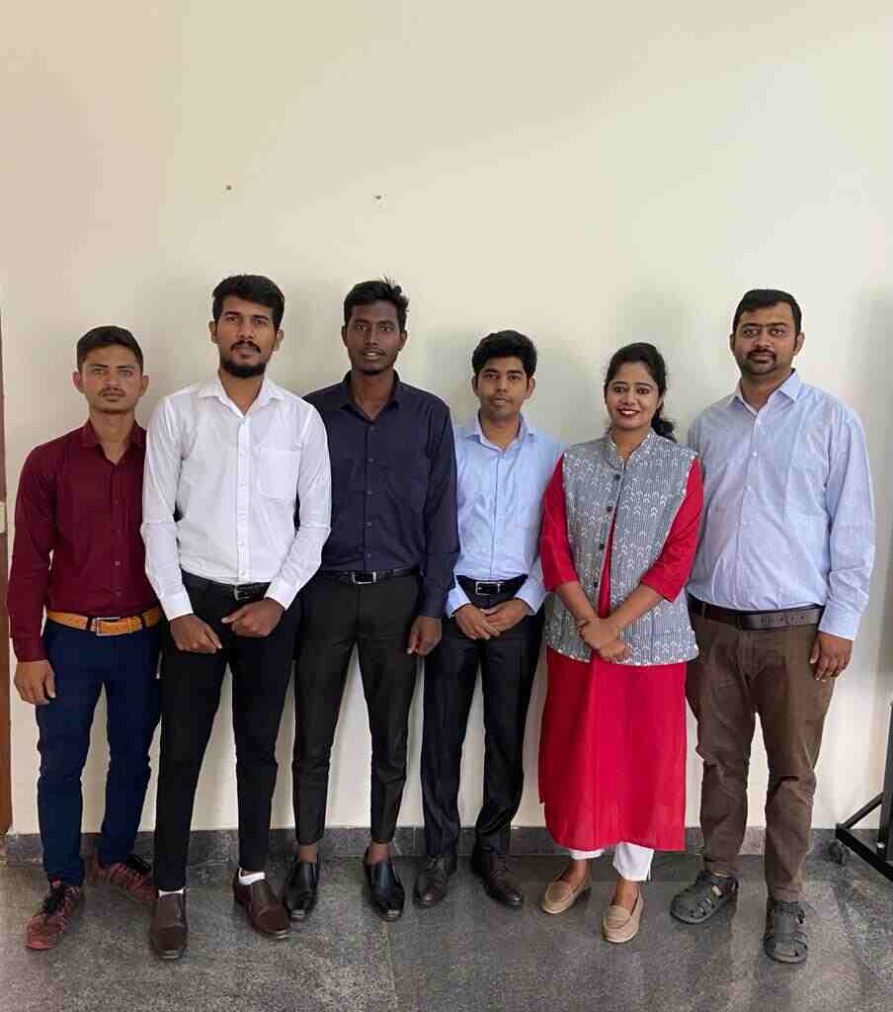

### KSCST PROJECT SELECTED FOR STATE LEVEL SEMINAR & EXHIBITION 2021-2022

2022-08-13

UG Project "Sustainability of Traditional Rural Mud House in Kanakapura Village: A Study related to Thermal Comfort" , is been selected for the State Level Seminar & Exhibition held at Visvesvarya Technological University. Belagavi on 13th & 14th August 2022. Project Students - ANUP, SACHIN SANGAPPA KAGA, CHAITANYA K N, PRADEEP KUMAR S T Project Guide's - Mr. Naveena M P & Sushma M

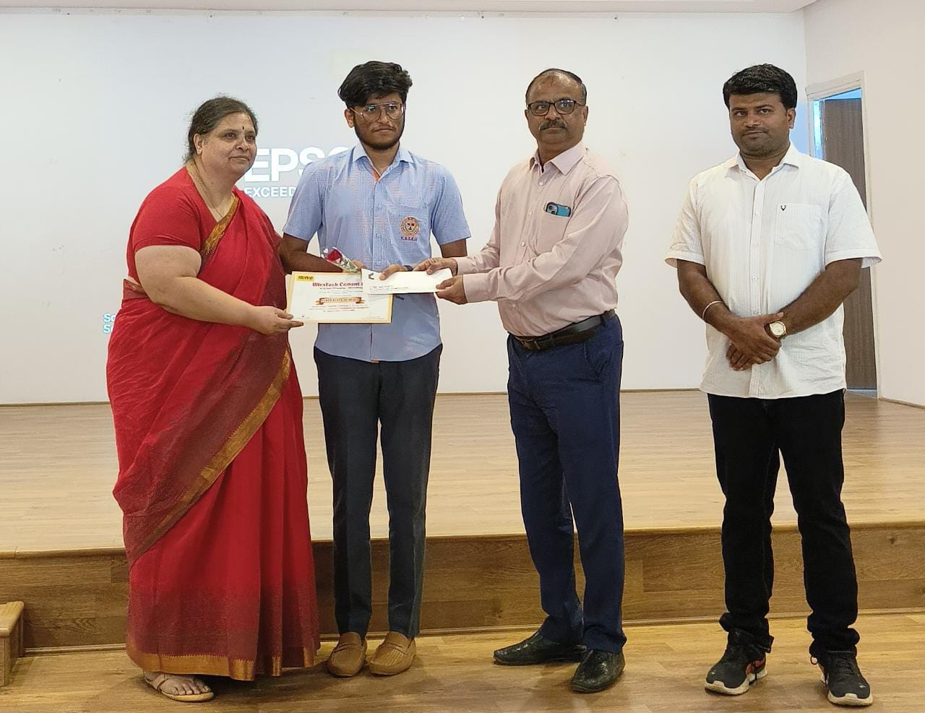

### CERTIFICATE OF MERIT FROM ULTRATECH CEMENT LIMITED

2023-03-01

Pavan S (1KG21CV409) has received the certificate of merit from UltraTech Cement Limited for Securing the Highest Marks in Concrete Technology in VTU External Exam.

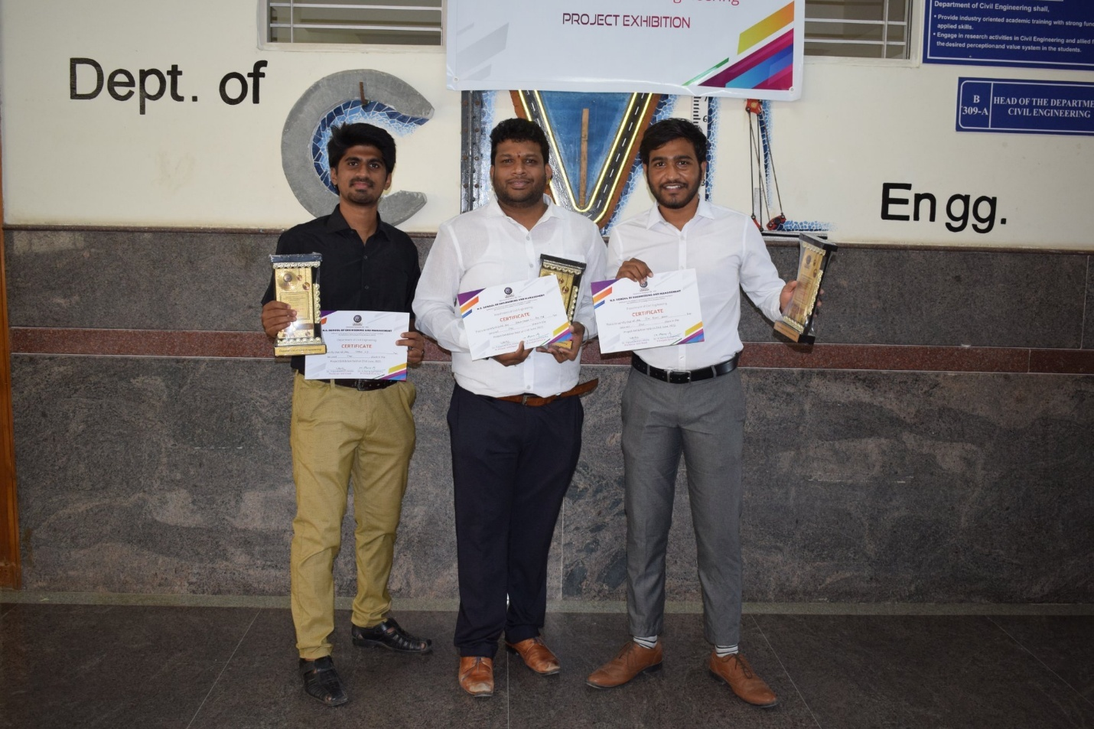

### WINNERS OF PROJECT EXHIBITION 2021-2022

2022-06-21

Project Exhibition for U G Final Year Students was organized on 21st of June 2022 by K. S. School of Engineering and Management for the students on "Innovative ideas in their projects" Project Title: "Smart Irrigation System using IOT" Project Students: Varun C J, Rohit Yadav, Ravi V, Abhinandan Bhagat Guide: Prof. Shashi Prasad N

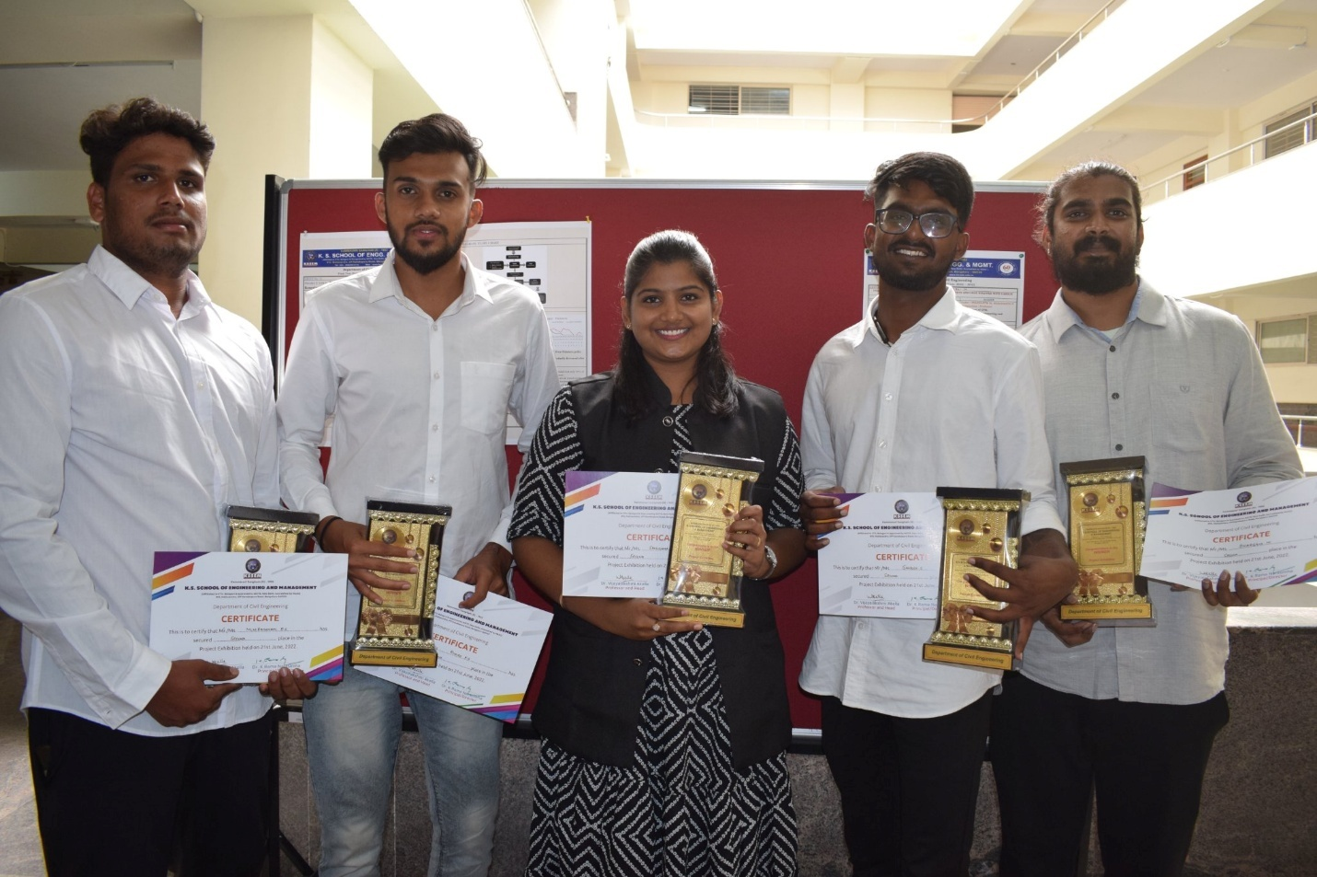

### RUNNERS OF PROJECT EXHIBITION 2021-2022

2022-06-21

Project Exhibition for U G Final Year Students was organized on 21st of June 2022 by K. S. School of Engineering and Management for the students on "Innovative ideas in their projects" Project Title: " "Transit Oriented Development - A Case Study of Namma Bengaluru Metro Phase 1" Project Students: Bhargava M, Rohit K S, Ganesh S, Muniratanam B S Guide: Prof. Sai Sushma B A

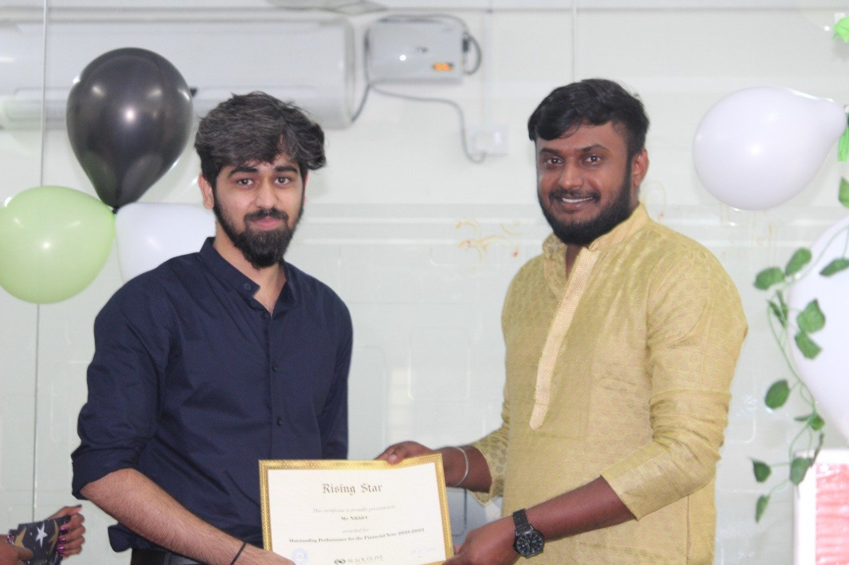

### OUTSTANDING PERFORMANCE FOR THE FINANCIAL YEAR 2021-2022

2022-01-09

Mr. Nikhil C, Alumni of Department of Civil Engineering, KSSEM has been awarded for "Outstanding Performance for the Financial Year 2021-2022 from "Black Olive Ventures Pvt. LTD."

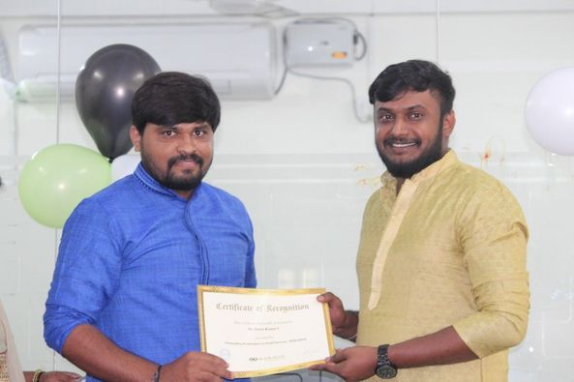

### OUTSTANDING PERFORMANCE AS FIELD SURVEYOR 2021-2022

2022-01-09

Mr. Tarun Kumar V, Alumni of Department of Civil Engineering, KSSEM as been awarded "Outstanding performance as Field Surveyor - 2021-2022" from "Black Olive Ventures Pvt. LTD."

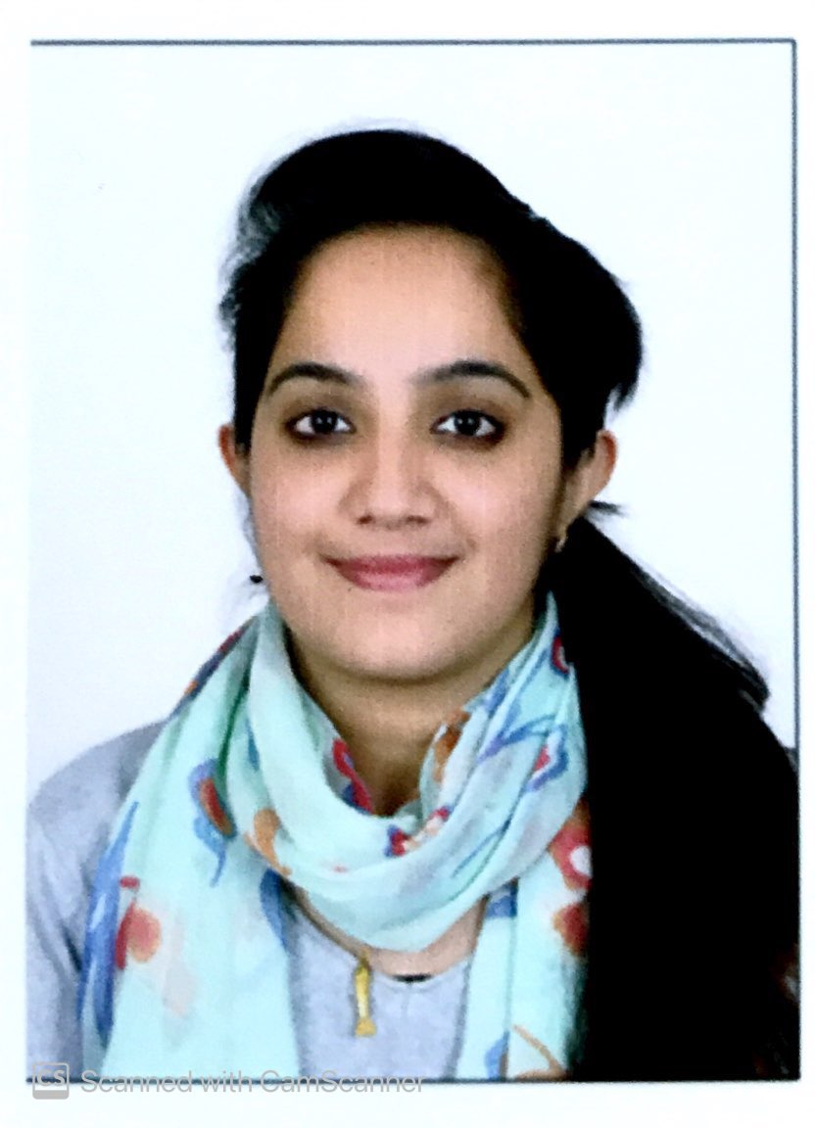

### TECHNICAL MANAGER AT AXIS BANK

Mrs SHALINI GOWDA S K, Alumni of Civil Department of batch 2012-16 Has been working as Technical Manager at AXIS BANK

### RUNNER UP OF PRESENTATION ON PRE-EMPLOYMENT TRAINING ON GOOD AND BAD PRATCICES OF CONCTRUCTION

Bharath Kadam and his team got the winning Prize for the presentation on Pre-Employment Training on Good and Bad Practices of Construction in association with UltraTech Cement Limited.

### WINNERS OF THE PROJECT EXHIBITION 2023-24

### List of FCD Students

* **Department Labs**
* Civil Engineering Department has fully furnished State of Art laboratories. All laboratories are well-equipped to run the academic laboratories courses. Highly experienced Technical staff are available in all the laboratories to assist the students to carry out their lab sessions.
* The Department has :
* Non-destructive testing Equipment (NDT)
* DC motor controlled Shake table
* Vibration table
* User designed Cam
* DC motor controller
* Accelerometer
* 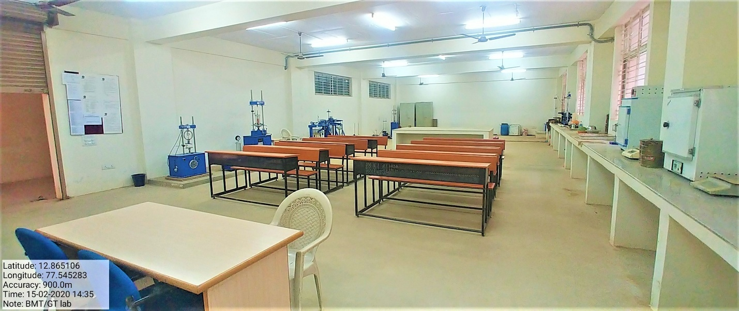
* **GEOTECHNICAL ENGINEERING LAB**
* B Block B004
* 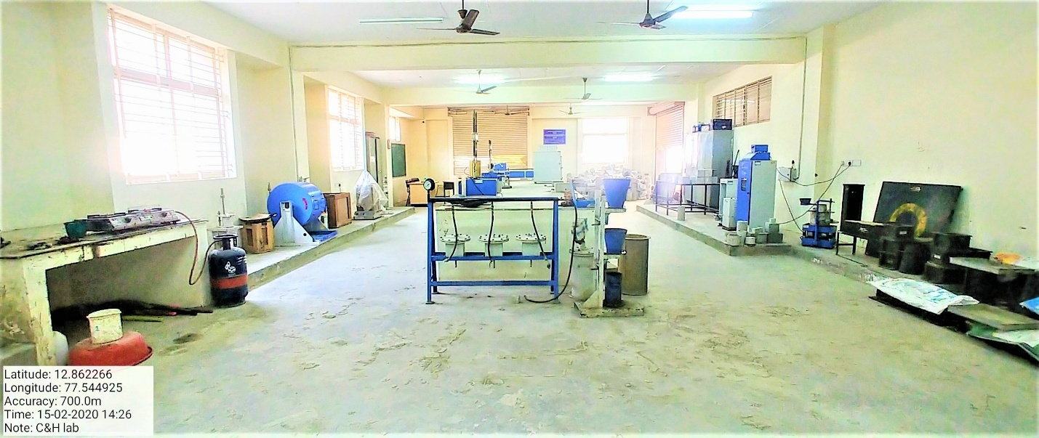
* **CONCRETE & HIGHWAY MATERIALS LAB**
* B Block B001
* 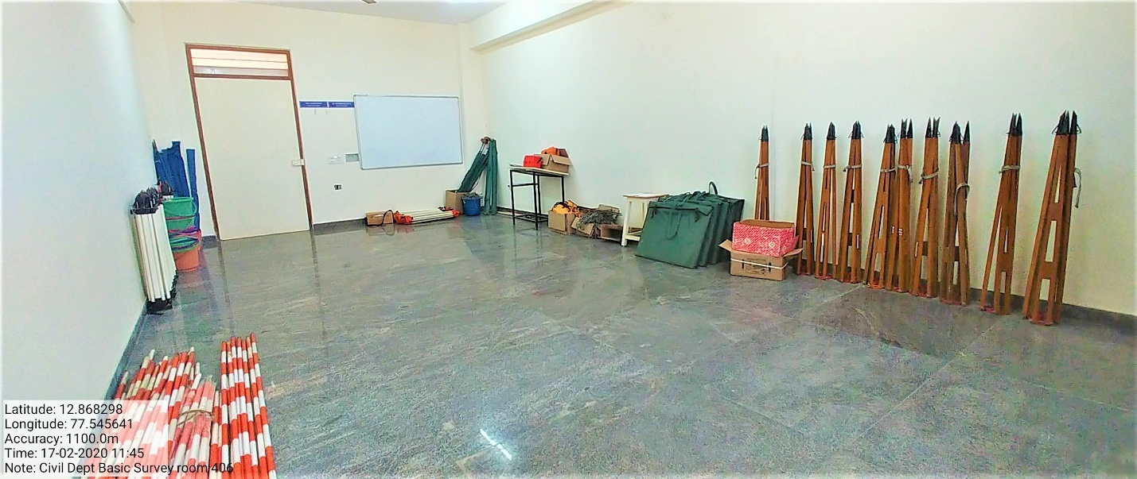
* **SURVEYING PRACTICE LAB**
* B Block B418
* 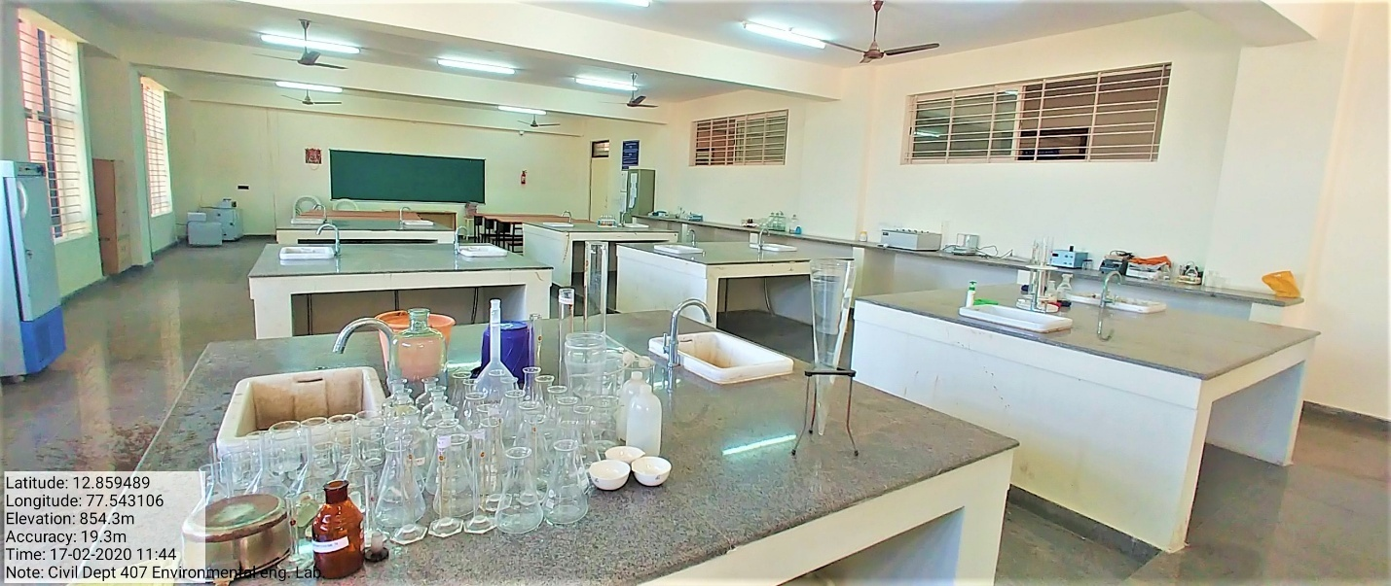
* **ENVIRONMENTAL ENGINEERING LAB**
* B Block B407
* 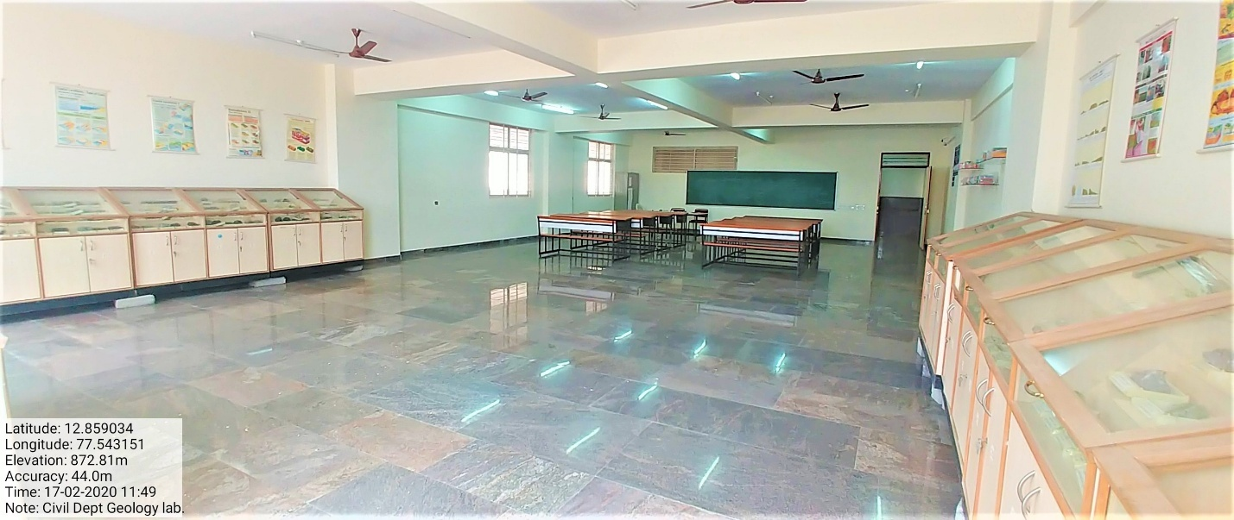
* **ENGINEERING GEOLOGY LAB**
* B Block B418
* 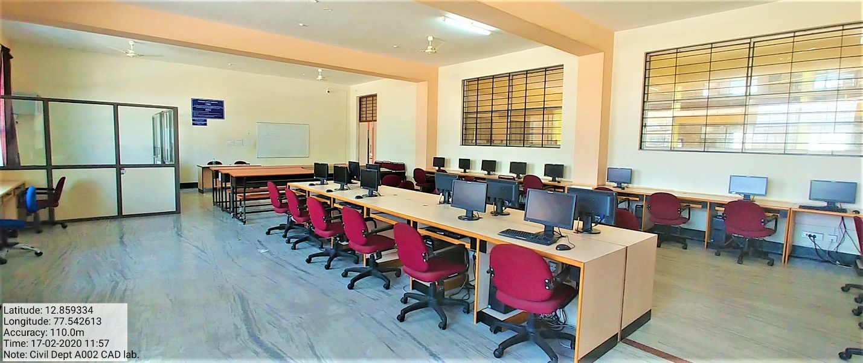
* **COMPUTER AIDED DESIGN LAB**
* A Block A001

### Gallery

[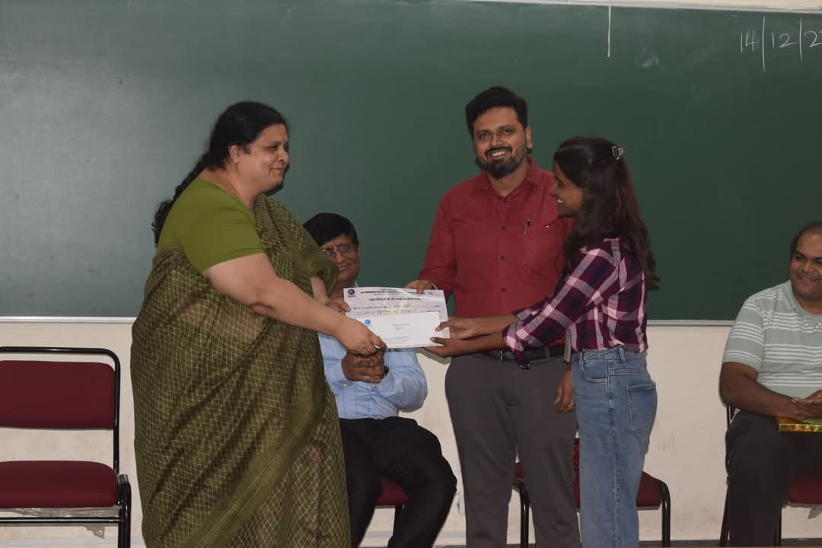](https://kssem.edu.in/images/1748679345265_image.jpeg) [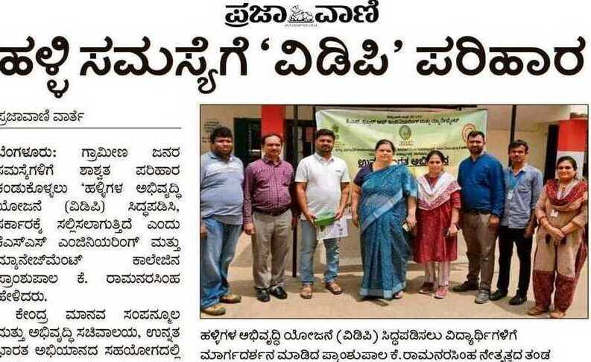](https://kssem.edu.in/images/1748680107622_image.jpg) [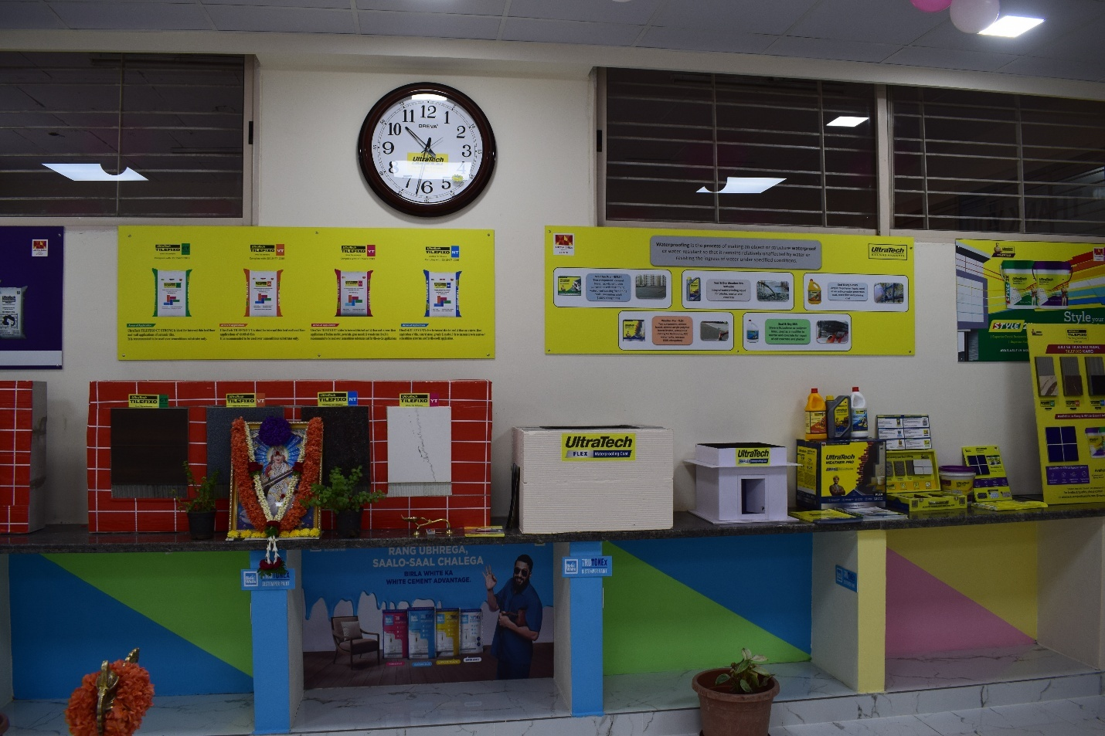](https://kssem.edu.in/images/1713250876746_image.JPG) [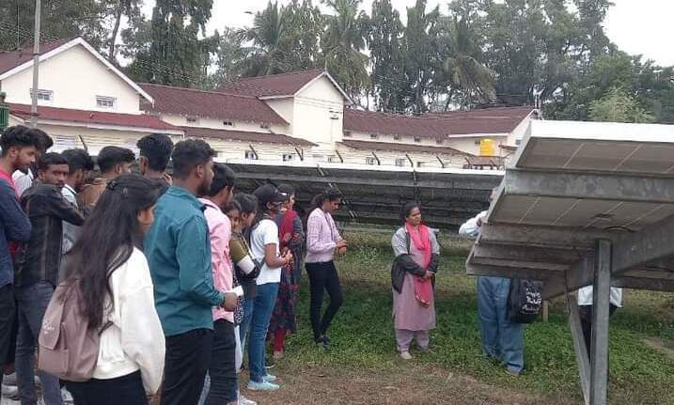](https://kssem.edu.in/images/1748679906448_image.jpg) [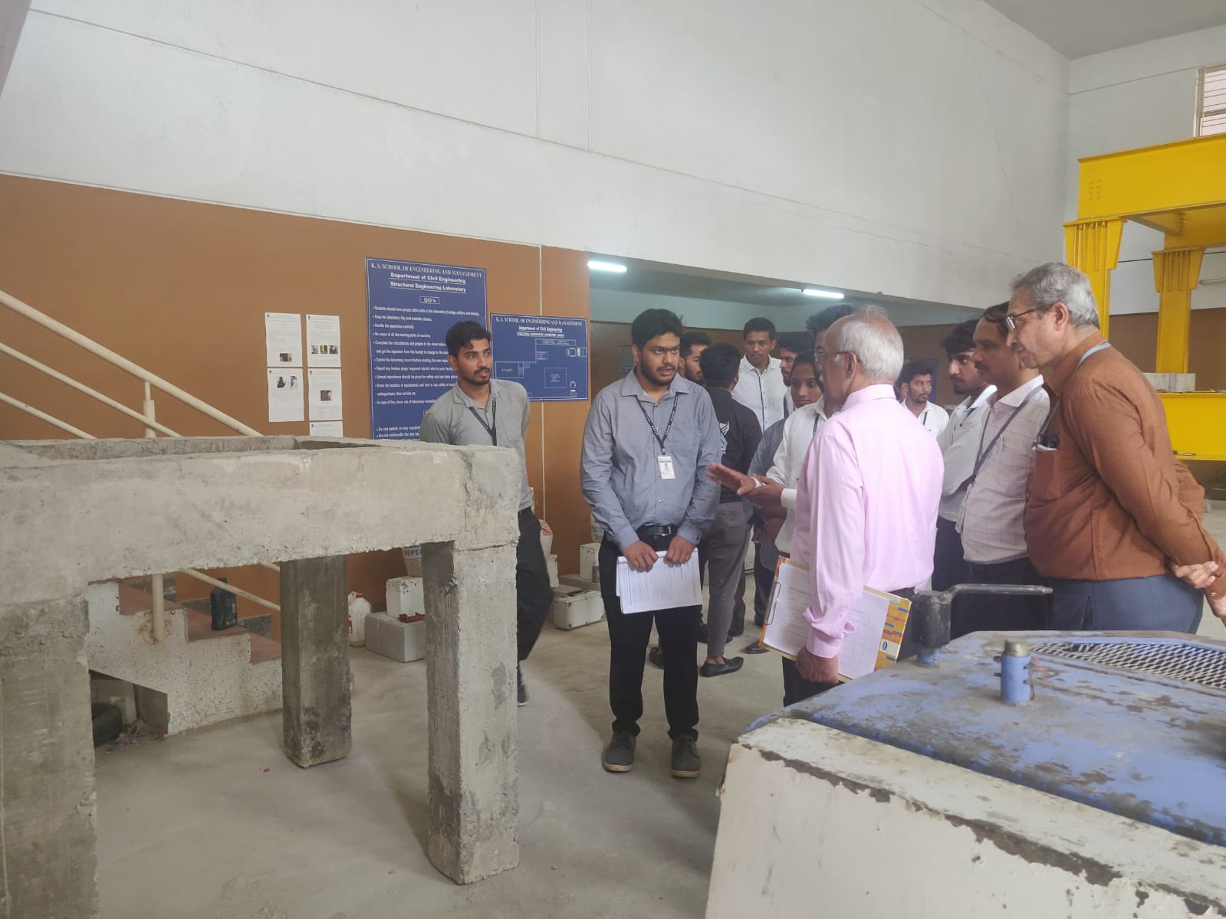](https://kssem.edu.in/images/1683622553207_image.jpg) [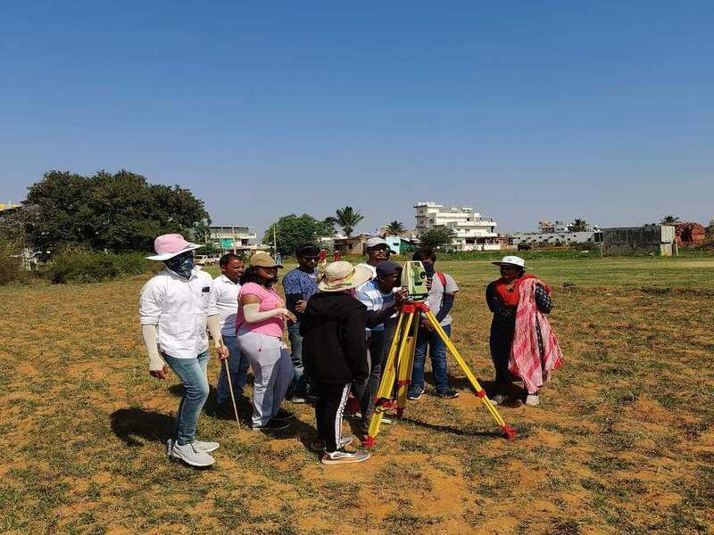](https://kssem.edu.in/images/1748679569182_image.jpg) [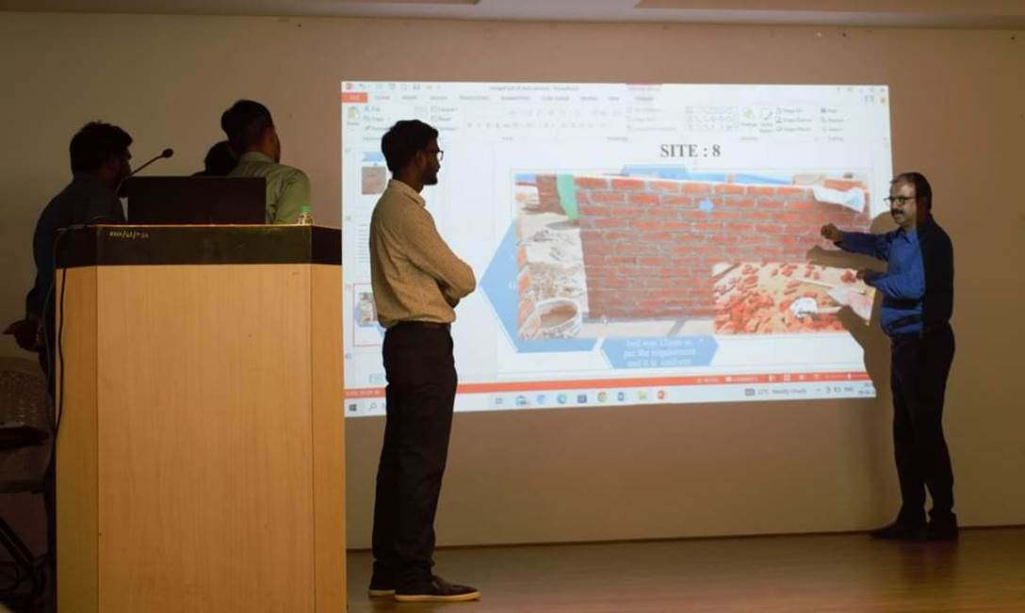](https://kssem.edu.in/images/1680166507089_image.jpg) [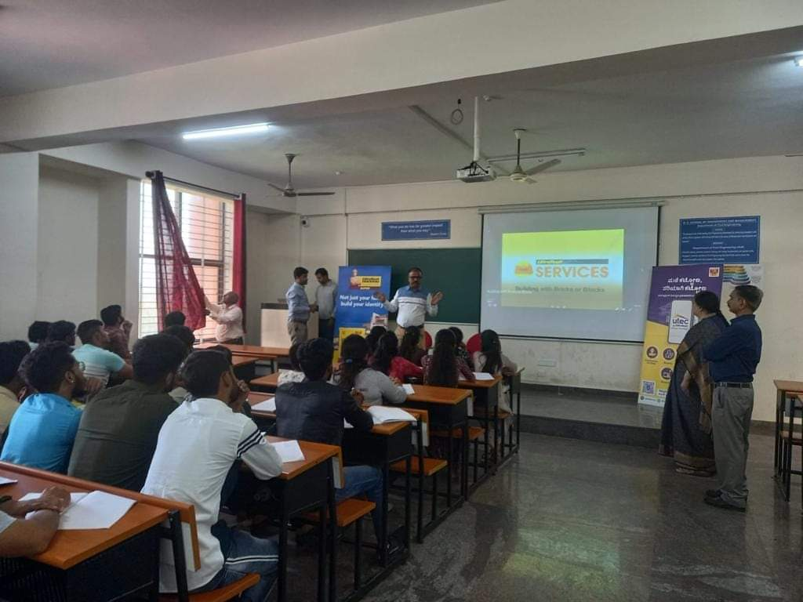](https://kssem.edu.in/images/1679889202424_image.jpg) [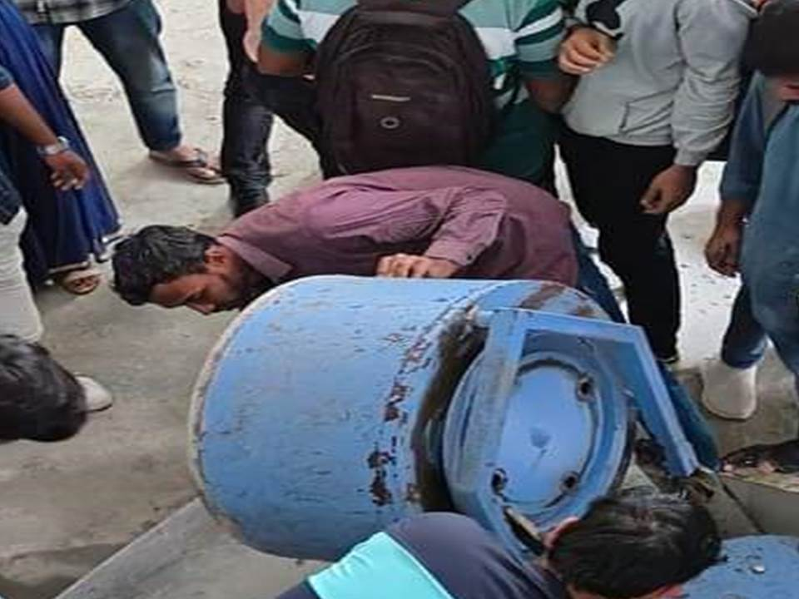](https://kssem.edu.in/images/1679892325580_image.jpg) [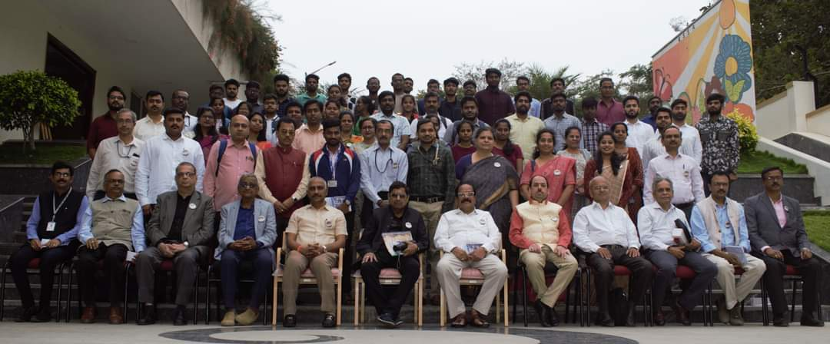](https://kssem.edu.in/images/1675665378684_image.jpg) [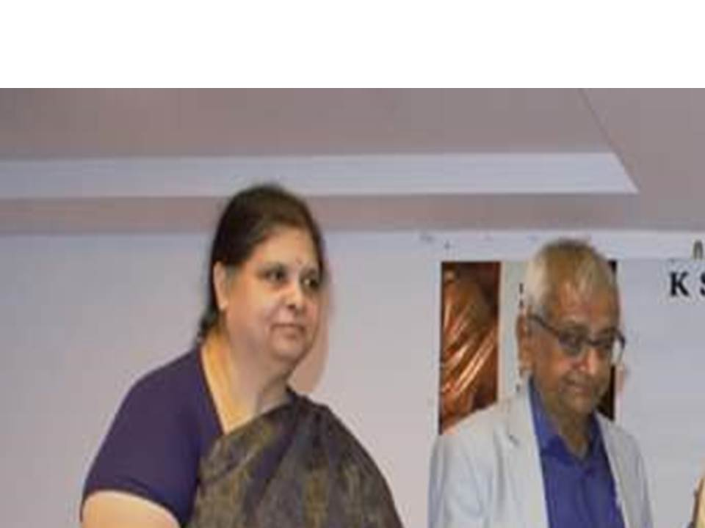](https://kssem.edu.in/images/1679897579944_image.jpg) [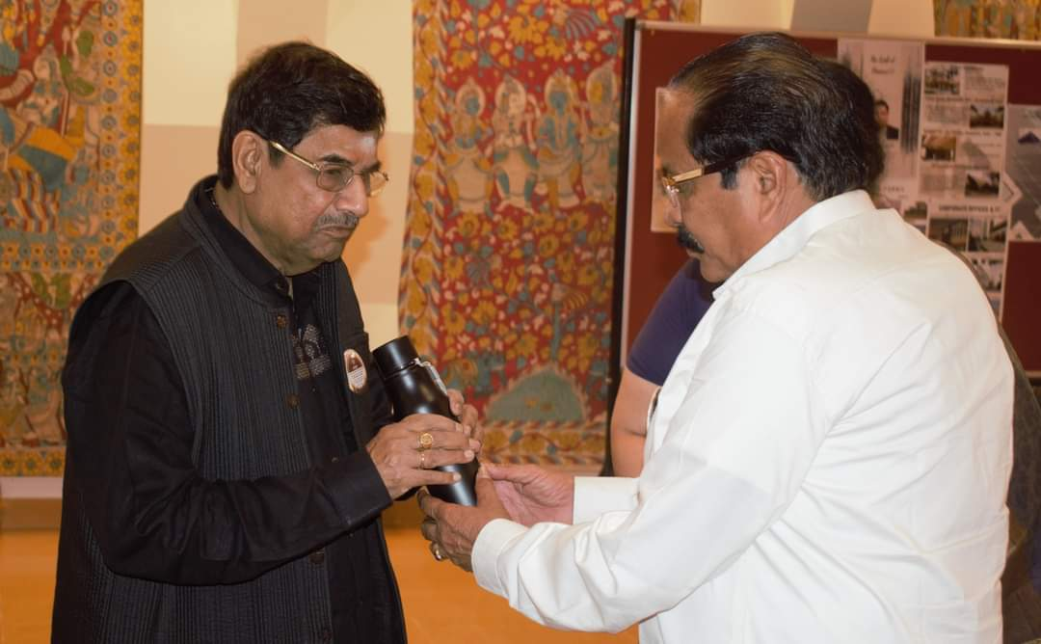](https://kssem.edu.in/images/1675665258557_image.jpg) [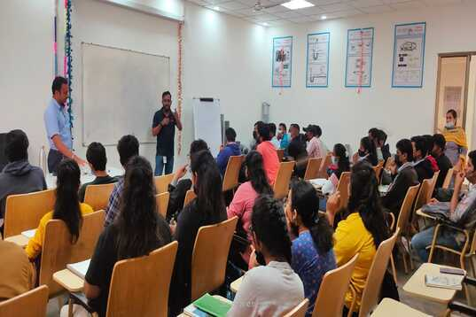](https://kssem.edu.in/images/1678692343388_image.jpg) [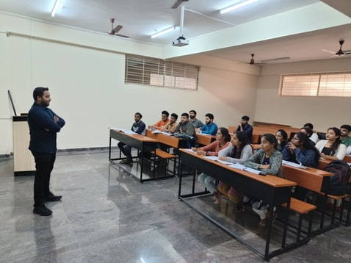](https://kssem.edu.in/images/1678692019793_image.jpg) [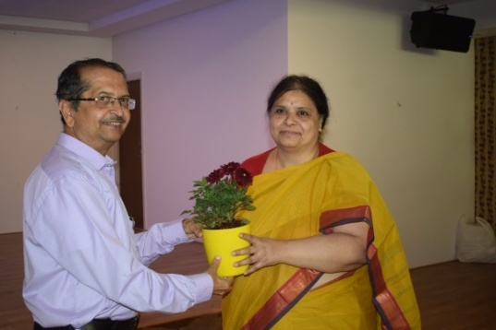](https://kssem.edu.in/images/1669627738658_image.jpg) [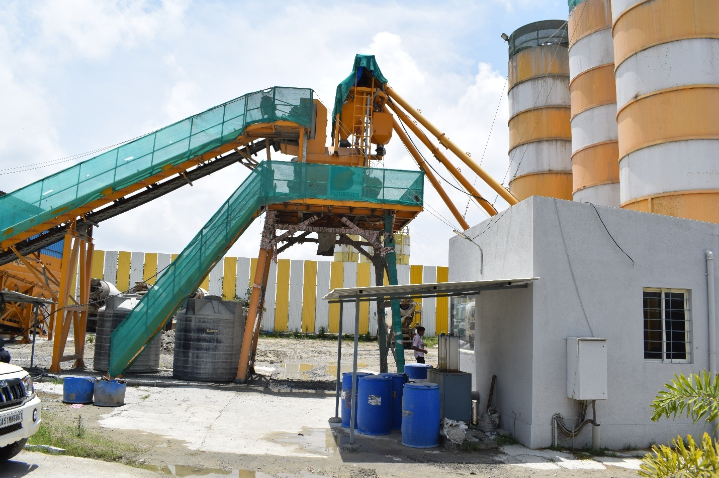](https://kssem.edu.in/images/1663838706339_image.JPG) [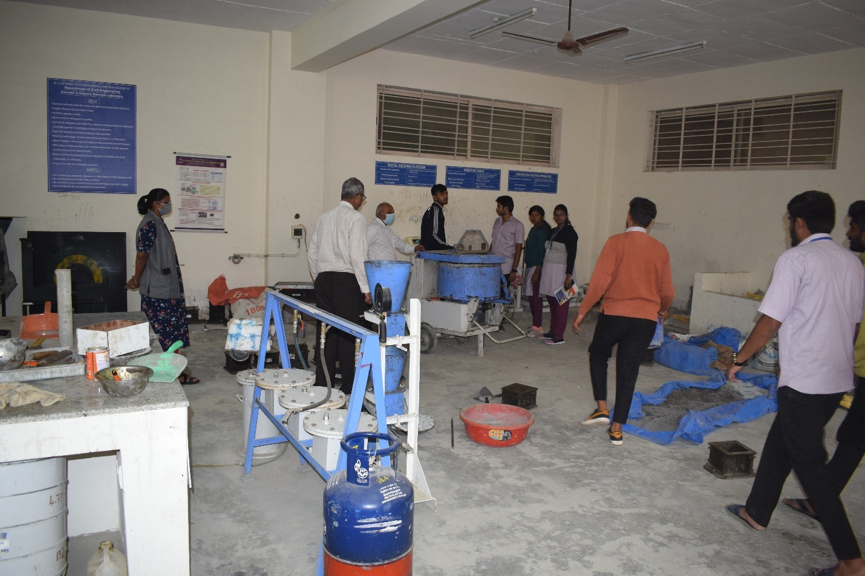](https://kssem.edu.in/images/1663838537691_image.JPG) [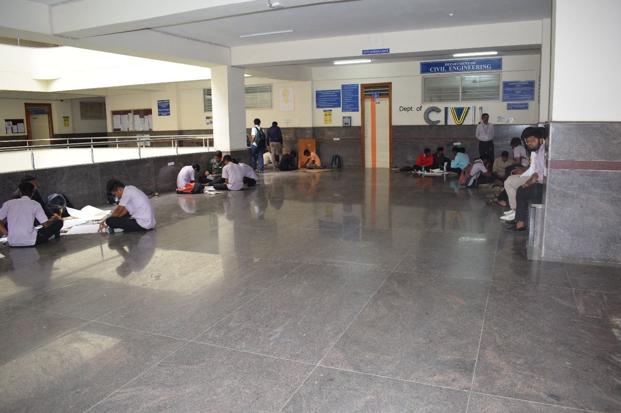](https://kssem.edu.in/images/1663838374026_image.JPG)  [[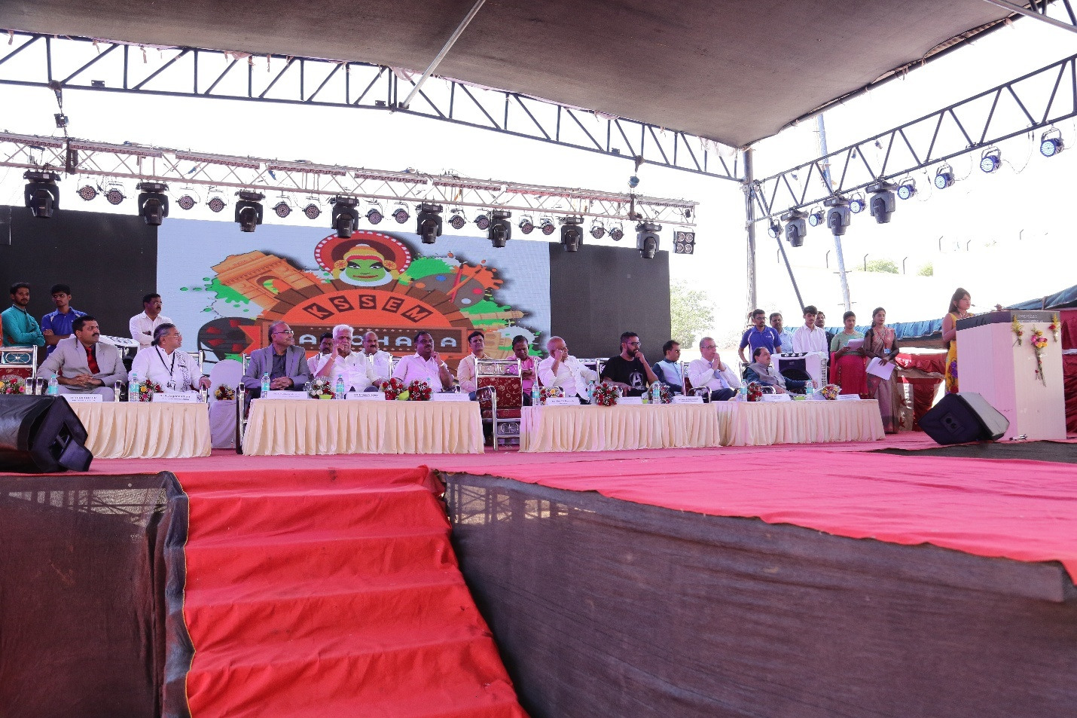](https://kssem.edu.in/images/1663837597749_image.JPG)**AAROHANA**](https://kssem.edu.in/images/1663837597749_image.JPG)

* **Departmental Library**
* Libraries are established for the systematic collection, organization, preservation and dissemination of knowledge and information. It is very important for person to preserve and maintain the valuable knowledge and information contained in the books and documents because we want to preserve our knowledge and wisdom for the coming generations. By preserving the documents in a library this knowledge can be made available to others so that they can benefit from it.
* Libraries play a vital role in the development of any society by enhancing the cause of education and academic research. They cater to the information needs of thousands of peoples.
* **Collection Of books**

|  |  |
| --- | --- |
| * **Quantitative review for the GMAT, version 9.0** | * Princeton Review |
| * **In class manual for the GMAT, version 9.1** | * Princeton Review |
| * **Official TOEFL ibt tests with audio V.1 Educational Testing Service.** | * Tata McGraw Hill Education. |
| * **30 days to a more powerful vocabulary Funk, Wilfred.** | * Lewis, Norman. |
| * **Simplified approach to basic electronics** | * Mahadevaswamy, U B. |
| * **C programming : student guide** | * NIIT |
| * **Programming in C** | * Somashekara, M T. |
| * **Engineering mathematics Part - III : for third semester B.E. classes (all branches) as per revised VTU syllabus 2011** | * Chandrasekharaiah, D S. |
| * **Higher engineering mathematics** | * Grewal, B S. Grewal, J S. |
| * **Elasticity for engineers** | * Sitharam, T G. Govindaraju, L. |
| * **Building with stabilized mud** | * Jagadish, K S. |
| * **Prestressed concrete structures** | * Dayaratnam, P. Sarah, P. |
| * **Design of reinforced concrete structures** | * Dayaratnam, P. Sarah, P. |
| * **Alternative building materials and technology** | * Ashwini Manjunath, B T. |
| * **Brick and reinforced brick structures** | * Dayaratnam, P. Sarah, P. |
| * **Limit state design of steel and RCC structures** | * Halakatti, Vijayakumar. Prakash, K E. Kumar, N S. et. al.... |
| * **Disaster management** | * Subramanian, R. |
| * **Elements of civil engineering and mechanics : as per revised syllabus of VTU, sem I/II, common to all branches** | * Sawant, H J. Nitsure, S P. |
| * **Text book of elements of civil engineering and mechanics : prepared as per new curriculum w.e.f 2018-19, prescribed by VTU Belgaum and also for other universities, for I/|II sem B.E.** | * Kolhapure, B K. |
| * **Structural design in steel** | * Raz, Sarwar Alam. |
| * **Environmental pollution control engineering** | * Rao, C S. |
| * **Surveying V.1** | * Punmia, B C. Jain, Ashok Kumar. and Jain, Arun Kumar. |
| * **Irrigation water resources and water power engineering** | * Modi, P N. |
| * **Concrete mix design made easy** | * Ultra Tech. Aditya Birla. |
| * **Advanced reinforced concrete design** | * Varghese, P C. |
| * **Textbook on elements of civil engineering and mechanics : as per VTU 14 CIV 13/23 syllabus** | * Bhavikatti, S S. |
| * **Constitution of India and professional ethics : as per latest VTU syllabus** | * Raja Ram, M. |
| * **Limit state design of steel structures-1 : based on IS: 800-2007 in S.I. units, for undergraduate and post-graduate students (LSD:SS)** | * Ramchandra. Gehlot, Virendra. |
| * **Geotechnical engineering** | * Gulhati, Shashi K. Datta, Manoj. |
| * **Construction management and entrepreneurship : for sixth sem B.E. civil engineering, as per the new syllabus of VTU (CBCS)** | * Ravi Kumar, R. Pradeep, M. |
| * **Strength of materials** | * Rattan, S S. |
| * **Prestressed concrete** | * Krishna Raju, N. |
| * **Text-book of building construction** | * Sharma, S K. Kaul, B K. |
| * **Building construction : an elementary as well as advanced course for engineering students** | * Punmia, B C. Jain, Ashok Kumar. and Jain, Arun Kumar. |
| * **Text book of building construction : including engineering materials, for engineering students** | * Arora, S P. Bindra, S P. |
| * **Standard hand book of civil engineering : for engineering students, teachers and field engineers Singh,** | * Gurcharan. Singh, Jagdish. |
| * **Jnana Jyothi K.P.S.C. group A, B, C post - civil engineering post, paper-2** | * Sanjeeva, H C. Lakshmi Shree, A J S. |
| * **Railway recruitment boards senior section engineer : centralised recruitment exam, popular master guide** | * Gupta, R. |
| * **Strength of materials : a textbook for the students of UPSC. (engg serivces); B.Sc. engg; and diploma courses, MKS and SI units** | * Khurmi, R S. |
| * **Geotechnical engineering** | * Venkatramaiah, C. |
| * **Soil mechanics and foundations : including laboratory experiments** | * Punmia, B C. |
| * **Textbook of fluid mechanics and hydraulic machines : for degree, UPSC (engg serivces) AMIE (India), in SI units** | * Bansal, R K. |
| * **Textbook of strength of materials : mechanics of solids, for degree, U.P.S.C. (engg. services), GATE and other competitive examinations, in S.I. units** | * Bansal, R K. |
| * **Building construction : an elementary as well as advanced course for engineering students** | * Punmia, B C. Jain, Ashok Kumar. and Jain, Arun Kumar. |
| * **Waste water engineering : environmental engineering - 2, including air pollution** | * Punmia, B C. Jain, Ashok Kumar. and Jain, Arun Kumar. |
| * **Water supply engineering : environmental engineering - 1, in S.I. units** | * Punmia, B C. Jain, Ashok Kumar. Jain, Arun Kumar. |
| * **Transportation engineering : railways, airports, docks and harbours** | * Srinivasa Kumar, R. |
| * **Statistics for management** | * Levin, Richard I. Rastogi, Sanjay. Rubin, David S. et. al.... |
| * **Soil engineering, theory and practice V.3 : selected topics** | * Singh, Alam. |
| * **Matrix analysis of framed structures** | * Weaver, William. Gere, James M. |
| * **Limit state design of reinforced concrete : as per IS 456 - 2000** | * Punmia, B C. Jain, Ashok Kumar. and Jain, Arun Kumar. |
| * **Foundation engineering** | * Varghese, P C. |
| * **Design of bridges** | * Krishna Raju, N. |
| * **Strength of materials, in SI units** | * Basavarajaiah, B S. Mahadevappa, P. |
| * **Environmental engineering and safety** | * Raut, Sangeeta. Sen, Sudip Kumar. |
| * **Text book of mineral processing** | * Rao, D V Subba. |
| * **Design of concrete structures : in SI system of units as per code IS: 456-2000** | * Ramchandra. Gehlot, Virendra. |
| * **Design of steel structures - 2, SI units, a book for under graduate and post graduate students** | * Ramchandra. Gehlot, Virendra. |
| * **Design of steel structures - 1, SI units, for under graduate and post graduate students, based on IS: 800-2007, and so also on newly revised code IS: 883-1994** | * Ramchandra. Gehlot, Virendra. |
| * **Special structural concretes** | * Siddique, Rafat. |
| * **Special structural concretes** | * Siddique, Rafat. |
| * **GATE graduate aptitude test in engineering : civil engineering, 2008** | * G K. |
| * **Textbook of fluid mechanics and hydraulic machines : for degree, UPSC (engg serivces) AMIE (India), in SI units** | * Bansal, R K. |
| * **Text book of engineering and general geology : for B.E. civil, mining and metallurgical engineering, B.Sc. (pass) and A.M.I.E. courses** | * Singh, Parbin. |
| * **Highway engineering** | * Khanna, S K. Justo, C E G. |
| * **GATE graduate aptitude test in engineering : civil engineering, 2017, solved papers (2000-2016)** | * C L Media. G K. |
| * **Irrigation and water power engineering** | * Punmia,B C. Lal, Pande Brij Basi. |
| * **Textbook of hydrology : in MKS and SI units, for degree, U.P.S.C. (engg. services) and A.M.I.E. Indian students** | * Reddy, P Jaya Rami. |
| * **Penguin yearbook 2009** | * O'Brien, Derek ed. |
| * **Introduction to soil reinforcement and geosynthetics** | * Shivakumar Babu, G L. |
| * **Essentials of soil mechanics and foundations : basic geotechnics** | * McCarthy, David F. |
| * **Fundamentals of remote sensing** | * Joseph, George. |
| * **Transportation engineering V.2 : railways, airports, docks and harbours, bridges and tunnels** | * Venkatramaiah, C. |
| * **Transportation engineering V.1 : highway engineering** | * Venkatramaiah, C. |
| * **Dynamics of structures** | * Paultre, Patrick. |
| * **Design of reinforced concrete structures** | * Subramanian, N. |
| * **Design of steel structures : limit states method, as per the Indian standard code IS 800 : 2007** | * Subramanian, N. |
| * **Energy and habitat : town planning and building design for energy conservation** | * Gupta, Vinod ed. |
| * **Hand book on civil engineering : ESE, GATE, PSUS and other competitive exams** | * Made Easy. |
| * **Reinforced concrete structures : RCC designs** | * Punmia, B C. Jain, Ashok Kumar. and Jain, Arun Kumar. |
| * **Solar energy : principles of thermal collection and storage** | * Sukhatme, Suhas P. |
| * **Finite element analysis : theory and application with ANSYS** | * Moaveni, Saeed. |
| * **Finite element analysis : procedures in engineering** | * Lakshminarayana, H V. |
| * **Finite element analysis : for engineering and technology** | * Chandrupatla, Tirupathi R. |
| * **Finite element analysis** | * Bhavikatti, S S. |
| * **Dynamics of structures : theory and applications to earthquake engineering** | * Chopra, Anil K. |
| * **Earthquake-resistant design of building structures** | * Hosur, Vinod. |
| * **Theory of vibration with applications** | * Thomson, William T. |
| * **Prestressed concrete** | * Krishna Raju, N. |
| * **Plane surveying** | * Chandra, A M. |
| * **Structural analysis** | * Hibbeler, R C. |
| * **Concrete technology : theory and practice** | * Gambhir, M L. |
| * **Strength of materials** | * Bhavikatti, S S. |
| * **Computational structural mechanics** | * Rajasekaran, S. Sankarasubramanian, G. |
| * **Structural analysis : a matrix approach** | * Pandit, G S. Gupta, S P. |
| * **Structural dynamics and vibration in practice : an engineering hand book** | * Thorby, Douglas. |
| * **Engineering mechanics, in SI units** | * Timoshenko, S. Young, D H. and Rao, J V. |
| * **CSI analysis reference manual for SAP 2000 ETABS safe and CSI bridge, structural and earthquake engineering software** | * Computers and Structures Inc. |
| * **Software verification examples for ETABS 2013, structural and earthquake engineering software** | * Computers and Structures Inc. |
| * **Lateral loads manual for ETABS 2013, structural and earthquake engineering software** | * Computers and Structures Inc. |
| * **Welcome to ETABS 2013 integrated building design software, structural and earthquake engineering software** | * Computers and Structures Inc. |
| * **Steel frame design manual IS 800 : 2007, for ETABS 2013, structural and earthquake engineering software** | * Computers and Structures Inc. |
| * **Concrete frame design manual IS 456 : 2000 for ETABS 2013, structural and earthquake engineering software** | * Computers and Structures Inc. |
| * **Introductory tutorial Part - I and II ETABS 2013, structural and earthquake engineering software** | * Computers and Structures Inc. |
| * **User's guide ETABS 2013 : integrated building design software, structural and earthquake engineering software** | * Computers and Structures Inc. |
| * **Primer for students** | * Nirjar, R S. Singh, Raghuvir. |
| * **All-in-one sunstar exam scanner B.E. 3rd sem Civil Engineering : previous exam papers solved, as per VTU** | * Chowdappa, M R. |
| * **All-in-one sunstar exam scanner B.E. 8th sem Civil Engineering : previous exam papers solved, as per VTU** | * Sunstar |
| * **Guidelines for the design of flexible pavements** | * Dhir, M P. Sharma, S C. Pandey, R K. et. al.... |
| * **Tell me more #2** | * Ahmad, Sultan. Kohil, K S. and Sam, D S. |
| * **Climatic data hand book** | * Ishwar Chand. Bhargava, P K. |
| * **Earthquake tips : learning earthquake design and construction** | * Murthy, C V R. |
| * **Torsteel design hand book : for reinforced concrete members with limit state design** | * Iyengar, K T S. Viswanatha, C S. |
| * **Green is red** | * Laul, Anil. Laul, Revati. Laul, Raghav. et. al.... |
| * **Energy-efficient buildings in India** | * Pachauri, R K. Majumdar, Mili. |
| * **Manual of tropical housing and building : climatic design** | * Koenigsberger, Otto. |
| * **Laboratory work in testing of engineering materials** | * Gururaja, D R. Sreehari, M N. |
| * **Construction equipment and it's management** | * Sharma, S C. |
| * **Making presentations** | * Hindle, Tim. |
| * **Bombay rains, bombay girls** | * Bose, Anirban. |
| * **Bhagavad-Gita as it is complete edition : with original sanskrit text, roman translation , english equivalents, translation and elaborate purports** | * Swami, A C Bhaktivedanta. Prabhupada. |
| * **Concise oxford thesaurus : a dictionary of synonyms** | * Kirkpatrick, Betty. |
| * **100 greatest man made wonders** | * Sechi-Johnson, Patricia. |
| * **Dam jahrbuch : architektur in Deutschland, architecture in Germany** | * Herausgegeben Von. Von, Mit Beitragen. Von, Und Bankritiken et. al.... |
| * **2014 infrastructure year book : the extraordinary infrastructure projects of the 2014 be inspired awards** | * Bentley |
| * **Inventions that changed the world** | * Sidharthan, P. |
| * **Energy-efficient buildings in India** | * Pachauri, R K. Majumdar, Mili. |
| * **Cracking the GRE with DVD 2014** | * Pierce, Doug. |
| * **Seismic design hand book** | * Naeim, Farzad. |
| * **Ultimate visual dictionary : 21st century supplement** | * Dorling Kindersley |
| * **Leed India NC : for new construction** | * Confederation of Indian Industry |
| * **Leed India CS : for core and shell** | * Confederation of Indian Industry |
| * **Building business capability through human resources : concepts, practices and case studies** | * Rahman, Siraj Ur. Prasad, S K. |
| * **Official guide for GMAT review 2015** | * John Wiley. |
| * **Life of pi : a novel** | * Martel, Yann. |
| * **One book for life success : transform yourself for peak performance** | * Somineni, Venu G. |
|  | * Abdul Kalam, A P J. |
| * **How to talk to anyone : 92 little tricks for big success in relationships** | * Lowndes, Leil. |
| * **Science of self-realization** | * Swami, A C Bhaktivedanta. Prabhupada. |
| * **Who moved my cheese? : an amazing way to deal with change in your work and in your life** | * Johnson, Spencer. |
| * **Ignited minds : unleashing the power within India** | * Abdul Kalam, A P J. |
| * **Siddhartha Hermann hesse** | * Rosner, Hilda. |
| * **Indian practical civil engineers hand book** | * Khanna, P N. |
| * **Dynamics of structures : theory and applications to earthquake engineering Chopra,** | * Anil K. |
| * **Structural design and drawing : reinforced concrete and steel** | * Krishna Raju, N. |
| * **Design of reinforced concrete structures IS : 456 - 2000** | * Krishna Raju, N. |
| * **Elements of civil engineering and engineering mechanics Shesha Prakash, M N.** | * Mogaveer, Ganesh B. |
| * **Elements of civil engineering and mechanics : as per revised syllabus of VTU** | * Sawant, H J. Nitsure, S P. |
| * **Surveying and levelling** | * Subramanian, R. |
| * **White tiger** | * Adiga, Aravind. |
| * **International system of units : a handbook on SI units for scientists and engineers** | * Soman, K. |
| * **Environmental impact assessment** | * Canter, Larry W. |
| * **Reinforced concrete design of tall buildings** | * Taranath, Bungale S. |
| * **Reinforced concrete design** | * Pillai, S Unnikrishna. Menon, Devdas. |
| * **Basic structural analysis** | * Muthu, K U. Ibrahim, Azmi. and Vijayanand, M. et. al... |
| * **Textbook of fluid mechanics and hydraulic machines : for degree, UPSC (engg serivces) AMIE (India), in SI units** | * Bansal, R K. |
| * **Principles of engineering geology** | * Gokhale, K V G K. |
| * **Indeterminate structural analysis** | * Muthu, K U. Narendra, H. Maganti, Janardhana. et. al.... |
| * **Construction equipment and it's management** | * Sharma, S C. |
| * **Surveying V.2** | * Duggal, S K. |
| * **Surveying** | * Bannister, A. Raymond, S. and Baker, R. |
| * **Structural analysis** | * Hibbeler, Russell, C. |
| * **Smart structures : analysis and design** | * Srinivasan, A V. McFarland, D Michael. |
| * **Reasoning ability and quantitative aptitude** | * TCY |
| * **Prestressed concrete structures** | * Dayaratnam, Pasala. |
| * **Intermediate structural analysis** | * Wang, C K. |
| * **Dynamics of structures : theory and applications to earthquake engineering** | * Chopra, Anil K. |
| * **Design of steel structures** | * Duggal, S K. |
| * **Design of reinforced concrete structures** | * Dayaratnam, P. |
| * **Advanced structural analysis** | * Menon, Devdas. |
| * **Finite element analysis : theory and programming** | * Krishnamoorthy, C S. |
| * **Design of steel structures** | * Subramanian, N. |
| * **Introduction to finite elements in engineering** | * Chandrupatla, Tirupathi R. Belegundu, Ashok D. |
| * **Finite element analysis in engineering design** | * Rajasekaran, S. |
| * **Structural design and drawing : reinforced concrete and steel** | * Krishna Raju, N. |
| * **Theory of elasticity and plasticity** | * Naveena, M P. |
| * **Textbook of finite element analysis** | * Seshu, P. |
| * **Finite element method : its basic and fundamentals** | * Zienkiewicz, O C. Taylor, R L. and Zhu, J Z. |
| * **Finite element method and computational structural dynamics** | * Shrikhande, Manish. |
| * **Art of effective english writing : for ISC students** | * Singh, Meena. Singh, O P. |
| * **Fundamentals of soil dynamics and earthquake engineering** |  |
| * **Structural dynamics for structural engineers** | * Hart, Gary C. Wong, Kevin. |
| * **Applied elasticity** | * Sitharam, T G. Govinda Raju, L. |
| * **Fundamentals of finite element method** | * Murigendrappa, S M. |
| * **Structural analysis V.1** | * Vaidyanathan, R. Perumal, P. |
| * **Hand book on masonry design and construction** | * Bureau of Indian Standards |
| * **Building construction : a practical guide in the technique of building construction for students preparing for AMIE, UPSC, degree, diploma and other examinations by Indian universities** | * Sushil Kumar. |
| * **Building construction : a text book for engineering students** | * Rangwala, S C. Dalal, Ketki B. |
| * **Environmental engineering** | * Peavy, Howard S. Rowe, Donald R. and Tchobanoglous, George. |
| * **Environmental studies : as per latest VTU syllabus for I/II sem BE, common to all branches** | * Geetha Balakrishna R. |
| * **Textbook of environmental engineering** | * Rao, P Venugopala. |
| * **Elements of environmental science and engineering** | * Meenakshi, P. |
| * **Environmental impact assessment methodologies** | * Anjaneyulu, Y. Valli Manickam. |
| * **Building constructions** | * Shah, Ramesh. |
| * **Building materials** | * Bhavikatti, S S. |
| * **Transportation engineering** | * Singh, Sateyesh. |
| * **Experiments in hydraulics and hydraulic machines : theory and procedures** | * Shesha Prakash, M N. |
| * **Fundamentals of heat and mass transfer** | * Incropera, Frank P. Dewitt, David P. |
| * **Planning and designing of residential buildings** | * Rao, Y N Raja. Subrahmanyam, Y. |
| * **Planning and designing of residential buildings** | * Rao, Y N Raja. Subrahmanyam, Y. |
| * **Building planning designing and scheduling** | * Singh, Gurcharan. Singh, Jagdish. |
| * **Civil engineering drawing** | * Malik, Rajvir Singh. Meo, Gurudev Singh. Mehta, Shri J C. |
| * **Civil engineering drawing and house planning** | * Verma, B P. |
| * **Manual of tropical housing and building : climatic design** | * Koenigsberger, O H. Ingersoll, T G. Mayhew, Alan. et. al.... |
| * **Civil engineering drawing** | * Singh, Gurcharan. Sharma, Subhash C. |
| * **Building materials in India : 50 years, a commemorative vol** | * Gupta, T N. Rai, Mohan. Ghosh, S P. et. al.... |
| * **GATE graduate aptitude test in engineering : civil engineering, 2017 (solved papers 2000-2016)** | * G K. |
| * **Handbook on civil engineering : contains well illustrated formulae and key theory concepts ESE, GATE, PSUs and other competitive exams** | * Singh, B. |
| * **Structural analysis - II : a simple approach, as per the new syllabus of V sem VTU - civil engineering also useful for all autonomous institutions** | * Rajendra Prasad, D S. |
| * **Structures** | * Schodek, Daniel L. Bechthold, Martin. |
| * **Limit state design in structural steel** | * Shiyekar, M R. |
| * **Earthquake-resistant design of structures** | * Duggal, S K. |
| * **Land drainage : principles, methods and applications** | * Bhattacharya, A K. Michael, A M. |
| * **Environmental engineering : a design approach** | * Sincero, Arcadio P. Sincero, Gregoria A. |
| * **Environmental studies : a practitioner's approach** | * Arceivala, Soli J. Asolekar, Shyam R. |
| * **Solid waste management** | * Sasikumar, K. Gopikrishna, Saroop. |
| * **Industrial waste water treatment** | * Patwardhan, A D. |
| * **Water supply engineering : environmental engineering V.1** | * Garg, Santosh Kumar. Garg, Rajeshwari. |
| * **Wastewater treatment : concepts and design approach** | * Karia, G L. Christian, R A. |
| * **Basic civil and environmental engineering** | * Shah, Ramesh. |
| * **GATE graduate aptitude test in engineering : civil engineering-2017, 26 years-solved papers with thorough explanations** | * Singh, B. |
| * **Building construction** | * Varghese, P C. |
| * **Air pollution** | * Rao, M N. Rao, H V N. |
| * **Theory of plates and shells** | * Timoshenko, S. Woinowsky-Krieger S. |
| * **Analysis and design practice of hydraulic concrete structures** | * Ghosh, Karuna Moy. |
| * **Hydraulic and pneumatic controls** | * Srinivasan, R. |
| * **Text book of hydraulics, fluid mechanics and hydraulic machines : for the students of UPSC (engg. services); B.Sc., engineering: section B of A.M.I.E. (I) and diploma courses, in MKS and SI units** | * Khurmi, R S. |
| * **Design of bridges** | * Krishna Raju, N. |
| * **Fluid mechanics and machinery** | * Kaleem Khan, Mohd. |
| * **Waste water engineering : treatment and reuse** | * Metcalf and Eddy Inc. Tchobanoglous, George. Burton, Franklin L. et. al.... |
| * **Design of bridges** | * Krishna Raju, N. |
| * **Laboratory manual in fluid mechanics and hydraulic machines : for degree and diploma students** | * Desmukh, T S. |
| * **Theory of machines** | * Rattan, S.S. |
| * **Hydraulic structures** | * Novak, P. Moffat, A I B. Nalluri, C. et. at.... |
| * **Principles and practice of bridge engineering** | * Bindra, S P. |
| * **Essentials of bridge engineering** | * Victor, D Johnson. |
| * **Theory of plates and shells** | * Bhavikatti, S S. |
| * **Design of reinforced concrete shells and folded plates** | * Varghese, P C. |
| * **Text book of hydraulic machines : for engineering students of various disciplines and competitive examinations, in SI units** | * Rajput, R K. |
| * **Hydraulics and hydraulic machines** | * Das, Madan Mohan. Saikia, Mimi Das. and Das, Bhargab Mohan. |
| * **Nalluri and feather stone's civil engineering hydraulics : essential theory with worked examples** | * Marriott, Martiu rev. |
| * **Fluid mechanics with laboratory manual** | * Majumdar, Bireswar. |
| * **Alternative building materials and technologies** | * Jagadish, K S. Reddy, B V Venkatarama. and Rao, K S Nanjunda. |
| * **Introduction to structural analysis and design** | * Rajan, S D. |
| * **Theory of structures : SI units** | * Punmia, B C. Jain, Ashok Kumar. and Jain, Arun Kumar. |
| * **Theory of structures : for engineering degree, diploma and AMIE students** | * Ramamrutham, S. Narayan, R. |
| * **Structural analysis : a unified approach** | * Roy, D S Prakash. |
| * **Transport management** | * Chattopadhyay, Subrata. |
| * **Transportation engineering : an introduction** | * Khisty, C Jotin. Lall, B Kent. |
| * **Text book of railway engineering : for engineering students** | * Arora, S P. Saxena, S C. |
| * **Airport planning and design** | * Khanna, S K. Arora, M G. |
| * **Operations research : theory, methods and applications** | * Sharma, S D. |
| * **Operations research : theory, methods and applications** | * Sharma, S D. |
| * **Operations research : applications** | * Ravi Ravindran, A. |
| * **Operations research : models and methods** | * Salimath, Chandrasekhar. Parashar, Bhupender. |
| * **Operations research : for engineering, CS, Commerce and management economics, statistics, mathematics, CA, ICWA, CS, also useful for IAS and other competitive examinations** | * Gupta, Prem Kumar. Hira, D S. |
| * **Operations research : for engineering, CS, Commerce and management economics, statistics, mathematics, CA, ICWA, CS, also useful for IAS and other competitive examinations** | * Gupta, Prem Kumar. Hira, D S. |
| * **Computer concepts and C programming techniques, I & II sem** | * Reddy, A M Padma. |
| * **Operations research : methodologies** | * Ravi Ravindran, A. |
| * **Operations research** | * Panneerselvam, R. |
| * **Operations research : an introduction** | * Taha, Hamdy A. |
| * **Operations research** | * Kalavathy, S. |
| * **Theory and problems of operations research** | * Bronson, Richard. Naadimuthu, Govindasami. |
| * **Operations research** | * Reddy, M Sreenivasa. |
| * **Constitution of India and professional ethics : as per latest VTU syllabus, for I/II sem B.E., common for all branches** | * Anupama, T S. |
| * **Constitution of India and professional ethics : as per latest VTU syllabus** | * Kaveri Swamy, M A. Sangayya Swamy. |
| * **Engineering optimization : theory and practice** | * Rao, Singiresu S. |
| * **Fundamentals of soil dynamics and earthquake engineering Bharat** | * Bhushan Prasad. |
| * **Earthquake-resistant design of structures** | * Duggal, S K. |
| * **Numerical methods for scientific and engineering competition** | * Jain, M K. Iyengar, S R K. and Jain, R K. |
| * **Earthquake resistant design of structures** | * Agarwal, Pankaj. Shrikhande, Manish. |
| * **Advanced soil dynamics and earthquake engineering** | * Bharat Bhushan Prasad. |
| * **spectrum element method in structural dynamics** | * Lee, Usik. |
| * **Understanding earthquake disasters** | * Sinvhal, Amita. |
| * **Earthquake-resistant confined masonry construction** | * Brzev, Svetlana. |
| * **Earthquake-resistant confined masonry construction** | * Brzev, Svetlana. |
| * **Strength of materials : mechanics of solids in SI units, a textbook for the students of BE/B.Tech, B.Sc., engineering, B.Arch, AMIE, UPSC (engg services), diploma courses and other engineering examinations** | * Khurmi, R S. Khurmi, N. |
| * **Analysis and design practice of steel structures** | * Ghosh, Karuna Moy. |
| * **Advanced structural dynamics** | * Selvam, Manick V K. |
| * **Structural dynamics : theory and computation** | * Paz, Mario. |
| * **Analytical methods in structural engineering** | * Raz, Sarwar Alam. |
| * **Analysis of structures V.1 : analysis design and details of structures, a textbook for engineering students** | * Vazirani, V N. Ratwani, M M. |
| * **Engineering rocks forn slopes, foundations and tunnels** | * Ramamurthy, T. |
| * **Engineering geology** | * Reddy, Venkat D. |
| * **Principles of geographical information systems** | * Burrough, Peter A. McDonnell, Rachael A. |
| * **Concepts and techniques of geographic information systems** | * Lo, C P. Yeung, Albert K W. |
| * **Theory of elastic stability** | * Timoshenko, Stephen P. Gere, James M. |
| * **Stability analysis and design of structures with 159 figures** | * Gambhir, Murari L. |
| * **Theory of plasticity and metal forming processes** | * Singh, Sadhu. |
| * **Theory of elasticity** | * Timoshenko, S P. Goodier, J N. |
| * **Structural plasticity : limit shakedown and dynamic plastic analysis of structures with 238 figures Yu** | * , Maohong. Ma, Guowei. Li, Jianchun. |
| * **Entrepreneurial development : for B.com, M.com and MBA students of all Inidan universities** | * Khanka, S S. |
| * **Entrepreneurship and management** | * Nagendra, S. Manjunath, V S. |
| * **Mechanical vibrations** | * Rao, Singiresu S. |
| * **Elastic stability of structural elements** | * Iyengar, N G R. |
| * **Basic soil mechanics and foundations** | * Singh, Alam. |
| * **Introduction to soil reinforcement and geosynthetics** | * Sivakumar Babu, G L. |
| * **Introduction to ground improvement engineering : a useful book for researchers, consultants, engineering students and practicising engineers** | * Mittal, Satyendra. |
| * **Foundation analysis and design** | * Bowles, Joseph E. |
| * **Slope stability and stabilization methods** | * Abramson, Lee W. Lee, Thomas S.Sharma, Sunil. et. al.... |
| * **Soil mechanics in engineering practice** | * Terzaghi, Karl. Peck, Ralph B. and Mesri, Gholamreza. |
| * **Soil engineering, theory and practice V.3 : selected topics** | * Singh, Alam. |
| * **Intermediate structural analysis** | * Wang, C K. |
| * **Structual analysis V.2** | * Vaidyanathan, R. Perumal, P. |
| * **Basic structural analysis** | * Reddy, C S. |
| * **Basic structural analysis** | * Muthu, K U. Ibrahim, Azmi. and Vijayanand, M. et. al... |
| * **Structural analysis** | * Thandavamoorthy, T S. |
| * **Concrete mix design made easy** | * Ultra Tech. Aditya Birla. |
| * **Structural analysis V.1** | * Bhavikatti, S S. |
| * **Structural analysis V.2** | * Bhavikatti, S S. |
| * **Analysis of structures V.1 : analysis design and details of structures** | * Vazirani, V N. Ratwani, M M. and Duggal, S K. |
| * **Structural engineering for architecture** | * Dongre, A P. |
| * **Fundamentals of structural mechanics and analysis** | * Gambhir, M L. |
| * **Analysis of structures V.2 : theory, design and details of structures, a text book for engineering students** | * Vazirani, V N. Ratwani, M M. and Duggal, S K. |
| * **Design of steel structures - 1, SI units, for under graduate and post graduate students, based on IS: 800-2007, and so also on newly revised code IS: 883-1994** | * Ramchandra. Gehlot, Virendra. |
| * **Design of steel structures - 1** | * Ramchandra. |
| * **Structural design and drawing V.3 : steel structures** | * Krishnamurthy, D. |
| * **Design of steel structures - 1, SI units** | * Ramchandra. |
| * **Steel structures and timber structures : analysis, design and details of structures V.3 : based on code ISI 800: Feb 1985, a text book for engineering students** | * Vazirani, V N. Ratwani, M M. |
| * **Concrete technology : theory and practice** | * Shetty, M S. |
| * **Concrete technology** | * Neville, A M. Brooks, J J. |
| * **Concrete technology** | * Santhakumar, A R. |
| * **Concrete technology** | * Santhakumar, A R. |
| * **Design of concrete mixes** | * Krishna Raju, N. |
| * **Concrete technology : theory and practice** | * Gambhir, M L. |
| * **Concrete technology** | * Vazirani, V N. Chandola, S P. and Vineet Kumar. |
| * **Indian standard criteria for earthquake resistant design of structures Part - I : general provisions and buildings** | * Bureau of Indian Standards |
| * **Indian standard plain and reinforced concrete code of practice** | * Bureau of Indian Standards |
| * **Waste water engineering : environmental engineering - 2, including air pollution** | * Punmia, B C. Jain, Ashok Kumar. and Jain, Arun Kumar. |
| * **Water supply engineering : environmental engineering - 1** | * Punmia, B C. Jain, Ashok Kumar. and Jain, Arun Kumar. |
| * **Highway engnineering** | * Wright, Paul H. Dixon, Karen K. and Meyer, Michael. |
| * **Harbour, dock and tunnel engineering : a text book for engineering students** | * Srinivasan, R. |
| * **Standard specifications and code of practice for road bridges, sec-II : loads and stresses** | * Indian Roads Congress |
| * **Design aids for reinforced concrete to IS:456-1978** | * Bureau of Indian standards |
| * **Elements of matrix and stability analysis of stuctures** |  |
|  | * Rehabilitation of concrete structures |
| * **Concrete technology** |  |
| * **Basics of structural dynamics and aseismic design** | * Damodarasamy, S R. Kavitha, S. |
| * **Fundamentals of soil dynamics and earthquake engineering** |  |
| * **Mechanical vibrations** | * Grover, G K. Nigam, S P. |
| * **Design loads for bridges** |  |
| * **Guidelines for earthquake resistant buildings** | * Paul, D K. Singh, Yogendra. and Ruhela, Mukesh Kumar. |
| * **Earthquake engineering practice** | * National Information Center of Earthquake Engineering (NICEE) |
| * **Irrigation engineering** | * Raghunath, H M. |
| * **Principles of hydrology** | * Yadupathi Putty, Mysooru R. |
| * **Water power engineering** | * Lamba, Naresh. |
| * **Ground water hydrology** | * Todd, David Keith. |
| * **Water resources engineering** | * Wurbs, Ralph A. James, Welsey P. |
| * **Hydrology : principles, analysis design** | * Raghunath, H M. |
| * **Textbook of hydrology : in MKS and SI units for degree, UPSC, engineering services and AMIE, Indian students** | * Reddy, P Jaya Rami. |
| * **Irrigation water resources and water power engineering** | * Modi, P N. |
| * **Irrigation and water resources engineering** | * Asawa, G L. |
| * **Prestressed concrete structures** | * Dayaratnam, Pasala. |
| * **Design and drawing of steel structures** | * Bhavikatti, S S. |
| * **Steel metallurgy : properties, specifications and applications** | * Mandal, S K. |
| * **Design of prestressed concrete structures** | * Lin, T Y. Burns, Ned H. |
| * **Prestressed concrete structures** | * Dayaratnam, Pasala. |
| * **Prestressed concrete structures** | * Dayaratnam, Pasala. |
| * **Prestressed concrete** | * Krishna Raju, N. |
| * **Book of quality audit and quality control (QA and QC) : a technical guide on building constructions and services** | * Suryanarayana, K S. |
| * **Quality materials for building construction (specification and tests) : a handbook for site engineers, site supervisor, contractor, quality engineer, site inspecting officer and management consultants** | * Suryanarayana, K S. |
| * **Design of steel structures - 2, SI units** | * Ram Chandra. |
| * **Official guide for GMAT review 2017 John Wiley. Graduate Management** | * Admission Council. |
| * **Barron's how to prepare for the TOEFL test of english as a foreign language with audio CDs** | * Sharpe, Pamela J. |
| * **R. Gupta's reasoning skills : a comprehensive book for all competitive exams** | * Ravinder Kumar. |
| * **Building maintenance and economic construction** | * Suryanarayana, K S. |
| * **English - Kannada civil engineering dictionary** | * Suryanarayana, K S. |
| * **Limit state design of steel structures** | * Duggal, S K. |
| * **Engineering mechanics and elements of civil engineering** | * Bhavikatti, S S. Duggal, S K. |
| * **Engineering mechanics : statics and dynamics** | * Dubey, N H. |
| * **Engineering mechanics** | * Kumar, K L. |
| * **Text book of applied mechanics : engineering mechanics** | * Ramamrutham, S. Narayanan, R. |
| * **Casting method of RCC structural members of a building : practical guidance for quality work** | * Suryanarayana, K S. |
| * **Classical mechanics with MATLAB applications** | * Hasbun, Javier E. |
| * **Textbook on elements of civil engineering and mechanics : as per VTU 14CIV13/23 syllabus** | * Bhavikatti, S S. |
| * **Textbook on elements of civil engineering and engineering mechanics : as per VTU 10CIV13/10CIV23 syllabus** | * Bhavikatti, S S. |
| * **Text book of mechanics of materials** | * Shesha Prakash, M N. Suresh, G S. |
| * **Elements of civil engineering and engineering mechanics** | * Shesha Prakash, M N. Mogaveer, Ganesh B. |
| * **Textbook of engineering mechanics, SI units** | * Rajput, R K. |
| * **Text book of elements of civil engineering and engineering mechanics : prepared as per new curriculum w.e.f 2014-15, prescribed by VTU Belgaum, for I/|II sem BE** | * Kolhapure, B K. |
| * **Elements of civil engineering and engineering mechanics : as per new CBCS scheme of VTU** | * Sreekeshava, K S. Arun Kumar, A S. |
| * **Engineering mechanics V.1 : statics** | * Meriam, J L. Kraige, L G. and Palm, William J. |
| * **Civil engineering contracts and estimates** | * Patil, B S. |
| * **Estimating and costing in civil engineering : theory and practice including specifications and valuation,M.K.S. system** | * Dutta, B N. |
| * **Surveying** | * Narayan, Gopal. |
| * **Surveying 3 : higher surveying** | * Punmia, B C. Jain, Ashok Kumar. Jain, Arun Kumar. |
| * **Surveying** | * Saikia, Mimi Das. Das, Bhargab Mohan. and Das, Madan Mohan. |
| * **Fundamentals of surveying** | * Roy, S K. |
| * **Text book of surveying** | * Rao, P Venugopala. Akella, Vijayalakshmi. |
| * **Text book of surveying** | * Rao, P Venugopala. Akella, Vijayalakshmi. |
| * **Surveying V.1** | * Duggal, S K. |
| * **Strength of materials** | * Basavarajaiah, B S. Mahadevappa, P. |
| * **Strength of materials** | * Bhavikatti, S S. |
| * **Strength of materials** | * Srivastava, A K. Gope, P C. |
| * **Strength of materials, SI units : for GBTV/MTV, B.Tech, B.Sc. B.E., U.P.S.C., I.E.S., A.M.I.E. and other engineering universities with solved papers** | * Pathak, S S. |
| * **Strength of materials : a practical approach, V.1** | * Rao, Prakash D S. |
| * **Mechanics of solids** | * Singh, Arbind Kumar. |
| * **Strength of materials : mechanics of solids in SI units** | * Rajput, R K. |
| * **Fundamentals of strength of materials** | * Chandramouli, P N. |
| * **Strength of materials** | * Subramanian, R. |
| * **Strength of materials** | * Subramanian, R. |
| * **Strength of materials** | * Subramanian, R. |
| * **Fundamentals of soil mechanics : a treatise on strength of materials** | * Gambhir, M L. |
| * **Strength of materials : for engineering, degree, diploma and AMIE students** | * Ramamrutham, S. Narayanan, R. |
| * **Design of reinforced concrete structures** | * Gambhir, M L. |
| * **Design of reinforced concrete structures** | * Gambhir, M L. |
| * **Fundamentals of reinforced concrete design** | * Gambhir, M L. |
| * **Limit state design of reinforced concrete** | * Varghese, P C. |
| * **Practical design of reinforced concrete structures** | * Ghosh, Karuna Moy. |
| * **Design of R.C.C. structural elements V.1 : RCC** | * Bhavikatti, S S. |
| * **Design of R.C.C. structural elements V.1 : RCC** | * Bhavikatti, S S. |
| * **Reinforced concrete structures** | * Khan, Naseer. |
| * **Concrete structures : analysis, design and details of structures, V.4** | * Vazirani, V N. Ratwani, M M. |
| * **Advanced reinforced concrete design** | * Varghese, P C. |
| * **Concrete structures : analysis, design and details of structures, in SI units according to new SI code 456, 1978 V.4** | * Vazirani, V N. Ratwani, M M. |
| * **Reinforced concrete structures** | * Sharief, M F. |
| * **Concepts and applications of finite element analysis** | * Cook, Robert D. Malkus, David S. Plesha, Michael E. et. al.... |
| * **Elementary structural design and drawing V.1** | * Krishnamurthy, D. |
| * **Reinforced concrete structures** | * Park, R. Paulay, T. |
| * **Reinforced concrete structures** | * Punmia, B C. Jain, Ashok Kumar. and Jain, Arun Kumar. |
| * **Limit state design of reinforced concrete : as per IS 456 - 2000** | * Punmia, B C. Jain, Ashok Kumar. and Jain, Arun Kumar. |
| * **Limit state design of reinforced concrete : as per IS 456 - 2000** | * Punmia, B C. Jain, Ashok Kumar. and Jain, Arun Kumar. |
| * **Design of reinforced concrete structures IS : 456 - 2000** | * Krishna Raju, N. |
| * **Reinforced concrete design : IS 456 - 2000, principles and practice** | * Krishna Raju, N. Pranesh, R N. |
| * **Design of reinforced concrete structures** | * Subramanian, N. |
| * **Design of reinforced concrete structures** | * Subramanian, N. |
| * **Design of reinforced concrete structures** | * Subramanian, N. |
| * **Reinforced concrete structures V.2** | * Punmia, B C. Jain, Ashok Kumar. and Jain, Arun Kumar. |
| * **Matrix analysis of framed structures** | * Weaver, William. Gere, James M. |
| * **Advance R.C.C. design V.2 : RCC** | * Bhavikatti, S S. |
| * **Textbook of fluid mechanics** | * Bansal, R K. |
| * **Soil mechanics and foundations** | * Punmia, B C. Jain, Ashok Kumar. and Jain, Arun Kumar. |
| * **Matrix methods of structural analysis : theory and problems** | * Natarajan, C. Revathi, P. |
| * **Design of steel structures : by limit state method, as per IS 800 - 2007** | * Bhavikatti, S S. |
| * **Earthquake-resistant design of structures** | * Duggal, S K. |
| * **Management and entrepreneurship** | * Naidu, N V R. Rao, T Krishna. |
| * **Management and entrepreneurship** | * Naidu, N V R. Rao, T Krishna. |
| * **Basics of structural dynamics and aseismic design** | * Damodarasamy, S R. Kavitha, S. |
| * **Basics of structural dynamics and aseismic design** | * Damodarasamy, S R. Kavitha, S. |
| * **Matrix methods of structural analysis** | * Godbole, P N. Sonparote, R S. and Dhote, S U. |
| * **Advanced reinforced concrete design : IS 456 - 2000** | * Krishna Raju, N. |
| * **Structural analysis : a matrix approach Pandit, G S. Gupta, S P.** | * Pandit, G S. Gupta, S P. |
| * **'Structural analysis : a matrix approach** | * 'Pandit, G S. Gupta, S P. |
| * **Computational structural mechanics** | * Rajasekaran, S. Sankarasubramanian, G. |

**Higher Education**

* The department conduct higher studies awareness program in order to motivate the students to do higher studies both within the country and abroad. The department in association with training and placement department helps students in understanding the importance of attempting various competitive exams like GATE, IELTS, GRE, TOEFL etc.
* **Higher Studies:**
* Structural Engineering
* Construction Technology
* Highway Engineering
* Transportation Engineering
* Geotechnical Engineering
* Environmental Engineering
* Computer aided Design
* Water resource and Land Management
* Rock Engineering and Underground Structure
* Industrial Structures
* Geo Informatics

### Civil Engineering Department Forum : ARCVIL

To foster the talents of Young Civil engineering students, we the students of civil engineering of KSSE initiated to open their very own technical forum called ARCVIL. The name ARCVIL is aiming at technical gathering, innovation, hard work and lots of fun!

**Teaching And Learning**

The faculty of Civil department attends various MOOCS and training programs on advanced topics, update their knowledge and skills, and gives additional inputs in the classes. Further, the faculty conducts various innovative teaching and learning activities inside and outside the classrooms to engage the students effectively and efficiently. The teaching and learning activities conducted by the faculty for the improvement of student learning includes:

* Teaching with working models, simulations and animated videos
* Assignments which include Miniprojects and Case studies
* Conduction of online and classroom quizzes, surprise class tests, open book assignments, group discussions, seminars etc.
* Usage of ICT, Pupilpod and Google classrooms for posting assignments and lecture materials
* Usage of Google forms and Kahoot for online interaction, assessment and evaluation

The instructional materials and pedagogical activities are uploaded in Google drive and the associated links are made available on institutional website for student and faculty access.

**Instructional Materials**

Instructional Materials are made available for public access.

course materials [[view here]](https://drive.google.com/drive/folders/1SV8Nm1Q51Br5GCTx2tTocLEbWfyKDFPo?usp=sharing)

**Pedagogical Activities**

Pedagogy is the method and practice of teaching an academic subject or theoretical concept. Pedagogical skills involves being able to convey knowledge and skills in ways that students can understand, remember and apply. Pedagogies involve a range of techniques, including whole-class and structured group work, guided learning and individual activity. Pedagogies focus on developing higher order thinking.

Pedagogy Report [[view here]](https://drive.google.com/drive/folders/1MPPxt-WBgu56CXMefOqC6bZ0WVmDIqK1)

**Pedagogy Review Form**

The Peer review forms associated with pedagogical activities are made available for public access, peer review, critique and further development.

Design of PSC [[view here]](https://drive.google.com/drive/folders/1ayvXzZFSo_U5H8I3pWwmoxJz7MKAlQjP)

Air Pollution [[view here]](https://drive.google.com/drive/folders/1euS5L8tvZmjqdp50-IBOVEXCWv2J56wQ)

CONCRETING TECHNIQUES AND PRACTICES [[view here]](https://drive.google.com/drive/folders/1dW2EUsFoYJs6sgHAwo3sFAAhdn4dMZJA)

Fire Safety In Buildings [[view here]](https://drive.google.com/drive/folders/1VEdZz8CZpqqumxzBzTsPovmPq4DYM1rP)

Geo Technical Engineering [[view here]](https://drive.google.com/drive/folders/10QBIv0BmQ4RFaL10H0T6lS9f4Jq0rlD0)

Hydrology and irrigation engineering [[view here]](https://drive.google.com/drive/folders/1TGGA9_NMVXMbxaoT9UA8DkLVrVc13_2Y)

SURVEYING [[view here]](https://drive.google.com/drive/folders/1wL-Ws2FFVV26Imc-stmXe0qCG9Xc1gcP)

Remote sensing &GIS [[view here]](https://drive.google.com/drive/folders/10mmyQSs8DM6iQ0KmqyXYEBOALNsUlv0_)

Universal Human Values [[view here]](https://drive.google.com/drive/folders/1GCxAxmh7c2rHCIPOIguzGqtfVh_dAkGp)

RESEARCH METHODOLOGY [[view here]](https://drive.google.com/drive/folders/1YDSN5SqxqLw9Mumw9pILI0nzjQtYNwsJ)

Construction Technology for Substructures and Superstructures (21CV72) [[view here]](https://https/drive.google.com/drive/folders/1fGXLVJzWItKdHDGWHoTTWrRQYK7_0ojU)

Fluid Mechanics [[view here]](https://drive.google.com/drive/folders/1sxpghAtV6rfXv1gllMhVDxdWfIRmln9x)

Prestressed Concret_BCV703 [view here]

Water supply and wastewater engineering (BCV304) [[view here]](https://drive.google.com/drive/folders/1MXznBRb1zmmv7bGQy2BFLkpZ6_QPsXJO)

Pedagogy Report on Water supply and wastewater engineering /BCV304 [[view here]](https://https/drive.google.com/file/d/19pxZ-mzahWtdAN8prS0k26Emoo92Exat/view?usp=drive_link)

Geotechnical Engineering (BCV502)_2024-25 [view here]

Geotechnical Engineering (BCV502)_2024-25 [view here]

Fire Safety in Buildings (BCV306D)_2024-25 [view here]

Construction Technology for Substructure and Superstructure (21CV72)_2024-25 [view here]

**Internships / Trainings**

Internships are foundational in preparing students for the workforce and providing opportunities after graduation. Most employers seek career-ready college graduates who have been equipped with prior experiences and skills in a given field. An internship is important because it can present you with new skills and opportunities that student would not receive otherwise. Interns not only gain technical knowledge within the industry of their choice, but they also learn how to interact with professionals in a workplace setting, and develop essential soft skills like time management, organization, adaptability, problem-solving and teamwork. An internship is the best way to gain work experience as a student. Internships give you the valuable practical experience needed along with theoretical knowledge. Employers often note that there is a disconnect between the requirements of the industry and the academics. This gap can be bridged by an internship and pitch you as an ideal candidate.

**Projects**

Final year project is one of the most important aspects of Engineering degree. Final year project will be the first exposure to the full rigour of Engineering practice. It is essential that students learn from this exposure and practise all of the engineering methodologies involved. It is particularly important that students learn not just to apply what they know, but to apply it with judgement.

**Industrial Visit / Site Visit**

Objectives of industrial visit is to provide students an insight regarding internal working of companies. Students know, theoretical knowledge which is not enough for making a good professional career. With an aim to go beyond academics, the department conducts industrial visit provides student a practical perspective on the world of work. The department also provides the visit to premier institutions like IISc and IIIT during Open Day and Open House respective events to give students awareness to newer technologies that help them in deciding the project topics during their final year.

**Field Visit_CV_2025-26**

Torekadanahalli Water Purification Plant

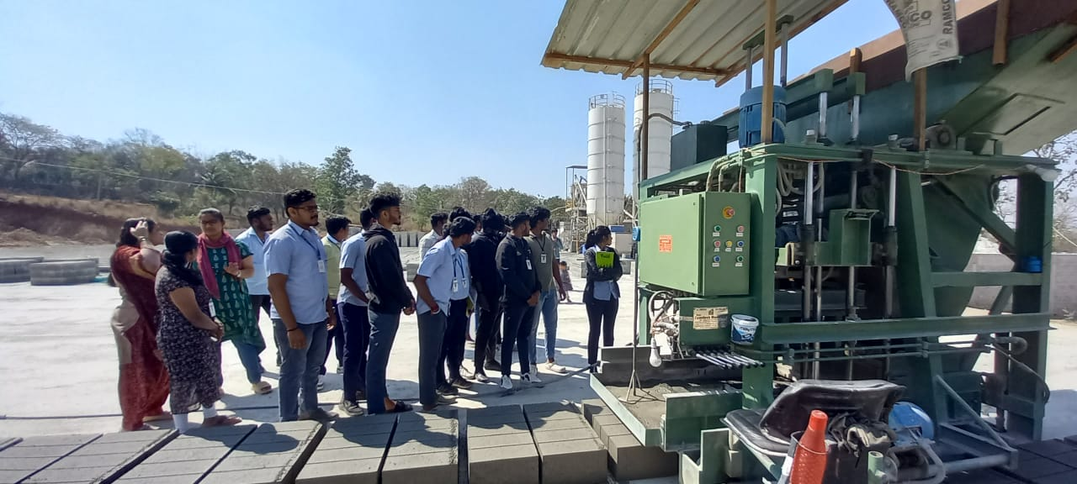

**Field Visit_CV_2024_25**

Visited to Shobha Concrete Blocks

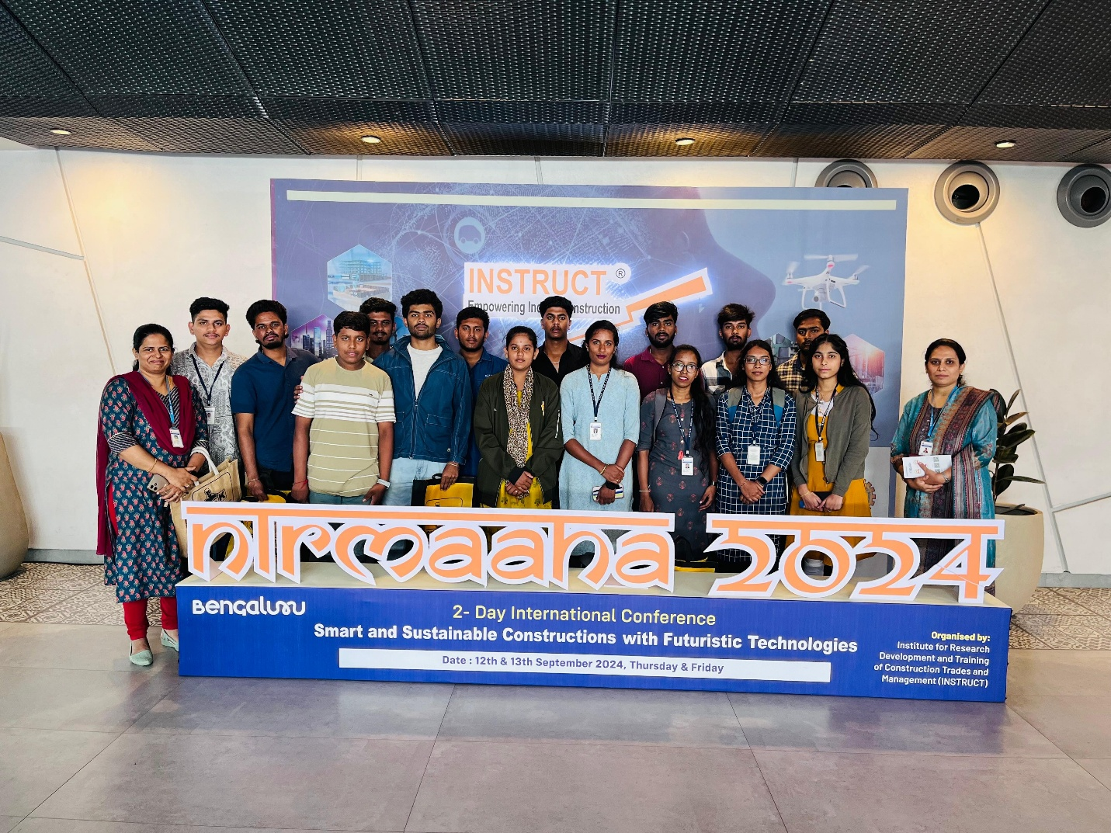

**Industrial Visit_Nirmaana_2024_25**

Department of Civil Engineering .K.S.School of Engineering & Management had organized one Day visit to NIRMAANA -2024,Smart and Sustainable Construction with Futuristic Technologies on 13th September 2024.

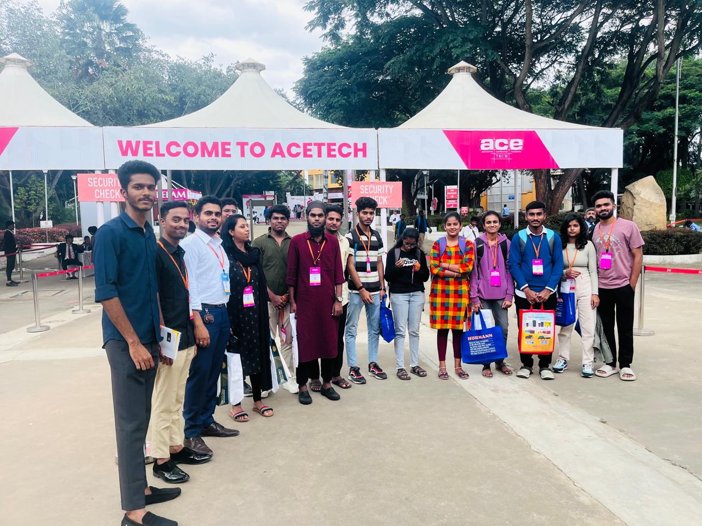

**Field Visit _CV_2024_25**

ACETECH Fair

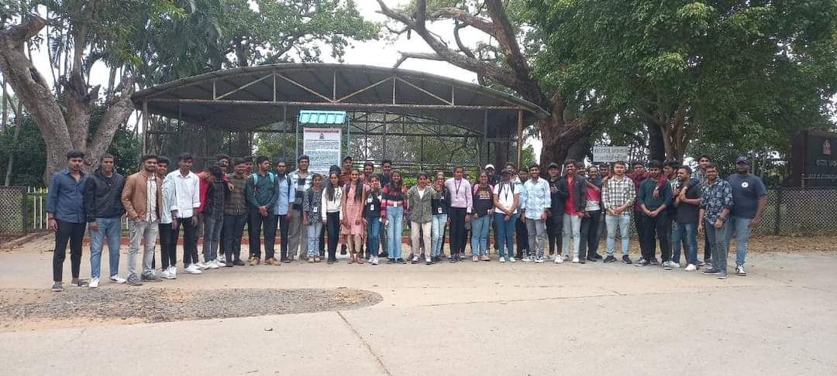

**Field visit_CV_2023_24**

Visited to Shivanasamudra Hydro powerplant

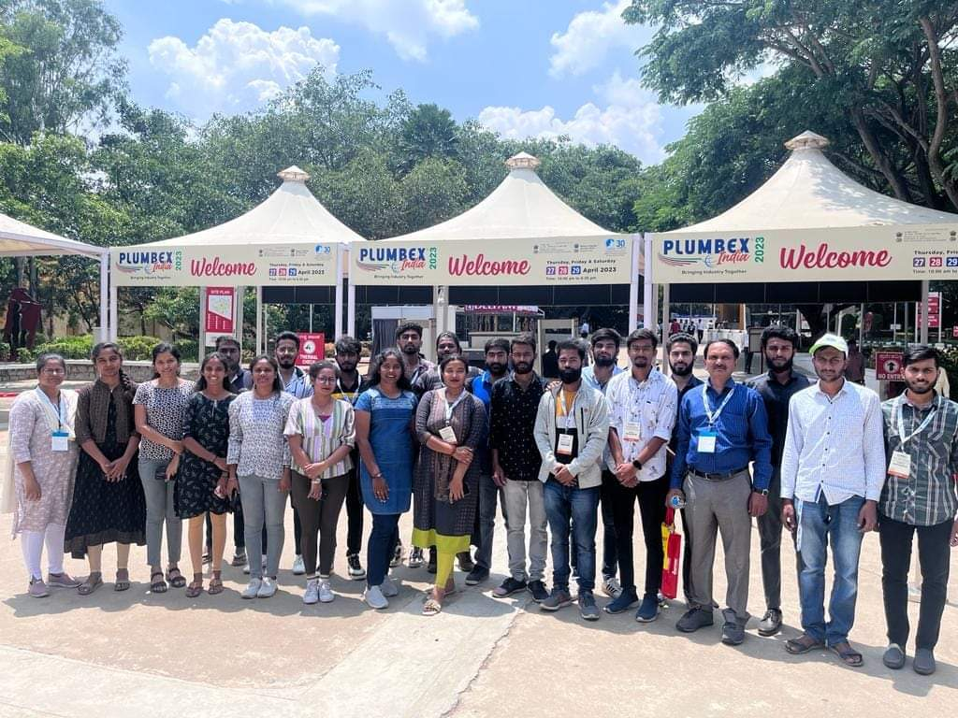

**Field Visit_2022_23**

International Plumbing Materials Fair

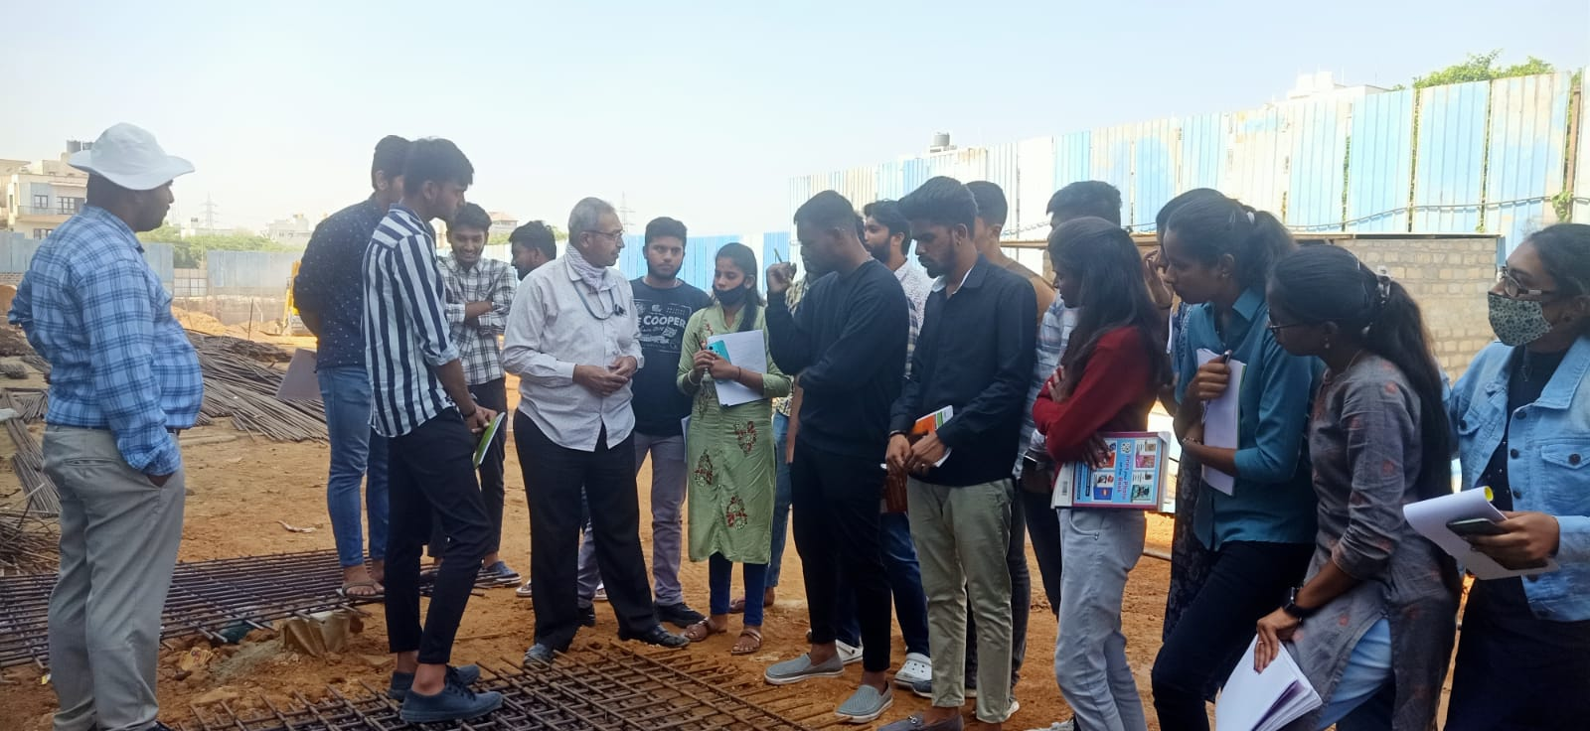

**Field Visit_CV_2022_23**

Construction Site Visit

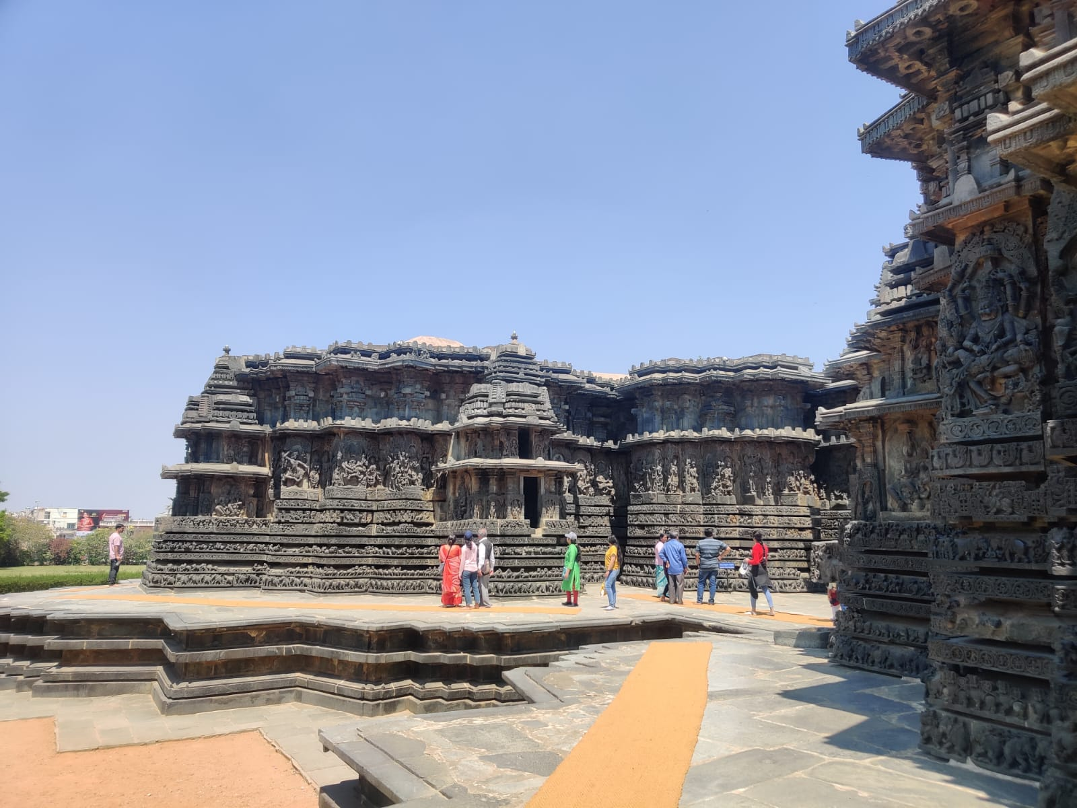

**Field Visit_CV_2022_23**

Heritage walk_Belur & Halebidu

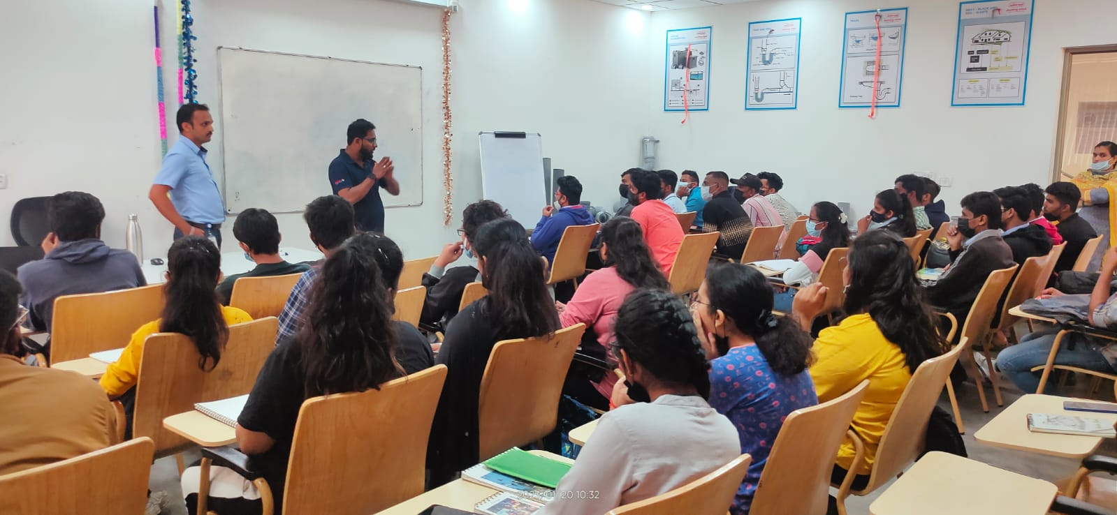

**Field Visit_CV_2022_23**

Ashirwad Plumbing School

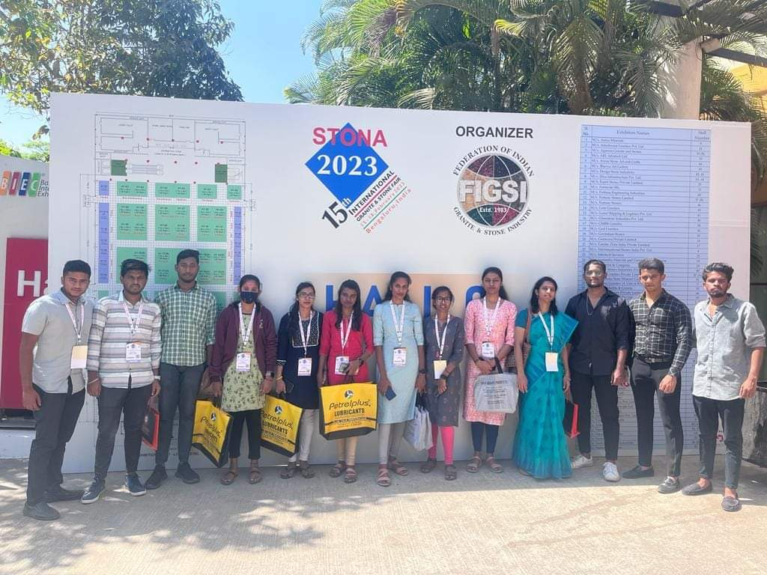

**Field Visit_2022-23**

Stona_2023

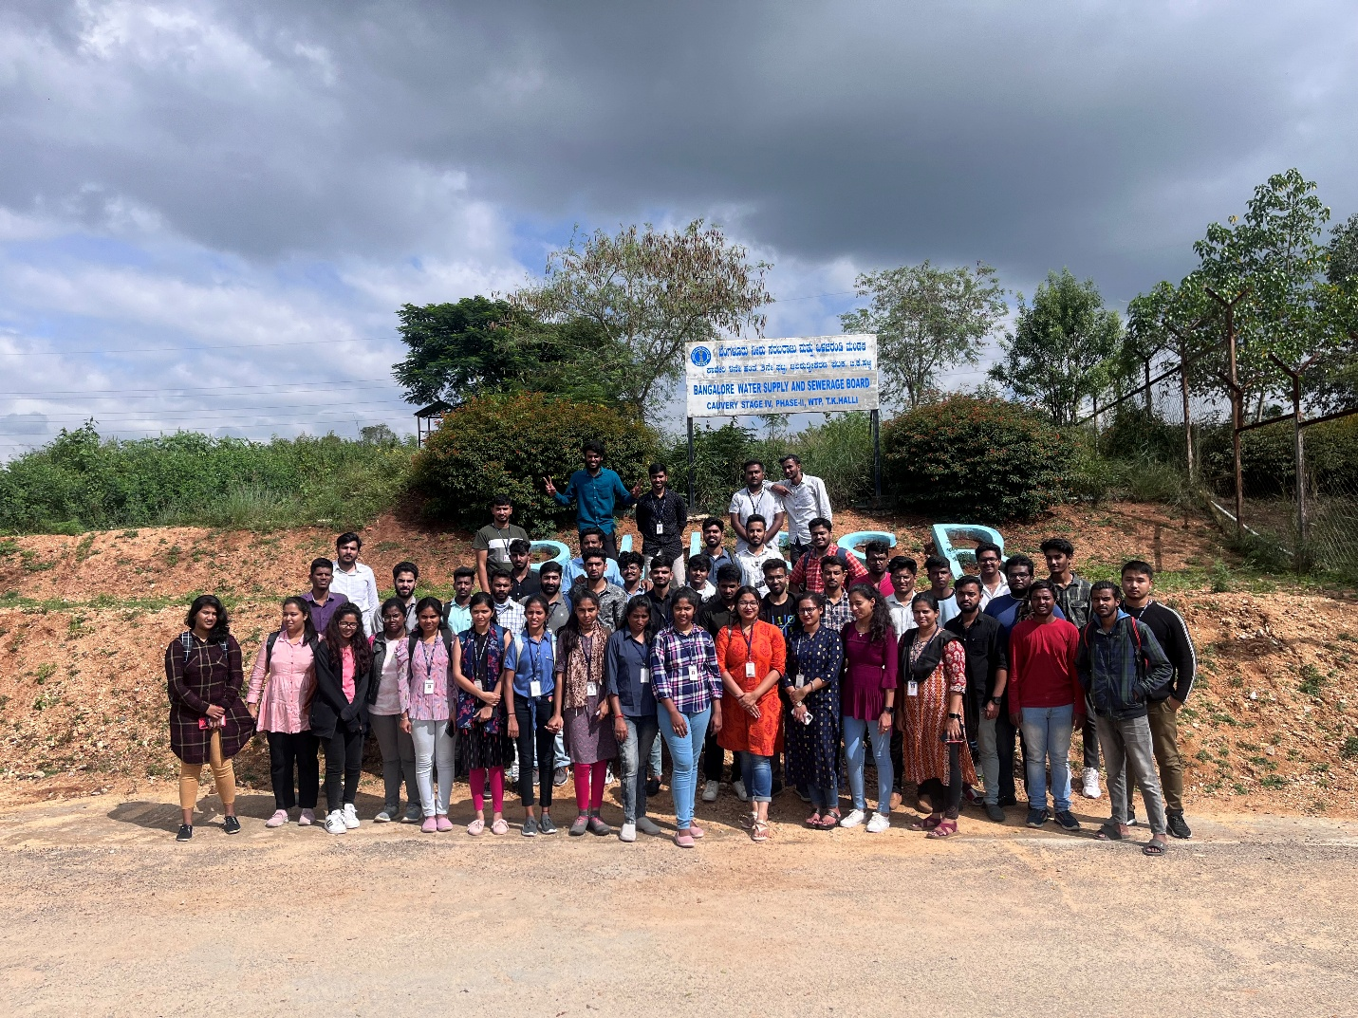

**Field Visit _CV_2022_23**

TK Halli Water Treatment Plant

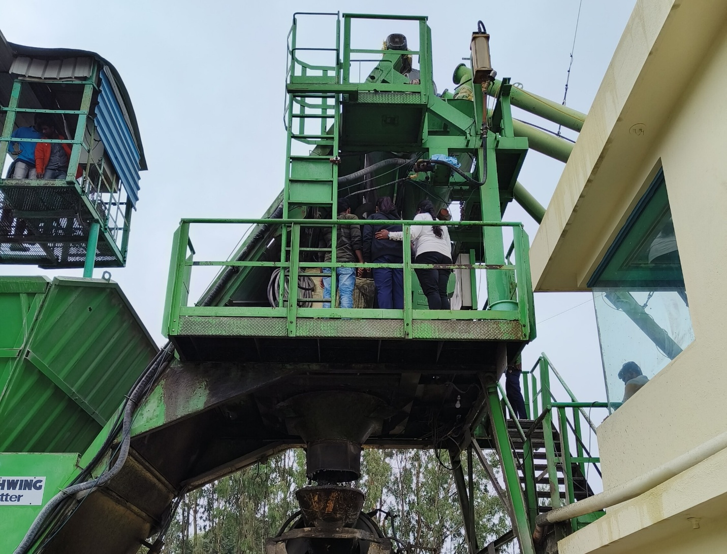

**Field Visit -CV-2022_23**

Concrete RMC Plant

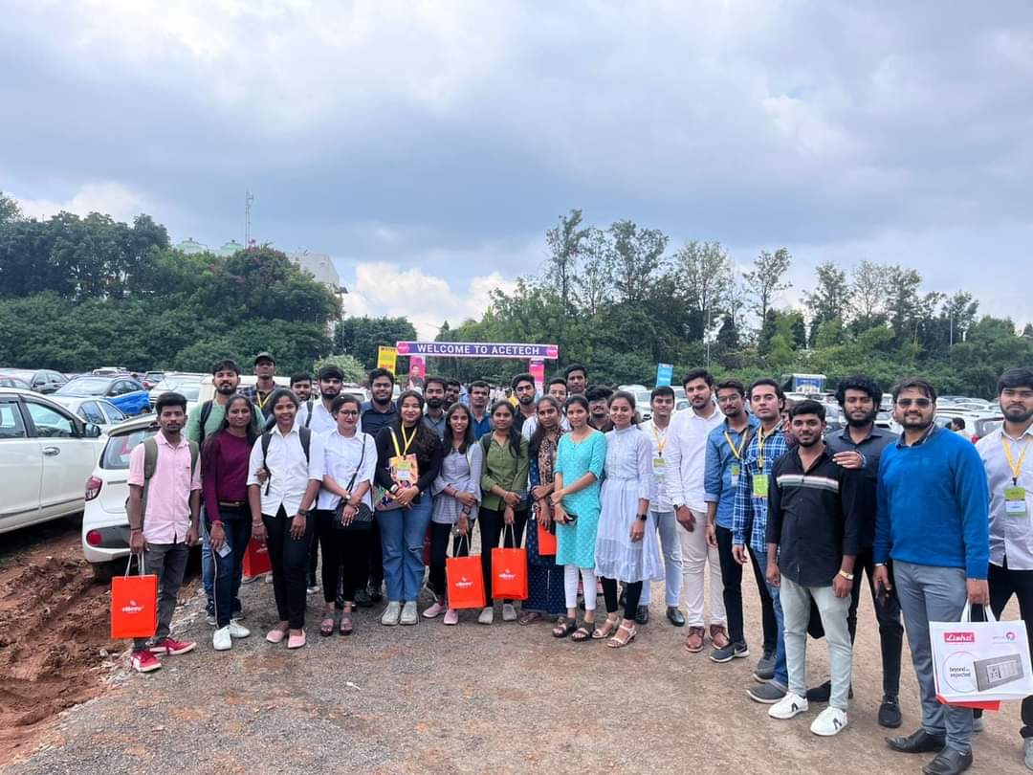

**Field Visit_2022_23**

International Architecture and Construction Materials Fair

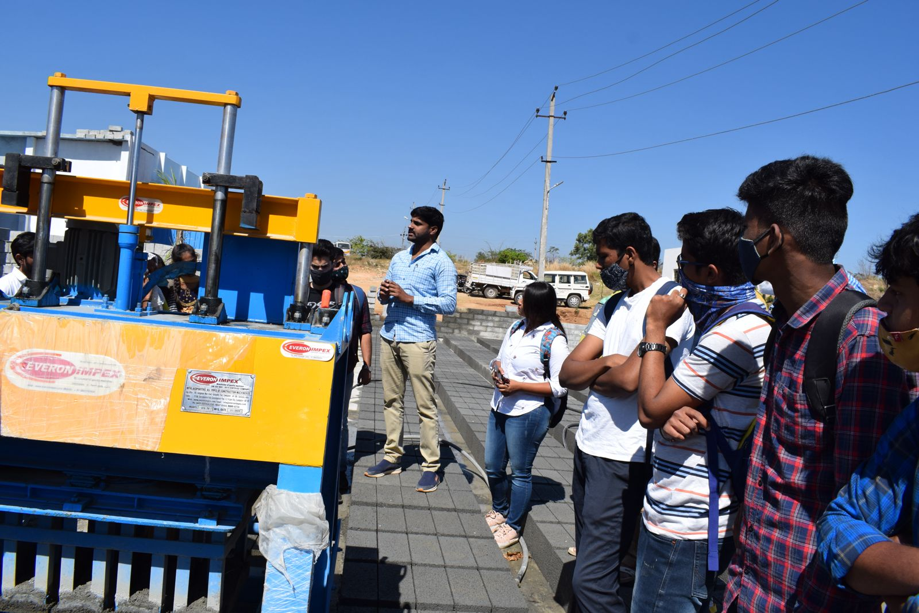

**Field Visit-CV-2020-21**

Field Visit-CV-2020-21

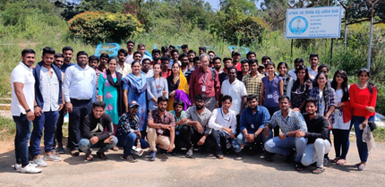

**Field Visit -CV-2019-20**

Torekadanahalli Water Purification Plant

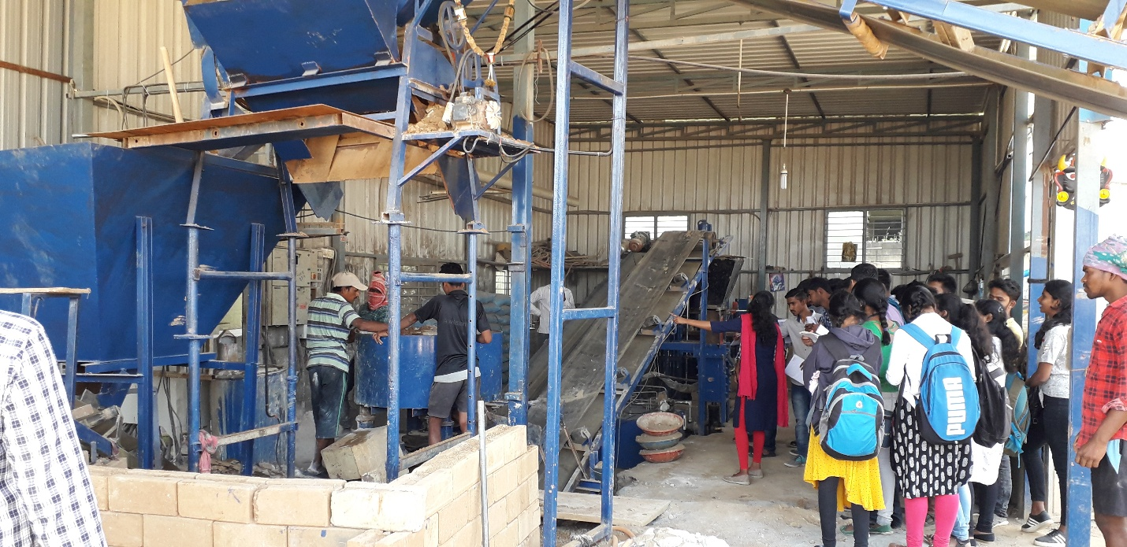

**Field Visit-CV-2019-20**

Stabilized Interlocking blocks Plant

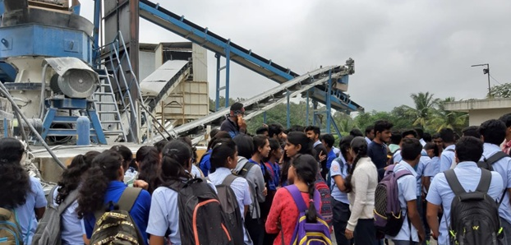

**Field Visit _CV_2019-20**

Concrete RMC Plant

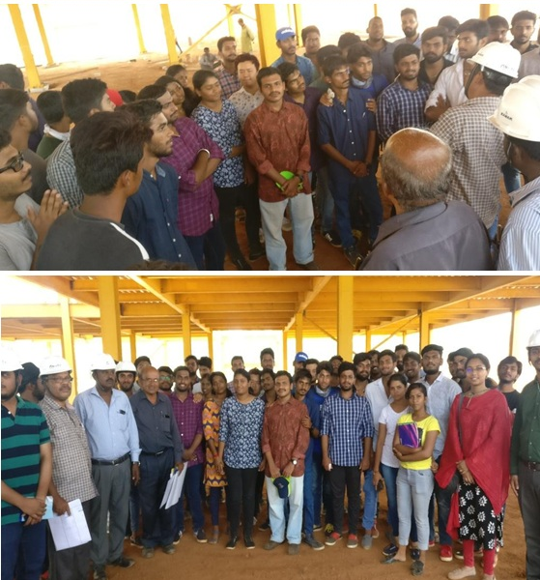

**Field Visit_CV_2019-20**

Steel Structures_Hospital Building

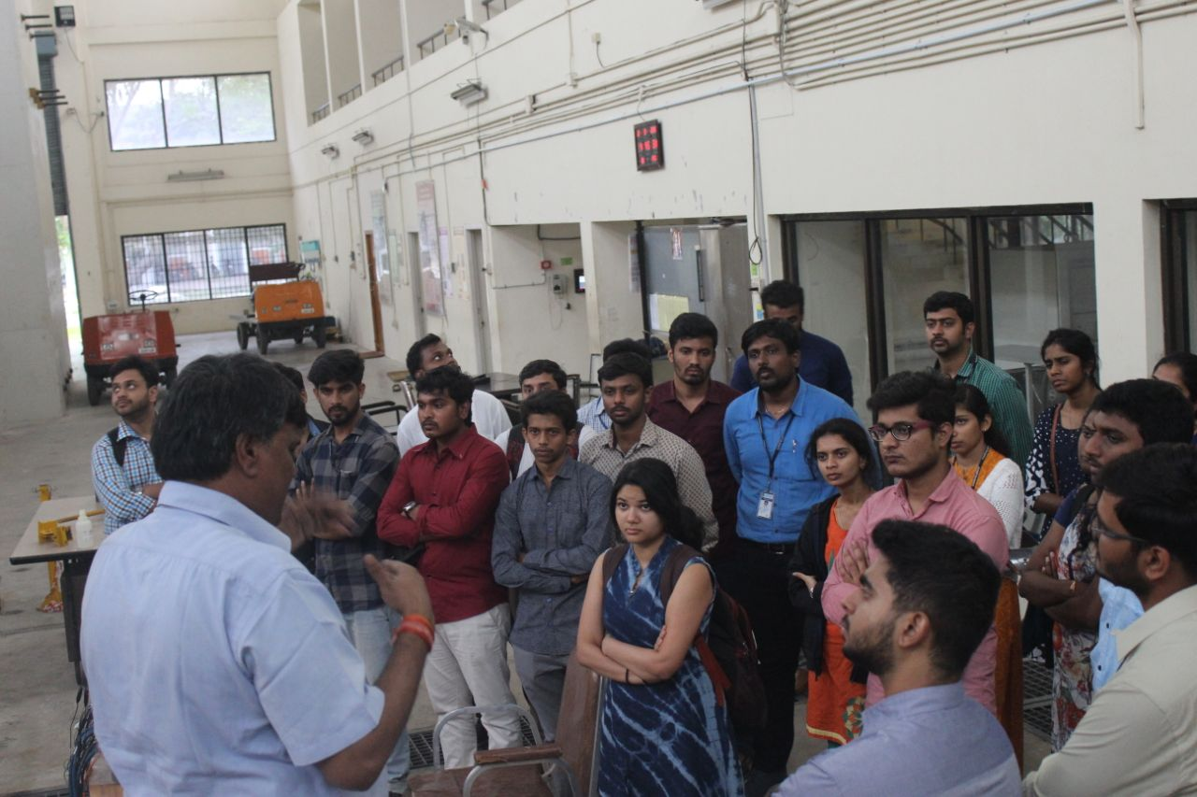

**Field Visit_CV_2018-19**

Structural Engineering Research Centre

**Project Exhibition**

Project Presentation is organized to evaluate the projects by experts from Academic Institutions and/Industry. The students demonstrate the projects to the jury. The evaluation is done and 2 prizes are awarded for the best projects.

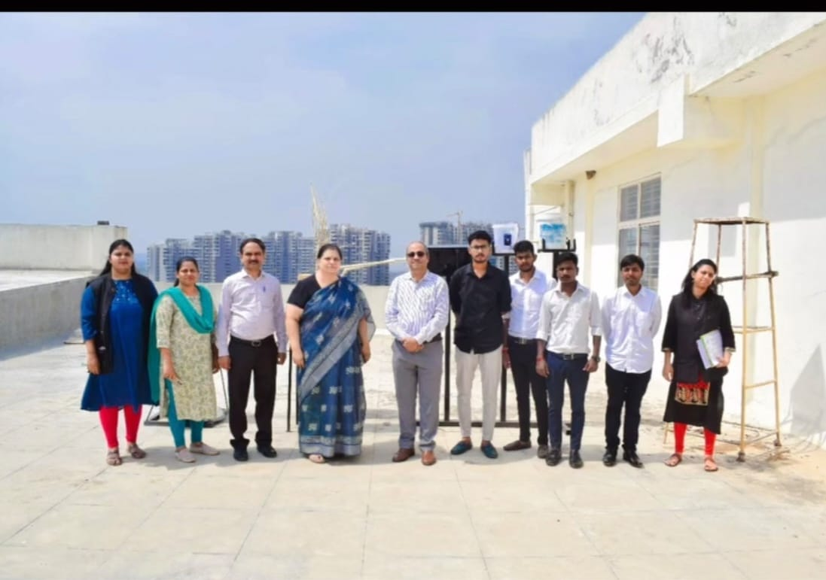

**Project Name: Project Exhibition**

Description: Project Exhibition for U G Final Year Students was organized on 8th of May 2024 by K. S. School of Engineering and Management for the students on "Innovative ideas in their projects" Project Title: " "Potential use of biofilters, constructed wetland and solar driven disinfection for grey water treatment in rural areas. " Project Students: Lakshmisha,Chandan, Bhemmaraju Guide: Dr.Rashmi HR and Mrs Pallavi M. Er Madan Mohan Rao,Cosultant was the Judge for the Event

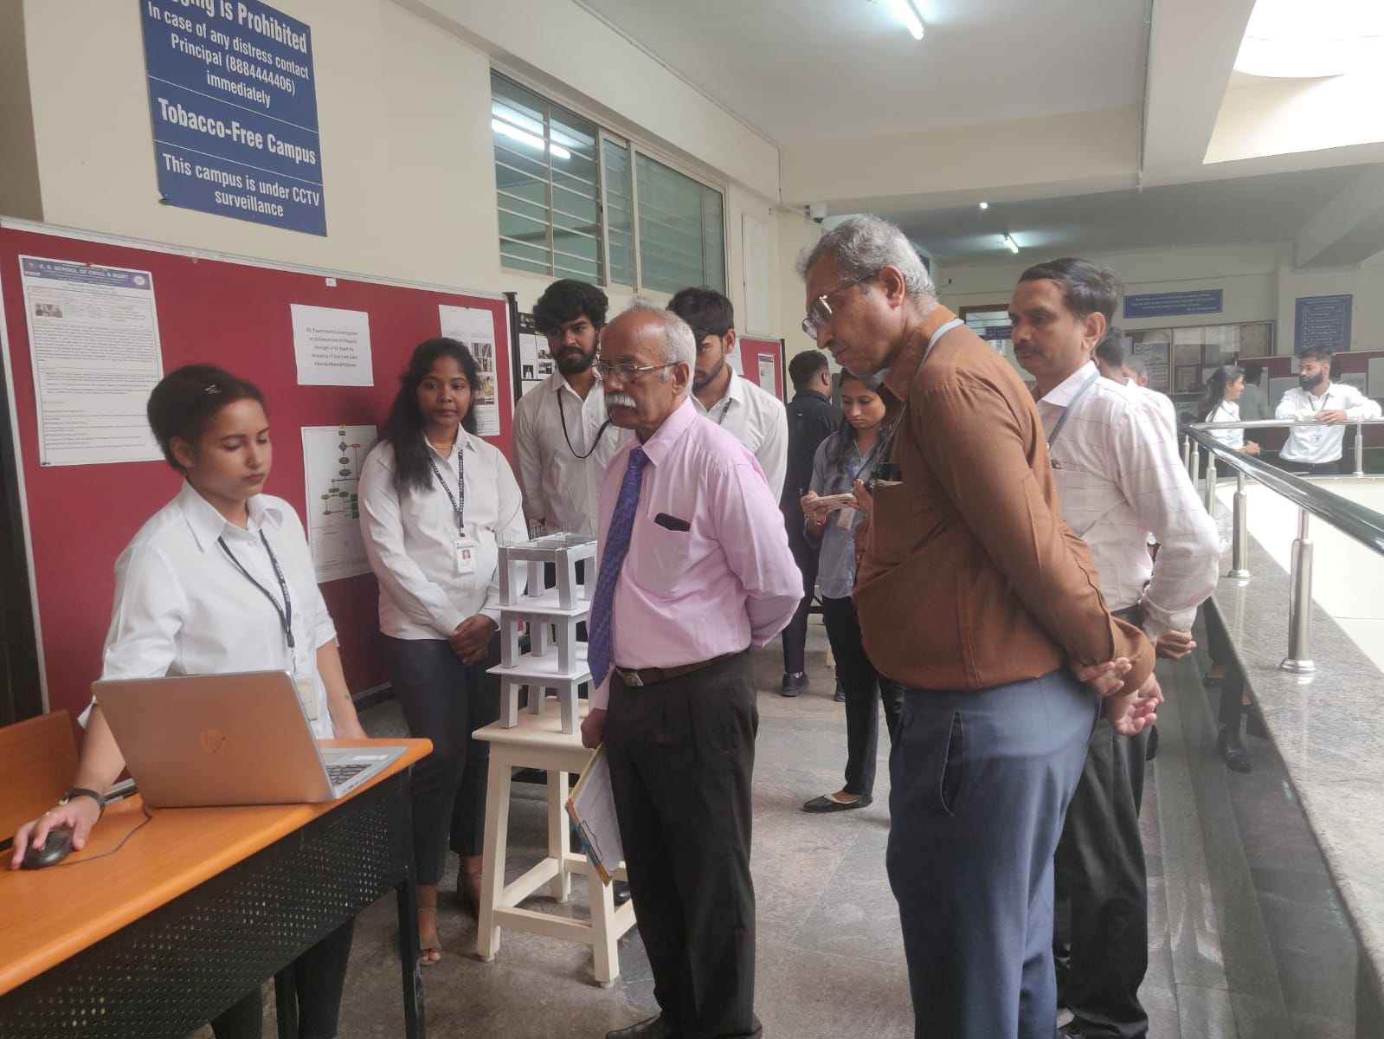

**Project Name: Project Exhibition**

Description: Project Exhibition 2022-2023 was organized on 08/05/23 by K. S. School of Engineering and Management for the projects designed and developed by students on innovative ideas.Dr, Rajeeva Subbaiah Venkatesh, Professor(Retd.),Dept. of Civil Engineering , NITK Surathkal was the Judge for the event.

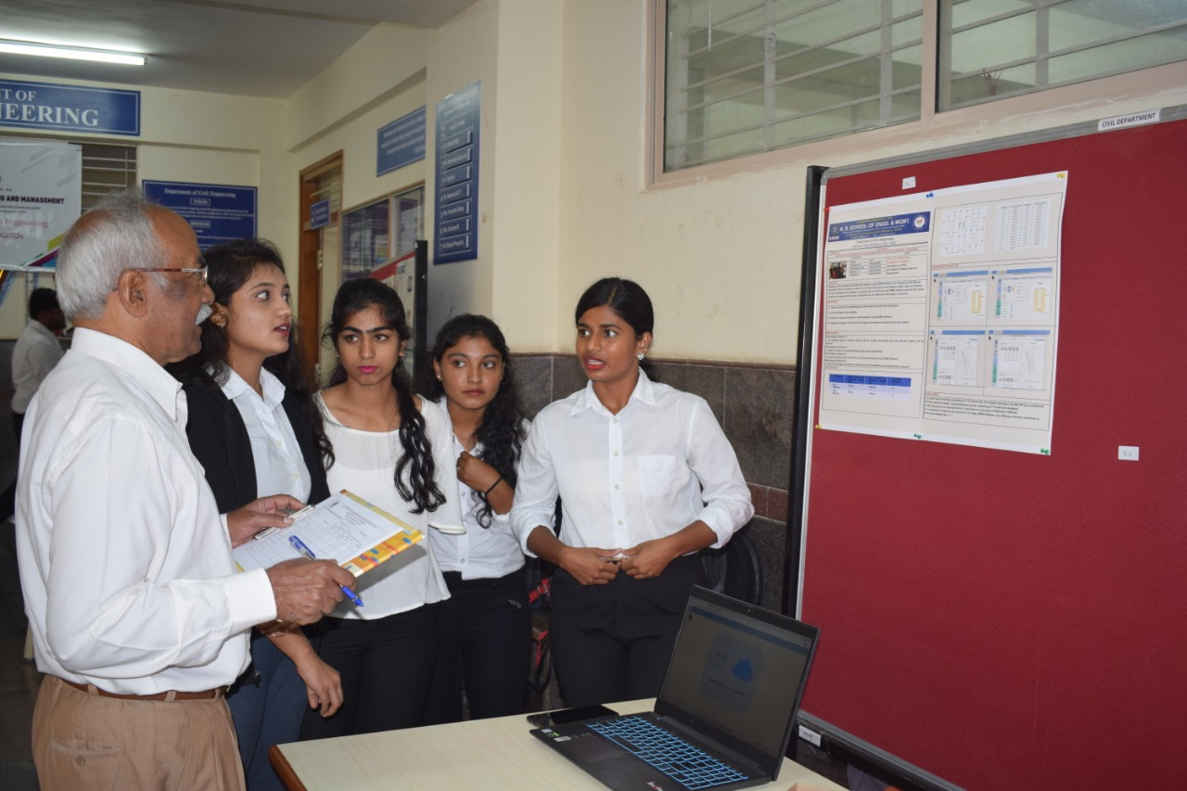

**Project Name: Project Exhibition**

Description: Description: Project Exhibition 2021-2022 was organized on 14/05/22 by K. S. School of Engineering and Management for the projects designed and developed by students on innovative ideas.Dr, Rajeeva Subbaiah Venkatesh, Professor (Retd.),Dept. of Civil Engineering , NITK Surathkal was the Judge for the event.

**MOUs Signed**

The Memorandum of Understanding details modalities and general conditions regarding collaboration between the INDUSTRY and KSSEM. Also facilititate for enhancing and encouraging students for interactions between the Industry Experts, Scientists, Research fellows and Faculty members for knowledge sharing with the following objectives:-

* Collaboration in conduction of conferences, workshops, seminars and hackthons.
* Provides industry exposure to KSSEM students.
* Mutually agreed guidance for student's projects and scholar's reserarch works through internship and industrial training.
* Provision given for the usage of institute infrastructure by industry like library, internet and computational facilities etc.

Sree Shobha Concretes [[view here]](https://kssem.edu.in/images/1746699071012_image.pdf)

Rapsol Technologies [[view here]](https://kssem.edu.in/images/1746279462649_image.pdf)

UltraTech Cement Limited [[view here]](https://kssem.edu.in/images/1713248202118_image.pdf)

Ascend [[view here]](https://kssem.edu.in/images/1665048765567_image.pdf)

CADD centre [[view here]](https://kssem.edu.in/images/1663829771577_image.pdf)

Sir MV Skills [[view here]](https://kssem.edu.in/images/1663829735728_image.pdf)

**NBA Links**

|  |
| --- |
| * Criteria 2   + - 2.2.5 Initiatives related to industry internship/summer training [view here](https://kssem.edu.in/images/1744715890283_report.pdf)   + - 2.2.5 Internship Certificate Sample [view here](https://kssem.edu.in/images/1744783225474_report.pdf)   + - 2.2.5 Industry Visit Feedback Form Sample [view here](https://kssem.edu.in/images/1744783319088_report.pdf)   + - 2.2.4_Industry Interaction_ Centre of Excellance [view here](https://kssem.edu.in/images/1745312006410_report.pdf)   + - 2.2.1 Teaching Learning Process [view here](https://kssem.edu.in/images/1745487255698_report.pdf)   + - 2.2.2 _Sample Question Paper [view here](https://kssem.edu.in/images/1745491447508_report.pdf)   + - 2.2.2_ Assignment Sample Paper [view here](https://kssem.edu.in/images/1745493124280_report.pdf)   + - 2.2.3 _Project List [view here](https://kssem.edu.in/images/1745577086622_report.pdf)   + - 2.2.3_Project Evaluation [view here](https://kssem.edu.in/images/1745649207352_report.pdf)   + - 2.2.3 _Project Individual Performance [view here](https://kssem.edu.in/images/1745649248711_report.pdf)   + - 2.2.1_Final [view here](https://kssem.edu.in/images/1746167924167_report.pdf)   + - 2.2.1_Slow Learners Chart [view here](https://kssem.edu.in/images/1746168277582_report.pdf)   + - 2.2.1_Slow Learners [view here](https://kssem.edu.in/images/1746168727015_report.pdf)   + - 2.1_Teaching and Learning [view here](https://kssem.edu.in/images/1746416260589_report.jpg)   + - 2.2.1 _VTU Calender [view here](https://kssem.edu.in/images/1746417144205_report.pdf)   + - 2.2.1_Collge Calender [view here](https://kssem.edu.in/images/1746417349539_report.pdf)   + - 2.2.1 _Departemnt Calender [view here](https://kssem.edu.in/images/1746417662361_report.pdf)   + - 2.2.1_Pedagogy Intiative [view here](https://kssem.edu.in/images/1746418655007_report.jpg)   + - 2.2.1_Fast Learners [view here](https://kssem.edu.in/images/1746421758680_report.pdf)   + - 2.2.5_Student Feedback [view here](https://kssem.edu.in/images/1746424043196_report.pdf)   + - 2.2.1_Weak students [view here](https://kssem.edu.in/images/1746424526816_report.jpg)   + - 2.2.5_Class Committe MEeting [view here](https://kssem.edu.in/images/1746424744421_report.pdf)   + - 2.2.1_Slow Learner Updated [view here](https://kssem.edu.in/images/1746426325017_report.pdf)   + - 2.2.5_Responce to Industrial Visit [view here](https://kssem.edu.in/images/1746507869140_report.pdf)   + - 2.2.5_Responce to Internship [view here](https://kssem.edu.in/images/1746508287550_report.pdf)   + - 2.2.2_QP [view here](https://kssem.edu.in/images/1746513055867_report.pdf)   + - 2.2.2_Question Paper [view here](https://kssem.edu.in/images/1746514939167_report.pdf)   + - 2.2.2_Scheme and Solution [view here](https://kssem.edu.in/images/1746514967197_report.pdf)   + - 2.2.2_Blue book [view here](https://kssem.edu.in/images/1746515018686_report.pdf)   + - 2.2.4_Offer Letter [view here](https://kssem.edu.in/images/1746516356174_report.pdf)   + - 2.2.5_Internship Details [view here](https://kssem.edu.in/images/1746517724884_report.pdf)   + - 2.2.1_VTU [view here](https://kssem.edu.in/images/1746520164670_report.pdf)   + - 2.1.2_BOS [view here](https://kssem.edu.in/images/1746695479291_report.pdf) |
| * Criteria 3   + - 3.3.1 Flow Chart [view here](https://kssem.edu.in/images/1745384631374_report.JPG)   + - 3.2.1 _CIE Blue book [view here](https://kssem.edu.in/images/1745572550038_report.pdf)   + - 3.2.1_Record Book [view here](https://kssem.edu.in/images/1745572615606_report.pdf)   + - 3.2.1_Poster [view here](https://kssem.edu.in/images/1745572699219_report.pdf)   + - 3.2.2_Internship Report [view here](https://kssem.edu.in/images/1745573183891_report.pdf)   + - 3.2.1 Project Report [view here](https://kssem.edu.in/images/1745573296586_report.pdf)   + - 3.2.1 Project Report [view here](https://kssem.edu.in/images/1745573332130_report.pdf)   + - 3.2.1 _Project Report [view here](https://kssem.edu.in/images/1745573454944_report.pdf)   + - 3.2.1 _Project Report [view here](https://kssem.edu.in/images/1745573586909_report.pdf)   + - 3.2.1_Lab [view here](https://kssem.edu.in/images/1745905805102_report.pdf)   + - 3.2.1_Project Report _21 Scheme [view here](https://kssem.edu.in/images/1745905993804_report.pdf)   + - 3.2.1_Lab Record [view here](https://kssem.edu.in/images/1745906084861_report.pdf)   + - 3.2.1_IA Document_2021 Batch [view here](https://kssem.edu.in/images/1745906178768_report.pdf)   + - 3.2.1_IA Document_2022 Batch [view here](https://kssem.edu.in/images/1745906289176_report.pdf)   + - 3.2.1_Technical Seminar_18 Scheme [view here](https://kssem.edu.in/images/1745906412698_report.pdf)   + - 3.2.1_2018 Scheme Flowchart [view here](https://kssem.edu.in/images/1745911085120_report.JPG)   + - 3.2.1_2021 Scheme Flowchart [view here](https://kssem.edu.in/images/1745911112234_report.JPG)   + - 3.2.1_2022 Scheme Flowchart [view here](https://kssem.edu.in/images/1745911135985_report.JPG)   + - Calculation of Score Level in Internal Assessment of Course [view here](https://kssem.edu.in/images/1746505013857_report.JPG)   + - Calculation of Levels for Direct Attainment [view here](https://kssem.edu.in/images/1746505061116_report.JPG)   + - Calculation of Scores for Semester End Exam [view here](https://kssem.edu.in/images/1746505105195_report.JPG)   + - Calculation of Survey Level [view here](https://kssem.edu.in/images/1746505159291_report.JPG)   + - 3.2.1 _CIE Blue book_2018 [view here](https://kssem.edu.in/images/1746512510111_report.pdf)   + - 3.3.1_PO & PSO EVALUATION SHEET 2018-2022, 2019-2023 [view here](https://kssem.edu.in/images/1746591830048_report.pdf) |
| * Criteria 4   + - 4.4 news letter.pdf [view here](https://kssem.edu.in/images/1746517119916_report.pdf)   + - 4.6.3_Student Publications [view here](https://kssem.edu.in/images/1746694431457_report.pdf) |
| * Criteria 5   + - 5.8_Financial Assistance [view here](https://kssem.edu.in/images/1744434246221_report.pdf)   + - 5.8.3_ Faculty Performance _CV [view here](https://kssem.edu.in/images/1744434686800_report.pdf)   + - 5.7_Product Development Updated [view here](https://kssem.edu.in/images/1745920359807_report.pdf)   + - 5.5 _Review Responce [view here](https://kssem.edu.in/images/1746181995646_report.pdf)   + - 5.5 _Image 1 [view here](https://kssem.edu.in/images/1746183834229_report.jpg)   + - 5.5 _Image 2 [view here](https://kssem.edu.in/images/1746184218029_report.jpg)   + - 5.5 _Image 3 [view here](https://kssem.edu.in/images/1746184557162_report.jpg)   + - 5.5_Image 4 [view here](https://kssem.edu.in/images/1746184581865_report.png)   + - 5.5_Image 5 [view here](https://kssem.edu.in/images/1746184609241_report.JPG)   + - 5.5 _Image 6 [view here](https://kssem.edu.in/images/1746184634553_report.JPG)   + - Peer Review Form (Innovative Teaching and Learning activities) [view here](https://kssem.edu.in/images/1746439137306_report.pdf)   + - LAB PHOTOS.pdf [view here](https://kssem.edu.in/images/1746441276426_report.pdf)   + - FACULTY ACHEIVEMENT- [view here](https://kssem.edu.in/images/1746441911267_report.pdf)   + - 5.7.3 Working Models,Monograms_CV [view here](https://kssem.edu.in/images/1746442191922_report.pdf)   + - 10 years service certificate [view here](https://kssem.edu.in/images/1746504048975_report.pdf)   + - 5.5 List of projects [view here](https://kssem.edu.in/images/1746507299227_report.pdf)   + - 5.5_Pedagogy Review Forms [view here](https://kssem.edu.in/images/1746518312388_report.pdf)   + - 5.5_Form [view here](https://kssem.edu.in/images/1746766893096_report.pdf) |
| * Criteria 6   + - 6.3_lab Photos [view here](https://kssem.edu.in/images/1745918450983_report.pdf)   + - 6.3 charts- List of Exp, Do's & dont's [view here](https://kssem.edu.in/images/1746680419565_report.pdf) |
| * Criteria 7   + - 7.2 _Academic Audit Process [view here](https://kssem.edu.in/images/1745564057413_report.jpg)   + - 7.2_Internal Audit Report [view here](https://kssem.edu.in/images/1745916684177_report.pdf)   + - 7.2_Internal Academic Audit Report Findings [view here](https://kssem.edu.in/images/1745916910888_report.pdf)   + - 7.2_External Academic Audit Report [view here](https://kssem.edu.in/images/1745917054859_report.pdf)   + - 7.2_NPTEL Certification [view here](https://kssem.edu.in/images/1746159809569_report.pdf)   + - 7.2_Internal Academic [view here](https://kssem.edu.in/images/1746521274215_report.pdf) |
| * Criteria 9   + - 9.6 Details of Achievements [view here](https://kssem.edu.in/images/1744360749293_report.pdf)   + - 9.2 Program Exit Survey [view here](https://kssem.edu.in/images/1744441907305_report.pdf)   + - 9.2 Employer Feedback Survey [view here](https://kssem.edu.in/images/1744441954656_report.pdf)   + - 9.2 Alumni Feedback Survey [view here](https://kssem.edu.in/images/1744441994031_report.pdf)   + - 9.2 Course End Survey [view here](https://kssem.edu.in/images/1744442752282_report.pdf)   + - 9.2 Faculty Feedback [view here](https://kssem.edu.in/images/1744443874685_report.pdf)   + - 9.5 Higher Education [view here](https://kssem.edu.in/images/1745219989039_report.pdf)   + - 9.5 Available Books for Higer Education [view here](https://kssem.edu.in/images/1745220168892_report.pdf)   + - 9.7 Rotaract Activity [view here](https://kssem.edu.in/images/1745220303038_report.pdf)   + - 9.5 offer Letter [view here](https://kssem.edu.in/images/1745220445551_report.pdf)   + - 9.5 Placed Student Details [view here](https://kssem.edu.in/images/1745220568755_report.pdf)   + - 9.5 Life Skills [view here](https://kssem.edu.in/images/1745220686317_report.pdf)   + - 9.5 Placement Drive [view here](https://kssem.edu.in/images/1745220794315_report.pdf)   + - 9.5 Placement Drive_2023 Batch [view here](https://kssem.edu.in/images/1745220909731_report.pdf)   + - 9.5_LIST OF ENTREPRENEURS [view here](https://kssem.edu.in/images/1745220988611_report.pdf)   + - 9.5 _Achivement Details [view here](https://kssem.edu.in/images/1745221092434_report.pdf)   + - 9.6 List of Patents [view here](https://kssem.edu.in/images/1745221232299_report.pdf)   + - 9.6 Patent File [view here](https://kssem.edu.in/images/1745221279425_report.pdf)   + - 9.7 NSS Activity 2021-22 [view here](https://kssem.edu.in/images/1745221370532_report.pdf)   + - 9.7 NSS Activity 2022-23 [view here](https://kssem.edu.in/images/1745221443261_report.pdf)   + - 9.7 _NSS Activity 2023-24 [view here](https://kssem.edu.in/images/1745221536316_report.pdf)   + - 9.7 NSS Activity _2024_25 [view here](https://kssem.edu.in/images/1745221606476_report.pdf)   + - 9.7_Rotaract Club Activity _2022-23 [view here](https://kssem.edu.in/images/1745221765185_report.pdf)   + - 9.7 _ Rotaract Activity _2023_24 [view here](https://kssem.edu.in/images/1745222109019_report.pdf)   + - 9.5_Placement Drive [view here](https://kssem.edu.in/images/1745222525241_report.pdf)   + - 9.5 _Placement Drive _2024 [view here](https://kssem.edu.in/images/1745222724700_report.pdf)   + - 9.3 Students Feedback on Facilities 2024-2025 [view here](https://kssem.edu.in/images/1745229619601_report.pdf)   + - 9.1 Proctor book sample [view here](https://kssem.edu.in/images/1745296939567_report.pdf)   + - 9.5 Training programmes for students [view here](https://kssem.edu.in/images/1745297030839_report.pdf)   + - 9.7 NSS Events [view here](https://kssem.edu.in/images/1745301969941_report.pdf)   + - 9.6 visiting card 1 [view here](https://kssem.edu.in/images/1745306479248_report.png)   + - 9.6 visiting card 2 [view here](https://kssem.edu.in/images/1745306497536_report.jpg)   + - 9.6 Faculty Ideathon 2024-pic [view here](https://kssem.edu.in/images/1745307765224_report.png)   + - 9.6 Manthan 2022 team-1 pic [view here](https://kssem.edu.in/images/1745307849171_report.png)   + - 9.6 Manthan 2022 team-2 pic [view here](https://kssem.edu.in/images/1745308039651_report.png)   + - 9.6 Manthan 2022 team-3 pic [view here](https://kssem.edu.in/images/1745308057806_report.png)   + - 9.6 Manthan 2022 certificate- pic [view here](https://kssem.edu.in/images/1745308079665_report.jpg)   + - 9.7 Atal innovation-JIT-pic [view here](https://kssem.edu.in/images/1745308381362_report.png)   + - 9.7 NSS Activity 2022-2023 -pic [view here](https://kssem.edu.in/images/1745308398924_report.jpg)   + - 9.7 NSS Activity 2023-2024 -pic [view here](https://kssem.edu.in/images/1745308413470_report.jpg)   + - 9.7 NSS Activity 2024-2025 -pic [view here](https://kssem.edu.in/images/1745308429624_report.jpg)   + - 9.7 students & volunteers-1-pic [view here](https://kssem.edu.in/images/1745308463326_report.jpg)   + - 9.7 students & volunteers-2-pic.jpg [view here](https://kssem.edu.in/images/1745308488114_report.png)   + - 9.7 UBA-1-pic [view here](https://kssem.edu.in/images/1745308505509_report.png)   + - 9.7 UBA-2-pic [view here](https://kssem.edu.in/images/1745308525028_report.jpg)   + - 9.7 UBA-3-pic [view here](https://kssem.edu.in/images/1745308545541_report.jpg)   + - 9.7 workshop on AI-1-pic [view here](https://kssem.edu.in/images/1745308675314_report.png)   + - 9.7 workshop on AI-2-pic [view here](https://kssem.edu.in/images/1745308693998_report.png)   + - 9.7 workshop on AI-3-pic.png [view here](https://kssem.edu.in/images/1745308875658_report.jpg)   + - 9.7 NSS Activity 2021-2022 -pic [view here](https://kssem.edu.in/images/1745311076063_report.png)   + - 9.7 Rotaract club 2022-2023 -pic.jpg [view here](https://kssem.edu.in/images/1745311161406_report.png)   + - 9.7 Rotaract club 2023-2024 -pic.jpg [view here](https://kssem.edu.in/images/1745311346469_report.png)   + - 9.7 Rotaract club 2024-2025 -pic.jpg [view here](https://kssem.edu.in/images/1745311389301_report.png)   + - 9.5 Placement Drive 2024 Batch [view here](https://kssem.edu.in/images/1745316711339_report.pdf)   + - 9.2 _Feedback [view here](https://kssem.edu.in/images/1746773881742_report.pdf)   + - 9.5 Placed students details updated [view here](https://kssem.edu.in/images/1746776078545_report.pdf)   + - 9.5 Placed students details updated (1).pdf [view here](https://kssem.edu.in/images/1746776524829_report.pdf) |
| * Criteria 10   + - 10.2.1 [view here](https://kssem.edu.in/images/1746182924082_report.jpg)   + - 10.2.1 [view here](https://kssem.edu.in/images/1746182924524_report.jpg) |